UNIT-I
INTRODUCTION TO MANAGERIAL ECONOMICS & DEMAND ANALYSIS

ECONOMICS
Economics is a study of human activity both at individual and national level. The economists of early age treated economics merely as the science of wealth. The reason for this is clear. Every one of us in involved in efforts aimed at earning money and spending this money to satisfy our wants such as food, Clothing, shelter, and others. Such activities of earning and spending money are called “Economic activities”.
According to Adam Smith

“Economics as the study of nature and uses of national wealth”.

According to Dr. Alfred Marshall

“Economics is a study of man’s actions in the ordinary business of life: it enquires how he gets his income and how he uses it”.
MICRO AND MACRO ECONOMICS

Micro Economics

- The study of an individual consumer or a firm is called Micro Economics. It is also called the theory of Firm.
- Micro means one millionth. Micro Economics deals with behaviour and problems of single individual and of micro organisation.
Managerial Economics

- Managerial Economics has its roots in micro economics and it deals with the micro or individual enterprises.
- It is concerned with the application of concepts such as Price Theory, Law of Demand and Theories of market structure and so on.
Macro Economics

- The study of aggregate or total level of economic activity in a country is called Macro Economics.

- It studies the flow of economic resources or factors of production (such as land, labour, capital, organisation and technology) from the resource owner to the business firms and then from the business firms to the households.
- It deals with the total aggregates. For instance, total national income, total employment, total output and total investment.
- It studies the interrelations among various aggregates and examines their nature and behaviour, their determination and causes of their fluctuations in them.
- It deals with the price level in general, instead of studying the prices of individual commodities.
- It is concerned with the level of employment in the economy.

- It discusses aggregate consumption, aggregate investment, price level and national income.
- The important tools of macro economics include national income analysis, balance of payments and theories of employment and so on.
INTRODUCTION TO MANAGERIAL ECONOMICS

- Managerial Economics as a subject gained popularity in USA after the publication of book “Managerial Economics” by Joel Dean in 1951.
- Managerial Economics refers to the firm’s decision making process.

- It could be also interpreted as “Economics of Management”.

- Managerial Economics is also called as “Industrial Economics” or “Business Economics”.
- Joel Dean observes managerial economics shows how economic analysis can be used in formulating policies.
DEFINITIONS OF MANAGERIAL ECONOMICS

- M.H.SPENCER AND L. SIEGELMAN
Managerial Economics defined as “the integration of economic theory with business practice for the purpose of facilitating decision making and forward planning by management”.
- BRIGHAM AND PAPPAS believe that managerial economics is “The application of economic theory and methodology to business administration practice”.

- C.I.SAVAGE AND T.R.SMALL therefore believes that managerial economics is concerned with business efficiency.
- HAGUE observes that

“Managerial Economics is a fundamental academic subject which seeks to understand and to analyse the problems of business decision-making”.
- In the words of PAPPAS AND HIRSHEY
“Managerial Economics applies economic theory and methods to business and administrative decision-making. Because it uses the tools and techniques of economic analysis to solve managerial problems, managerial economics links traditional economics with decision sciences to develop important tools for managerial decision-making”.
- MICHAEL R.BAYE defines

  - Managerial Economics as “the study of how to direct scarce resources in a way that most efficiently achieves a managerial goal”.
- HAYNES, MOTE AND PAUL define
Managerial Economics as “economics applied in decision-making. They consider this as a bridge between the abstract theory and the managerial practice”.
Managerial Economics, therefore, focuses on those tools and techniques, which are useful in decision-making.
MANAGERIAL ECONOMICS:

Managerial Economics refers to the firm’s decision making process. It could be also interpreted as “Economics of Management”. Managerial Economics is also called as “Industrial Economics” or “Business Economics”.

Managerial Economics bridges the gap between traditional economics theory and real business practices in two days. First it provides a number of tools and techniques to enable the manager to become more competent to take decisions in real and practical situations. Secondly it serves as an integrating course to show the interaction between various areas in which the firm operates.

NATURE / CHARACTERISTICS OF MANAGERIAL ECONOMICS

- Close to microeconomics: Managerial economics is concerned with finding the solutions for different managerial problems of a particular firm. Thus, it is more close to microeconomics.
- Operates against the backdrop of macroeconomics: The macroeconomics conditions of the economy are also seen as limiting factors for the firm to operate. In other words, the managerial economist has to be aware of the limits set by the macroeconomics conditions such as government industrial policy, inflation and so on.
- Normative statements: A normative statement usually includes or implies the words ‘ought’ or ‘should’. They reflect people’s moral attitudes and are expressions of what a team of people ought to do. For instance, it deals with statements such as ‘Government of India should open up the economy. Such statement are based on value judgments and express views of what is ‘good’ or ‘bad’, ‘right’ or ‘ wrong’. One problem with normative statements is that they cannot to verify by looking at the facts, because they mostly deal with the future. Disagreements about such statements are usually settled by voting on them.
- Prescriptive actions: Prescriptive action is goal oriented. Given a problem and the objectives of the firm, it suggests the course of action from the available alternatives for optimal solution. If does not merely mention the concept, it also explains whether the concept can be applied in a given context on not. For instance, the fact that variable costs are marginal costs can be used to judge the feasibility of an export order.
- Applied in nature: ‘Models’ are built to reflect the real life complex business situations and these models are of immense help to managers for decision-making. The different areas where models are extensively used include inventory control, optimization, project management etc. In managerial economics, we also employ case study methods to conceptualize the problem, identify that alternative and determine the best course of action.
- Offers scope to evaluate each alternative: Managerial economics provides an opportunity to evaluate each alternative in terms of its costs and revenue. The managerial economist can decide which is the better alternative to maximize the profits for the firm.
- Interdisciplinary: The contents, tools and techniques of managerial economics are drawn from different subjects such as economics, management, mathematics, statistics, accountancy, psychology, organizational behaviour, sociology and etc.
- Assumptions and limitations: Every concept and theory of managerial economics is based on certain assumption and as such their validity is not universal. Where there is change in assumptions, the theory may not hold good at all.

SCOPE OF MANAGERIAL ECONOMICS

The main focus in managerial economics is to find an optimal solution to a given managerial problem, the problem may related to production, reduction or control of cost,

determination of price of a given product or service, make or decisions, inventory decisions, capital management or profit planning and management, investment decisions or human resource management. While all these are the problems, the managerial economics makes use of the concepts, tools and techniques of economics and other related discipline to find an optimal solution to a given managerial problem.
The main Areas of Managerial Economics

- Demand Decision:

  - The analysis and forecasting of demand for a given product and service is the first task of the managerial economist.
  - The behavioural implications such as the needs of the customers responses to a given change in the price or supply are analysed in a scientific manner.
  - The impact of changes in prices, income levels and prices of alternative products / services are assessed and accordingly the decisions are taken to maximise the profits.
  - Demand at different price levels at different points of time ias forecast to plan the supply accordingly and initiate changes in price, if necessary, to enlarge the customer base and gain more profits.
  - Determination elasticity of demand and demand forecasting constitute the strategic issues that the managerial economist handles in a scientific way.

- Input-Output Decision:

  - Here, the costs of inputs in relation to output are studied to optimise the profits.

  - Production function and cost function are estimated given certain parameters.

  - The behaviour of costs at different levels of production is assessed here.

  - some costs are fixed, some are semi-variable and others are perfectly variable.

  - The quantity of production increases remains constant or decreases with additional increase in outputs.
  - This decision deals with changes in the production following changes in inputs which could be substitutes or complementary.
  - The entire focus of this decision is to optimise(maximise) the output at minimum cost.

  - If it is necessary for the manager to know the relationship between the cost and output both in the short-run and long-run to position his products amidst the competitive environment.
- Price-Output Decision:

  - Here, the production is ready and the task is to determine the price these in different market situations such as perfect market and imperfect markets ranging from monopoly, monopolistic competition, duopoly and oligopoly.
  - The features of these markets and how price is determined in each of these competitive situations is studied here.
  - The pricing policies, methods, strategies and practices constitute crucial part of the study of managerial economics.

- Profit -related Decisions:

  - Here we employ the techniques such as Break even analysis, cost reduction and cost control and ratio analysis to ascertain the level of profits.
  - We determine break-even point beyond which firm start getting profits.

  - In other words, if the firm produces less than break- even point, it loses.

  - We can also plan the production needed to attain a given level of profits in short-run.

  - Cost reduction and cost control deal with the strategies to reduce the wastage and thereby reduce the costs.
  - These indirectly enhance the level of profits.

  - Ratio analysis helps to determine the liquidity, solvency, profitability of the activities of the firm.
  - There are certain ratios used to analyse and interpret the profitability of the firm given a set of accounting data.

- Investment Decisions

- Investment decisions are also called capital budgeting decisions.

- These involve commitment of large funds, which determine the fate of the firm.

- These decisions are irreversible.

- Hence the manager needs to be more attentive while committing his scarce funds, which have alternative uses.
- The allocation and utilisation of investments is paramount importance.

- Capital has a cost. It is expensive. Hence, it is to be utilised in such a way as to maximise the return on capital invested.
- It is necessary to study the cost of capital structure and investment projects before the funds are committed.


- Economic Forecasting and Forward Planning

- Economic forecasting leads to forward planning.

- The firm operates in an environment which is dominated by the external and internal factors.
- The external factors include major forces such as government policy, competition, employment, labour, price and income levels and so on.
- These influence its decision relating to production, human resources, finance and marketing.
- The internal factors include its policies and procedures relating to finance, people, market and products.
- It is necessary to forecast the trends in the economy to plan for the future in terms of investments, profits, products and markets. This will minimise the risk and uncertainty about the future.
Demand Analysis

Demand

Demand in common parlance means the desire for an object. But in economics demand is something more than this. According to Stonier and Hague, “Demand in economics means demand backed up by enough money to pay for the goods demanded”. This means that the demand becomes effective only it if is backed by the purchasing power in addition to this there must be willingness to buy a commodity.

Every want supported by the willingness and ability to but constitutes demand for a particular product or services. In other words, if I want a car and I cannot pay for it, there is no demand for the cat from my side

A product or services is said to have demand when three conditions are satisfied:

- Desire on the part of the buyer to buy
- Willingness to pay for it
- Ability to pay the specified price for it.

DETERMINANTS OF DEMAND

- There are so many factors on which the demand for a commodity depends. These factors are Economic, Social as well as Political factors.
- The affect of all these factors on the amount of demanded for the commodity is called Demand Function.
- The following are some of the factors that cause a change in demand other than price factor.
- PRICE OF THE COMMODITY:

  - The most important factor affecting on demand is the price of the commodity.

  - The amount of the commodity demanded at a particular price is more popularly called price demand. The relation between price and demand is called the Law of Demand.
  - It is not only the existing price but also expected changes in price, which affect demand.
- PRICES OF RELATED GOODS

- CHANGE IN THE PRICES OF SUBSTITUTES:

  - In case of substitutes like tea and coffee an increase in price of one commodity leads to an increase in the demand for other commodity and vice versa.
  - The rise in price of coffee shall raise the demand for tea.

- CHANGE IN THE PRICES OF COMPLEMENTARIES:

In case of complementariness like car and petrol a fall in price of one commodity leads to an increase in the demand for other commodity and vice versa.
If the price of pens goes up, their demand is less as a result of which the demand for ink is also less. The price and demand go in opposite direction. The effect of changes in price a commodity on amounts demanded of related commodities is called cross demand.
- INCOME OF THE CONSUMER

  - The third most important factor influencing demand is consumer income.

  - In fact we can establish a relationship between the consumer income and demand at different levels of income, price and other things remaining same.
  - The demand for a normal commodity goes up and falls down when income rises and falls down.
  - But in case of Giffen goods the relationship is opposite.

  - Demand always changes with a change in the incomes of the people.

  - When income increases the demand for several commodities increases and vice versa.
- TASTES AND FASHIONS OF CONSUMERS

  - The fourth most important factor influencing demand is consumers’ tastes and fashions.
  - The demand also depends on consumer's taste. Tastes include fashion, habit, customs etc.
  - A customer taste is also affected by advertisement.

  - If the taste for a commodity goes up, its amount demanded is more even at the same price.
  - This is called increase in demand. The opposite is called decrease in demand.

  - A change in the tastes and fashions brings about a change in demand for a commodity.
  - When commodity goes out of fashion, the demand for it will decrease even though the price remains the same. Demand curve shifts to the left.
- AFFECT OF WEALTH

  - The amount demanded of the commodity is also affected by the amount of wealth as well as its distribution.
  - When the wealth of the people is more, demand for the normal commodities is also more.
  - If wealth is more equally distributed, the demand for necessaries and comforts is more.
  - On the other hand, if some people are rich, while the majorities are poor, the demand for luxuries is generally higher.
- CHANGE IN POPULATION

  - Increase in population increases demand for necessaries of life.

  - The compositions of population also affect demand.

  - Composition of population means the proportion of young and old and children as well as the ratio of men and women.
  - A change in composition of population has an affect on the nature of demand for different commodities.
  - A change in size as well as composition of population will affect the demand for certain commodities.
  - For example: An increase in size of population will increase the demand for food grains. Similarly, an increase in percentage of women increases the demand for bangles and sarees.
- CHANGES IN CLIMATE AND WEATHER

  - Demand always changes with a change in weather or climate even though price remains unchanged.
  - In summer the demand for cool drinks increases and in winter it decreases.

  - The climate of an area and the weather prevailing there has a decisive effect on consumer’s demand.
  - In cold areas woollen cloth is demanded. During hot summer days, ice is very much in demand. On a rainy day , ice cream is not so much demanded.
- CHANGES IN GOVERNMENT POLICY

  - Government policy affects the demand for commodities through taxation.

  - Taxing a commodity increases its price and demand goes down.

  - Similarly, financial help from government increases the demand for a commodity while lowering its price.
- EXPECTATIONS REGARDING THE FUTURE

  - If consumers expect changes in price of commodity in future, they will change the demand at present even when the present price remains the same.
  - Similarly, if consumers expect their incomes to rise in the near future they may increase the demand for a commodity just now.
- STATE OF BUSINESS:

  - The level of demand for different commodities also depends upon the business conditions in the country.
  - If the country is passing through boom conditions, there will be a marked increase in demand.
  - On the other hand, the level of demand goes down during depression conditions.

- ADVERTISEMENT:

  - Advertisement has become the most popular means in changing the demand for a commodity in the modern world.
  - By a regular advertisement the preference of the consumers can be influenced.

- TECHNICAL PROGRESS

  - Due to technical progress new commodities will enter into the market and demand for the old commodities will decrease.
  - For example, Due to the introduction of electronic watches the demand for ordinary watches has decreased.
Demand function

Demand function is a mathematical expression of relation between the quantity demanded and its determinants. It can be expressed as follows

QD = F( P, I, Psc, T, A)

Where

Qd = quantity demand

F = functional relational between input P = price of the product
I = income of the consumer

Psc= price of substituted or complementary T = taste and preference
A = advertisement

Law of Demand

INTRODUCTION OF DEMAND:

DEMAND ANALYSIS

  - Demand in common practice / ordinary language means the desire for an object. Suppose a person desires to have a car. It is called demand in ordinary usage.
  - But in economics demand has a separate meaning which is quite distinct from the above meaning.
  - A mere desire cannot become demand in Economics.

  - A desire which is backed up by (i) ability to buy and (ii) willingness to pay the price, is called demand. Unless the desire is accompanied by ability to buy and willingness to pay, it cannot be called demand in Economics.
DEFINITIONS OF DEMAND

- According to Stonier and Hague,

  - “ Demand in economics means demand backed up by enough money to pay for the goods demanded”.
  - This means that the demand becomes effective only if it is backed by purchasing power in addition to this there must be willingness to buy a commodity.

  - Thus demand in economics means the desire backed by the willingness to buy a commodity and the purchasing power to pay.
- In the words of Benham,

  - “The demand for anything at a given price is the amount of it which will be bought per unit of time at that price ”. (Thus demand is always at a price for a definite quantity at a specified time.)
  - Thus demand has three essentials i.e., price, quantity and time. Without these three demand has no significance in economics.
DEFINITIONS OF LAW OF DEMAND

- ALFRED MARSHALL stated that Law of Demand as

  - “a rise in the price of commodity or service is followed by a reduction in demand and fall in price is followed by an increase in demand, if the conditions of demand remain constant.”
  - Marshall stated that the Law of Demand basing on the law of Diminishing Marginal Utility..
- In the words of SAMUELSON

- the Law of Demand may be stated as

- “Other things being equal, the quantity demanded increases with a fall in price and decreases with a rise in price.”
.Law of Demand

Law of demand states the relationship between price and quantity demanded. As per the law when price is increased demand will decrease, and similarly, when price is decrease demand will increase, this law assumed that, other things remaining constant, the change in price will inversely affect demand, thus the relationship between price and demand is inverse.

A rise in the price of a commodity is followed by a fall in demand and a fall in price is followed by a rise in demand, if a condition of demand remains constant.

DEMAND SCHEDULE

- The Law of Demand may be explained with the help of the following Demand Schedule.

Price of Mangoes  ( Rs.) | Quantity Demanded
1 | 25
2 | 20
3 | 15
4 | 10
5 | 5
DEMAND CURVE

5 D 4
3

Price (Rs)2

1

D

5 10 15 20 25

Quantity Demanded

From the above table it is clear that as price of Mangoes rises from Rs.1 to Rs.2 demand falls from 25 to 20.
- When the price of Mangoes rises to Rs.5 quantity demand falls to 5 Mangoes.

- In the same way as price rises , quantity demand falls on the basis of demand schedule. We can draw a demand curve from the above Demand Schedule as follows.

- In the above Diagram, demand is shown on OX –axis and price is shown on OY- axis. DD is the demand curve.
- The demand curve DD shows the inverse relation between price and quantity demand of Mangoes.
- The demand curve slopes downward from left to right. ASSUMPTIONS OF LAW OF DEMAND
Law of Demand is based on the following assumptions. The Law will hold good only if the following assumptions are fulfilled.
  - That the tastes and fashions of the people remain unchanged.

  - That the people’s income remains unchanged / constant.

  - That the prices of related goods remain unchanged / same.

  - That there are no substitutes for the commodity in the market.

  - That the commodity is not the one which has prestige value such as diamonds etc.
  - That the demand for the commodity should be continuous.

  - That the people should not expect any change in the price of the commodity. EXCEPTIONS TO THE LAW OF DEMAND
- Some times in case of some commodities demand curve slopes upwards from left to right. It shows that when price rises demand also rises and when price falls demand also falls. In this case the demand curve has a positive slope. We can draw the Exceptional Demand Curve as follows.

Price (Rs.)
D
D

Quantity Demanded

In the above Diagram, demand is shown on OX –axis and price is shown on OY- axis.
- DD is the demand curve.

- When price increases from OP to OP1 quantity demand also increases from OQ to OQ1 and the price falls down from OP1 to OP quantity demand also falls down from OQ1 to OQ.
- Hence the exceptional demand curve slopes upwards from left to right in this diagram.
- The following are the important exceptions to the Law of Demand.

1. Giffen Paradox 2. Prestige goods 3. Speculation 4. Trade Cycles 5. Changes in Expectations.
- GIFFEN PARADOX

  - In the early part of the 19th Century, Sir Robbert Giffen, a British Economist observed that the Low paid British workers were purchasing more bread, when its price increased.
  - This is some thing contrary to the law of demand.

  - He observed that the people spend a major portion of their incomes on bread only a small part on meat.
  - Meat is more costly but less essential that bread.

  - When the price of the bread increased, they reduced the expenditure on meat.

  - With the money thus saved they purchased more bread to compensate for the loss of meat.
  - Thus where the price of bread is increases, its demand is also increased. This is the against law of demand.
  - This paradox was stated by Sir Robbert Giffen. Therefore, it is called Giffen Paradox.
  - Marshall could not explain this. It appeared to be a paradox to him.

  - The Demand Curve for Giffen goods(Inferior goods) goes upward from left to right as shown in the above diagram.
- PRESTIGE GOODS:

  - This exception is explained by Veblen. Costly goods like Diamonds, cars etc., are called prestige goods or as Veblen goods.
  - Generally rich people purchase those goods for the sake of prestige.

  - The use of such articles increases the prestige of owners.

  - So rich people may buy more of such goods when their prices rise.

  - Thus the amount demanded rises instead of falling, when the prices fall they do not purchase them because their value is reduced.
  - Therefore the demand decreases when the price falls.

  - This is against to the Law of Demand.

  - Since this exception is stated by Veblen, it is called Veblen effect.

.3. SPECULATION:

  - When the price of a commodity rises and people expect that it will rise still further.

  - Hence they buy more of that commodity.

  - Similarly, if they expect that there is going to be a further fall in the price, demand may not expand.
  - This is contrary to the Law of Demand.

- TRADE CYCLES:

  - During the periods of economic prosperity, people buy more even when the prices rise.
  - This happens because the incomes of the people have gone up.

  - During times of depression, people buy less and less even when prices fall.

- CHANGES IN EXPECTATIONS:

  - When people expect a further rise in prices, people buy more when prices rise.

  - They want avoid paying more in future.

  - Similarly, when people expect the prices to fall in further, they buy less and less as prices fall.

  - They may be expecting a further in prices.

ELASTICITY OF DEMAND

Elasticity of demand explains the relationship between a change in price and consequent change in amount demanded. “Marshall” introduced the concept of elasticity of demand. Elasticity of demand shows the extent of change in quantity demanded to a change in price.
In the words of “Marshall”, “The elasticity of demand in a market is great or small according as the amount demanded increases much or little for a given fall in the price and diminishes much or little for a given rise in Price”
Elastic demand: A small change in price may lead to a great change in quantity demanded. In this case, demand is eastic.
In-elastic demand: If a big change in price is followed by a small change in demanded then the demand in “inelastic”.

Types of Elasticity of Demand:

There are three types of elasticity of demand:

- Price elasticity of demand
- Income elasticity of demand
- Cross elasticity of demand
- Advertising elasticity of demand

Price elasticity of demand:

Elasticity of demand in general refers to price elasticity of demand. In other words, it refers to the quantity demanded of a commodity in response to a given change in price. Price elasticity is always negative which indicates that the customer tends to buy more with every fall in the price, the relationship between the price and the demand is inverse.

Proportionate change in the quantity demand of commodity

Price elasticity =

Proportionate change in the price of commodity Q2 - Q1/ Q1
Edp =

P2 – P1 /P1

Where:

Q1 = quantity demand price before change Q2 = quantity demand price after change P1 = price before change
P2 = price after change

Income elasticity of demand:

Income elasticity of demand refers to the quantity demand of a commodity in response to a given change in income of the consumer.

Proportionate change in the quantity demand of commodity

Income Elasticity =

Proportionate change in the income of the people

Q2 - Q1/ Q1

EdI =

I2 – I1 /I1

Where:

Q1 = quantity demand price before change Q2 = quantity demand price after change I1 = income before change
I2 = income after change

Cross elasticity of demand:

Cross elasticity of demand refers to the quantity demanded of a commodity in response to a change in the price of a related good, which may be substitute or complement.

Proportionate change in the quantity demand of commodity “X” Cross elasticity =
Proportionate change in the price of commodity “Y”

Q2 - Q1/ Q1

EdP =

P2 – P1 /P1

Where:

Q1 = quantity demand price before change Q2 = quantity demand price after change P1 = price before change
P2 = price after change

Advertising elasticity of demand:

It refers to increase in the sales revenue because of change in the advertising expenditure. In other words, there is a direct relationship between the amount of money spent on advertising and its impact on sales. Advertising elasticity is always positive.
Proportionate change in the quantity demand of product “X” Advertising elasticity =
Proportionate change in advertisement costs.

Q2 - Q1/ Q1

EdP = A2 – A1 /A1

Where:

Q1 = quantity demand price before change Q2 = quantity demand price after change A1 = advertising before change
A2 = advertising after change

Measurement Elasticity of Demand

- Perfectly elasticity of demand
- Perfectly inelasticity of demand
- Relatively elasticity of demand
- Relatively inelasticity of demand
- Unity elasticity of demand

Perfectly elasticity of demand:

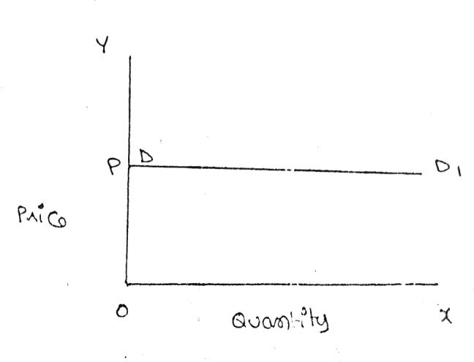When any quantity can be sold at a given price, and when there is no need to reduce price, the demand is said to be perfectly elastic. In such cases, even a small increase in price will lead to complete fall in demand.
JNTU World

Perfectly inelasticity of demand:

When a significant degree of change in price leads little or no change in the quantity demanded, then the elasticity is said to be perfectly inelasticity. In other words, the demand is said to be perfectly inelasticity when there is no change in the quantity demanded even though there is a big change in the price.

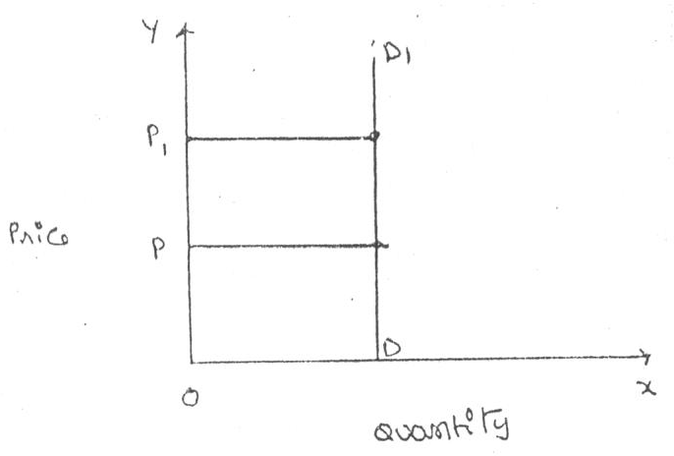

Relatively elasticity of demand:

The demand is said to be relatively elasticity when the change in demand is more then the change in the price.
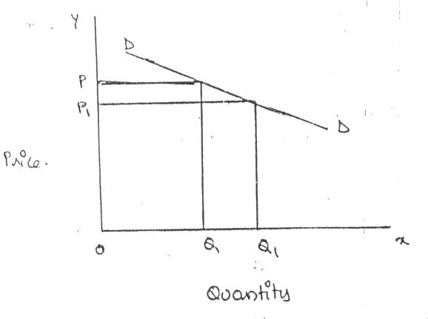
JNTU World

Relatively inelasticity of demand:

The demand is said to be relatively inelasticity when the change in demand is less than the change in the price.

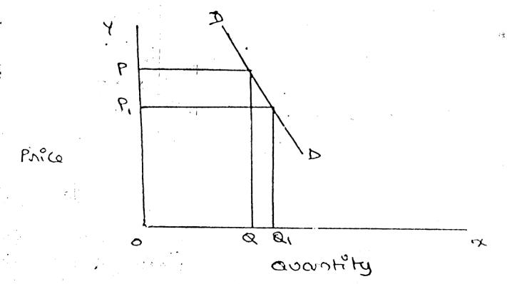

Unity elasticity:

The elasticity in demand is said to be unity when the change in demand is equal to the change in price.

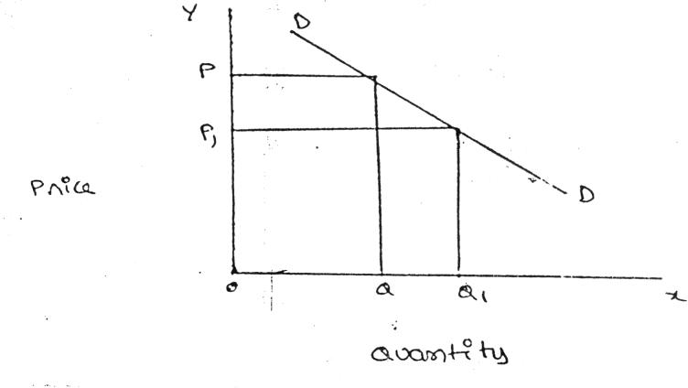
JNTU World

Significance of Elasticity Of Demand

- Price of factors of production:

The factors of production are land, labour, capital, organizations and technology. These have a cost; we have to pay rent, wages, interest, profits and price for these factors of production.

Price fixation:

the manufacturer can decide the amount of price that can be fixed for his product based on the concept of elasticity, if there is no competition, in other words in the case of a monopoly, the manufacture is free to fix his price as long as it does not attract the attention of the government, when there are close substitutes, the product is such that its consumption can be postponed, it cannot be put to alternative uses and so on, then the price of the product cannot be fixed very highly.

Government policies

  - Tax policies: government extensively depends on this concept to finalize its polices relating to taxes and revenues. Where the product is such that the people cannot postpone its consumptions, the government tends to increase its, price, such as petrol and diesel, cigarettes, and so on.

  - Raising bank deposits : if the government wants to mobilize larger deposits from the consumer it propose to raise the rates of fixed deposits marginally and vice versa.

  - Public utilities: government uses the concept of elasticity in fixing charges for the public utilities such as elasticity tariff, water charges, ticket fare in case of road or rail transport .

Forecasting demand:

Income elasticity is used to forecast demand for a particular product or services. The demand for the products can be forecast at a give income level. The trader can estimate the quantity of goods to be sold at different income levels to realize the targeted revenue.

Planning the levels of output and price:

The knowledge of price elasticity is very useful to producers. The producer can evaluate whether a change in price will bring in adequate revenue or not. In general, for items whose demand is elastic, it would benefit him to charge relatively low price. On the other hand, if the demand for the product is inelastic, a little higher price may be helpful to him to get huge profits without losing sales.

DEMAND FORECASTING

Demand forecasting refers to an estimate of future demand for the product. It is an objective assessment of the future course of demand, in recent times, forecasting plays an important role in business decision – making. The survival and prosperity of a business firm depend on its ability to meet the consumer’s needs efficiently and adequately. Demand forecasting has an important influence on production planning. It is essential for a firm to produce the required quantities at the right time.

It is also essential to distinguish between forecasting of demand and forecast of sales, sales forecasts are important for estimating revenue, cash requirements and expenses whereas, demand forecasting relate to production, inventory control, timing, reliability of forecast etc. however, there is not much difference between these terms.

METHODS OF DEMAND FORECASTING

  - Survey methods
  - Statistical methods
  - Expert opinion methods
  - Test marketing
  - Controlled experiments
  - Judgmental approach

STATISTICAL METHODS

Statistical method is used for long run forecasting. In this method, statistical and mathematical techniques are used to forecast demand. This relies on past data.
1. Trend projection method: these are generally based on analysis of past sales patterns. These methods dispense with the need for costly market research because the necessary information is often already available in company files. This method is used in case the sales data of the firm under consideration relate to different time periods, i.e., it is a time – series data. There are five main techniques of mechanical extrapolation.
- Trend line by observation: this method of forecasting trend is elementary, easy and quick. It involves merely the plotting of actual sales data on a chart and them estimating just by observation where the trend line lies. The line can be extended towards a future period and corresponding sales forecast is read form the graph.

- Least squares methods: this technique uses statistical formulae to find the trend line which best fits the available data. The trend line is the estimating equation, which can be used for forecasting demand by extrapolating the line for future and reading the corresponding values of sales on the graph.

- Time series analysis: where the surveys or market tests are costly and time – consuming, statistical and mathematical analysis of past sales data offers another methods to prepare the forecasts, that is, time series analysis.

- Moving average method: this method considers that the average of past events determine the future events. In other words, this method provides consistent results when the past events are consistent and unaffected by wide changes.

- Exponential smoothing: this is a more popular technique used for short run forecasts. This method is an improvement over moving averages method, unlike in moving averages method, all time periods here are given varying weight, that is , value of the given variable in the recent times are given higher weight and the values of the given variable in the distant past are given relatively lower weights for further processing.

- Barometric Technique: Simple trend projections are not capable of forecasting turning paints. Under Barometric method, present events are used to predict the directions of change in future. This is done with the help of economics and statistical indicators. Those are (1) Construction Contracts awarded for building materials (2) Personal income (3) Agricultural Income. (4) Employment (5) Gross national income (6) Industrial Production (7) Bank Deposits etc.
- Simultaneous equation method: in this method, all variable are simultaneously considered, with the conviction that every variable influence the other variables in an

economic environment. Hence, the set of equations equal the number of dependent variable which is also called endogenous variables.

- Correlation and regression methods: correlation and regression methods are statistical techniques. Correlation describes the degree of association between two variable such as sales and advertisement expenditure. When the two variable tend to change together, then they are said to be correlated.

Expert opinion methods:

Well informed persons are called experts; experts constitute yet another source of information. These persons are generally the outside experts and they do not have any vested interest in the results of a particular survey. As expert is good at forecasting and analysis the future trend in a give product or service at a given level of technology. The service of an expert could be advantageously used when a firm uses general economic forecasting or special industry fore casting prepared outside the firm.

Test marketing:

It is likely that opinions given by buyers, salesman or other experts may be, at times, misleading. This is the reason why most of the manufactures favour to test their product or service in a limited market as test – run before they launch their product nationwide.

Controlled experiments:

Controlled experiment refer to such exercise where some of the major determinants of demand are manipulated to suit to the customers with different tastes and preferences, income groups, and such others, it is further assumed that all other factors remain the same.

Judgmental approach:

When none of the above methods are directly related to the given product or service, the management has no alternative other than using its own judgment. Even when the above methods are used, the forecasting process is supplemented with the factor of judgment for the following reasons
- Historical data for significantly long period is not available
- Turning point in terms of policies or procedures or causal factors cannot be precisely determined
- Sale fluctuation are wide and significant
- The sophisticated statistical techniques such as regression and so on, may not cover all the signing.

Survey of buyers
intentions
Sample method
Census methods
- Trend projection methods
  - Trend line by observation
  - Least square method
  - Time series analysis
  - Moving averages method
  - Exponential smoothing
2. Barometric techniques
3. Simultaneous equations
method
4. Correlation and regression
method
STATISTICAL METHODS
SURVEY METHODS
OTHER METHODS

- Expert opinion methods
- Test marketing
- Controlled experiments
- Judgmental approach
Survey of sale force

DEMAND FORECASTING METHOD

Factors Governing Demand Forecasting
- Functional nature of demand: market demand for a particular product or service is not a single number but it is a function of a number of factors, for instance, higher volumes of sales can be realized with higher levels of advertising or promotion efforts.

- Types of forecasting: based on the period under forecast, the demand forecast can be of two types1) short – run forecasting and 2) long – run forecasting. Short run forecasts cover a period of one year whereas long- run forecasting any period ranging from one year to 20 years.

- Forecasting level: the forecasting ,au ne at the firm level, industry level, national level or at the global level.
  - Firm level: firm level means estimating the demand for the products and services offered by a single firm

  - Industry level: the aggregate demand estimated for the good and service of all the firms constitutes the industry level forecast. The total estimate of different trade associations can also be view as industry level forecast.

  - National level : national level forecasting is for the whole economy, national level forecasts are worked out based on the levels of income, savings of the consumers.

  - Global level: globalization and deregulation , the entrepreneurs have started exploring the foreign markets for which the global level forecasts are utilized.

- Degree of orientation: demand forecasts can be worked out based on total sales or product or service wise sales for a given time period. Forecasting in terms of total sales can be viewed as general forecast whereas product or service – wise or region or customer segment – wise forecast is referred is referred to as specific forecast.

- New product: it is relatively easy to forecast demand for established products or products which are currently in use. The new product in consideration can be analyzed as a substitute for some existing product. Assess the demand through a sampled or total survey of consumers’ intentions over the new product features and price.
- Nature of good: The goods are classified into producer goods, consumer goods, consumer durables and services. The patterns of forecasting in each of these differ.
- Degree of competition: there may be a single trader or a few traders depending upon the nature of goods and services.

Unit – II

THEORY OF PRODUCTION AND COST ANALYSIS

Samuelson define the production function as “the technical relationship which reveals the maximum amount of output capable of being produced by each and every set of inputs”
Michael define production function as “that function which defines the maximum amount of output that can be produced with a given set of inputs”.

The production function expresses a functional relationship between physical inputs and physical outputs of a firm at any particular time period. The output is thus a function of inputs. Mathematically production function can be written as

Q = F(L1,L2,C,O,T)

Where Q is the quantity of production, F explains the functions, that is, the type of relation between inputs and outputs , L1,L2,C,.O,T refer to land, labout, capital, organization and technology respectively. These inputs have been taken in conventional terms. In reality, material also can be included in a set of inputs.
A manufacturer has to make a choice of the production function by considering his technical knowledge, the process of various factors of production and his efficiency level to manage. He should not only select the factors of production but also should work out the different permutations and combinations which will mean lower cost of inputs for a given level of production.
In case of an agricultural product, increasing the other factors of production can increase the production, but beyond a point, increase output can be had only with increased use of agricultural land, investment in land forms a significant portion of the total cost of production for output, whereas, in the case of the software industry, other factor such as technology , capital management and others become significant. With change in industry and the requirements the production function also needs to be modified to suit to the situation.
Production Function With One Variable Input

The laws of returns states that when at least one factor of production is fixed or factor input is fixed and when all other factors are varied, the total output in the initial stages will increase at an increasing rate, and after reaching certain level or output the total output will increase at declining rate. If variable factor inputs are added further to the fixed factor input, the total output may decline. This law is of universal nature and it proved to be true in agriculture

and industry also. The law of returns is also called the law of variable proportions or the law of diminishing returns.

Definition According to G. Stigler

“If equal increments of one input are added, the inputs of other production services being held constant, beyond a certain point the resulting increments of product will decrease i.e. the marginal product will diminish”.
According to F. Benham

“As the proportion of one factor in a combination of factors is increased, after a point, first the marginal and then the average product of that factor will diminish”.

Units of labour | Total production(tp) | Marginal  product (mp) | Average  product (ap) | Stages
0 | 0 | 0 | 0 | Stages 1
1 | 10 | 10 | 10
2 | 22 | 12 | 11
3 | 33 | 11 | 11 | Stages 2
4 | 40 | 7 | 10
5 | 45 | 5 | 9
6 | 48 | 3 | 8 | Stages 3
7 | 48 | 0 | 6.85
8 | 45 | -3 | 5.62
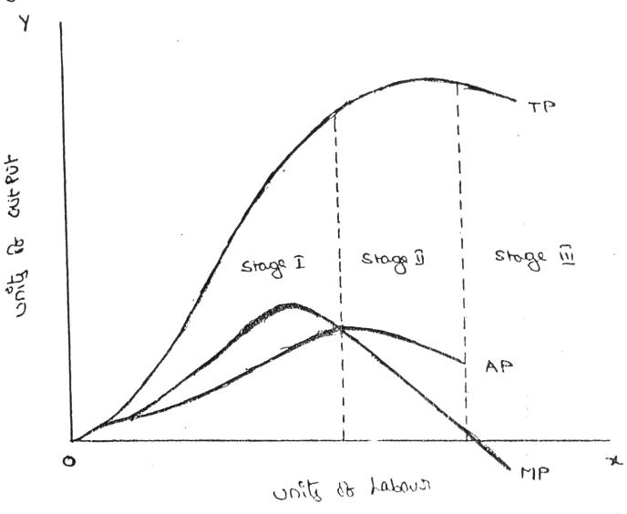

From the above graph the law of variable proportions operates in three stages. In the first stage, total product increases at an increasing rate. The marginal product in this stage increases at an increasing rate resulting in a greater increase in total product. The average product also increases. This stage continues up to the point where average product is equal to marginal product. The law of increasing returns is in operation at this stage. The law of diminishing returns starts operating from the second stage awards. At the second stage total product increases only at a diminishing rate. The average product also declines. The second stage comes to an end where total product becomes maximum and marginal product becomes zero. The marginal product becomes negative in the third stage. So the total product also declines. The average product continues to decline.
Production Function With Two Variable Inputs And Laws Returns

Production process that requires two inputs, capital© and labour (L) to produce a given output(Q). There could be more than two inputs in a real life situation, but for a simple analysis, we restrict the number of inputs to two only. In other words, the production function based on two inputs can be expressed as

Q = f( C,L)

Where c= capital , L = labour,

Normally, both capital and labour are required to produce a product. To some extent, these two inputs can be substituted for each other. Hence the producer may choose any combination of labour and capital that gives him the required number of units of output, for any one combination of labour and capital out of several such combinations. The alternative combinations of labour and capital yielding a given level of output are such that if the use of one factor input is increased , that of another will decrease and vice versa. How ever, the units of an input foregone to get one unit of the other input changes, depends upon the degree of substitutability between the two input factors, based on the techniques or technology used, the degree of substitutability may vary.

ISO - QUANTS

The term Isoquants is derived from the words ‘iso’ and ‘quant’ – ‘Iso’ means equal and ‘quent’ implies quantity. Isoquant therefore, means equal quantity. Isoquant are also called isopridcut curves, an isoquant curve show various combinations of two input factors such as capital and labour, which yield the same level of output.
As an isoquant curve represents all such combinations which yield equal quantity of output, any or every combination is a good combination for the manufacturer. Since he prefers all these combinations equally , an isoquant curve is also called product indifferent curve.
An isoquant may be explained with the help of an arithmetical example

Combinations | Labour (units) | Capital (Units) | Output (quintals)
A | 1 | 10 | 50
B | 2 | 7 | 50
C | 3 | 4 | 50
D | 4 | 4 | 50
E | 5 | 1 | 50
Combination ‘A’ represent 1 unit of labour and 10 units of capital and produces ‘50’ quintals of a product all other combinations in the table are assumed to yield the same given output of a product say ‘50’ quintals by employing any one of the alternative combinations of the two factors labour and capital. If we plot all these combinations on a paper and join them, we will get continues and smooth curve called Iso-product curve as shown below.
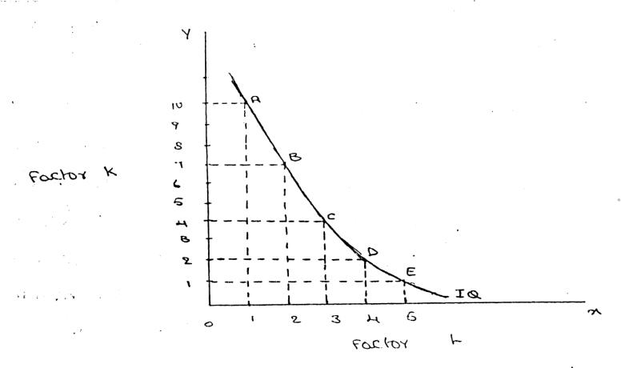

Labour is on the X-axis and capital is on the Y-axis. IQ is the ISO-Product curve

which shows all the alternative combinations A, B, C, D, E which can produce 50 quintals of a product
Features of isoquant

- downward sloping: isoquant are downward sloping curves because , if one input increase, the other one reduces. There is no question of increase in both the inputs to yield a given output. A degree of substitution is assumed between the factors of production. In other words, an isoquant cannot be increasing, as increase in both the inputs does not yield same level of output. If it is constant, it means that the output remains constant through the use of one of the factor is increasing, which is not true, isoquant slope from left to right.
- Convex to origin: isoquant are convex to the origin. It is because the input factors are not perfect substitutes. One input factor can be substituted by other input factor in a diminishing marginal rate. If the input factors were perfect substitutes , the isoqunt would be a falling straight line. When the inputs are used infixed proportion, and substitution of one input for the other cannot trake place, the isoquant will be L shaped
- do not intersect: two isoquant do not intersect with each other. It is because, each of these denote a particular level of output. If the manufacturer wants to operate at a higher level of output, he has to switch over to another isoquant with a higher level of output and vice versa.
- do not axes: the isoquant touches neither X-axis nor Y- axis, as both inputs are required to produce a given product.
ISO COST

Iso cost refers to that cost curve that represent the combination of inputs that will cost the producer the same amount of money. In other words, each isocost denotes a particular level of total cost for a given level of production. If the level of production changes, the total cost changes and thus the isocost curve moves upwards, and vice verse.
Isocost curve is the locus traced out by various combinations of L and K, each of which costs the producer the same amount of money (C ) Differentiating equation with respect to L, we have dK/dL = -w/r This gives the slope of the producer’s budget line (isocost curve). Iso cost line shows various combinations of labour and capital that the firm can buy for a given factor prices. The slope of iso cost line = PL/Pk. In this equation , PL is the price of labour and Pk is the price of capital. The slope of iso cost line indicates the ratio of the factor prices. A set of isocost lines can be drawn for different levels of factor prices, or different sums of money. The iso cost line will shift to the right when money spent on factors increases or firm could buy more as the factor prices are given.
With the change in the factor prices the slope of iso cost lien will change. If the price of labour falls the firm could buy more of labour and the line will shift away from the origin. The

slope depends on the prices of factors of production and the amount of money which the firm spends on the factors. When the amount of money spent by the firm changes, the isocost line may shift but its slope remains the same. A change in factor price makes changes in the slope of isocost lines as shown in the figure.

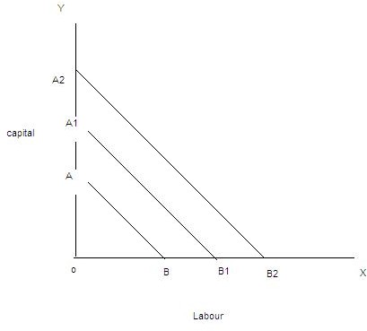

Least Cost Combination Of Inputs

The manufacturer has to produce at lower costs to attain higher profits. The isocost and isoquants can be used to determined the input usage that minimizes the cost of production.
Where the slope of isoquant is equal to that of isocost, there lies the lowest point of cost of production. This can be observed by superimposing the isocosts on isoproduct curves. It is evident that the producer can, with a total outlay.

The firm can achieve maximum profits by choosing that combination of factors which will cost it the least. The choice is based on the prices of factors of production at a particular time. The firm can maximize its profits either by maximizing the level of output for a given cost or by minimizing the cost of producing a given output. In both cases the factors will have to be employed in optimal combination at which the cost of production will be minimum. The least cost factor combination can be determined by imposing the isoquant map on isocost line. The point of tangency between the isocost and an isoquant is an important but not a necessary condition for producer’s equilibrium. The essential condition is that the slope of the isocost line must equal the slope of the isoquant. Thus at a point of equilibrium marginal physical productivities of the two factors must be equal the ratio of their prices. The marginal physical

product per rupee of one factor must be equal to tht of the other factor. And isoquant must be convex to the origin. The marginal rate of technical substitution of labour for capital must be diminishing at the point of equilibrium.

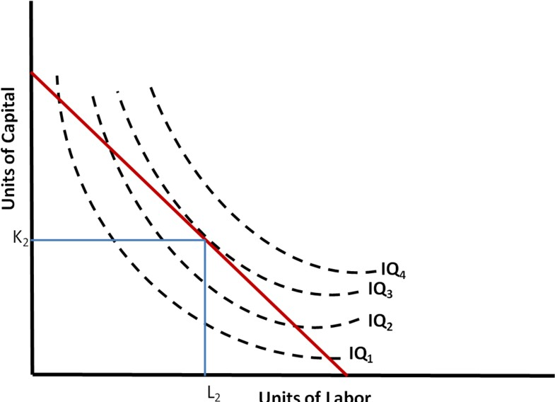

Marginal Rate Of Technical Substitution

The marginal rate lof technical substitution (MRTS) refers to the rate at which one input factor is substituted with the other to attain a given level of output. In other words, the lesser units of one input must be compensated by increasing amounts of another input to produce the same level of output.

Isoquants are typically convex to the origin reflecting the fact that the two factors are substitutable for each other at varying rates. This rate of substitutability is called the “marginal rate of technical substitution” (MRTS) or occasionally the “marginal rate of substitution in production”. It measures the reduction in one input per unit increase in the other input that is just sufficient to maintain a constant level of production. For example, the marginal rate of substitution of labour for capital gives the amount of capital that can be replaced by one unit of labour while keeping output unchanged.

To move from point A to point B in the diagram, the amount of capital is reduced from Ka to Kb while the amount of labour is increased only from La to Lb. To move from point C to point D, the amount of capital is reduced from Kc to Kd while the amount of labour is increased from Lc to Ld. The marginal rate of technical substitution of labour for capital is equivalent to the absolute slope of the isoquant at that point (change in capital divided by change in labour). It

is equal to 0 where the isoquant becomes horizontal, and equal to infinity where it becomes vertical.

The opposite is true when going in the other direction (from D to C to B to A). In this case we are looking at the marginal rate of technical substitution capital for labour (which is the reciprocal of the marginal rate of technical substitution labour for capital).

It can also be shown that the marginal rate of substitution labour for capital, is equal to the marginal physical product of labour divided by the marginal physical product of capital.

In the unusual case of two inputs that are perfect substitutes for each other in production, the isoquant would be linear (linear in the sense of a function ). If, on the other hand, there is only one production process available, factor proportions would be fixed, and these zero-substitutability isoquants would be shown as horizontal or vertical lines.
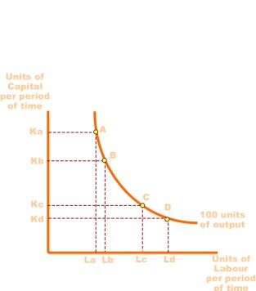

LAW OF RETURNS TO SCALE

There are three laws of returns governing production function. They are

  - Law of increasing returns to scale
This law states that the volume of output keeps on increasing with every increase in the inputs,. Where a given increase in inputs leads to a more than proportionate increase in the output, the law of increasing returns to scale is said to operate. We can introduce division of labour and other technological means to increase production. Hence, the total product increases at an increasing rate.
  - Law of constant returns to scale

When the scope for division of labour gets restricted, the rate of increase in the total output remains constant, the law of constant returns to scale is said to operate, this law states that the rate of increase/decrease in volume of output is same to that of rate of increase/decrease in inputs.
  - Law of decreasing returns to scale
Where the proportionate increase in the inputs does not lead to equivalent increase in output, the output increases at a decreasing rate, the law of decreasing returns to scale is said to operate. This results in higher average cost per unit.

These laws can be illustrated with an example of agricultural land. Take one acre of land. If you till the land well with adequate bags of fertilizers and sow good quality seeds, the volume of output increases the following table illustrates further

Capital (in units) | Labor( in units) | % of increase in both inputs | Output(in units) | % of increase in output | Law applicable
1 | 3 | --- | --- | --- | ---
2 | 6 | 100 | 120 | 140 | Law of increase returns to scale
4 | 12 | 100 | 240 | 100 | Law of constant returns to scale
8 | 24 | 100 | 360 | 50 | Law of decrease returns to scale

INTERNAL AND EXTERNAL ECONOMIES OF SCALE

INTERNAL ECONOMIES refer to the economies introduction costs which accrue to the firm alone when it expands its output. The internal economies occur as a result of increase in the scale of production.
- Managerial Economics: as the firm expands, the firm needs qualified managerial personnel to handle each of its functions marketing, finance, production, human resources and others in a professional way. Functional specialization ensure minimum wastage and lowers the cost of production in the long –run.

- Commercial Economics: the transaction of buying and selling raw material and other operating supplies such as spares and so on will be rapid and the volume of each

transaction also grows as the firm grows, there could be cheaper savings in the procurement, transportation and storage cost, this will lead to lower costs and increased profits.
- Financial Economics: The large firm is able to secure the necessary finances either for block capital purposes or for working capital needs more easily and cheaply. It can barrow from the public, banks and other financial institutions at relatively cheaper rates. It is in this way that a large firm reaps financial economies.

- Technical Economies: Technical economies arise to a firm from the use of better machines and superior techniques of production. As a result, production increases and per unit cost of production falls. A large firm, which employs costly and superior plant and equipment, enjoys a technical superiority over a small firm. Another technical economy lies in the mechanical advantage of using large machines. The cost of operating large machines is less than that of operating mall machine. More over a larger firm is able to reduce it’s per unit cost of production by linking the various processes of production. Technical economies may also be associated when the large firm is able to utilize all its waste materials for the development of by-products industry. Scope for specialization is also available in a large firm. This increases the productive capacity of the firm and reduces the unit cost of production.
- Marketing Economies: The large firm reaps marketing or commercial economies in buying its requirements and in selling its final products. The large firm generally has a separate marketing department. It can buy and sell on behalf of the firm, when the market trends are more favorable. In the matter of buying they could enjoy advantages like preferential treatment, transport concessions, cheap credit, prompt delivery and fine relation with dealers. Similarly it sells its products more effectively for a higher margin of profit.
- Risk Bearing Economies: The large firm produces many commodities and serves wider areas. It is, therefore, able to absorb any shock for its existence. For example, during business depression, the prices fall for every firm. There is also a possibility for market fluctuations in a particular product of the firm. Under such circumstances the risk- bearing economies or survival economies help the bigger firm to survive business crisis.
- Economics Of Larger Dimension: large – scale production is required to take advantage of bigger size plant and equipment. For example, the cost of a 1.00.000 units capacity plant will not be double that of 50.000 units capacity plant. Likewise the cost of a 10.000 ton oil tanker will not be double that of a 5000 ton oil tanker. Engineers go by what is called two by three rule wherein when the volume is increase by 100%, the material required will increase only by two – thirds. Technical economies are available

only from large size, improved methods of production processes and when the products are standardized.
- Economics Of Research And Development: large organizations such as Dr.Reddy’s labs, Hindustan Lever spend heavily on research and development and bring out several innovative products. Only such firms with a strong research and development base can cope with competition globally.

EXTERNAL ECONOMICS:

External economics refer to all the firms in the industry, because of growth of the industry as a whole or because of growth of ancillary industries, external economics benefit al the firms in the industry as the industry expands. This will lead to lowering the cost of production and thereby increasing the profitability. The external economics can be grouped under three types:
A). Economies of Concentration: When an industry is concentrated in a particular area, all the member firms reap some common economies like skilled labour, improved means of transport and communications, banking and financial services, supply of power and benefits from subsidiaries. All these facilities tend to lower the unit cost of production of all the firms in the industry.
- Economics Of Research And Development: all the firms can pool resources to finance research and development activities and thus share the benefits of research. There could be a common facility to shares journals, newspapers and other valuable reference material of common interest.
- Economics Of Welfare: there could be common facilities such as canteen, industrial housing, community halls, schools and colleges, employment burearu, hospitals and so on, which can be used in common by the employees in the whole industry.
COST ; the institute of cost and management accountants (ICMA) has define cost as “ the amount expenditure, actual or notional, incurred on or attributable to a specified thing or activity”. It is the amount of resources sacrificed to achieve a specific objective. A cost must be with reference to the purpose for which it is used and the conditions under which it is computed. To take decision, managers wish to know the cost of something.
cost refer to the expenditure incurred to produce a particular product or services. All cost involve a sacrifice of some kind or other to acquire some benefit. For example , if I want to eat food, I should be prepared to sacrifice money.
Cost refers to the amount of expenditure incurred in acquiring something. In business firm, it refers to the expenditure incurred to produce an output or provide service. Thus the cost

incurred in connection with raw material , labour, other heads constitute the overall cost of production.

COST CONCEPTS :

A managerial economist must have a clear understanding of the different cost concepts for clear business thinking and proper application. The several alternative bases of classifying cost and the relevance of each for different kinds of problems are to be studied. The various relevant concepts of cost are:

OPPORTUNITY COST:

In simple terms, it is the earning from the second is alternative. It represents the maximum possible alternative income that was have been earned if the resources were put to alternative use.
Opportunity cost can be distinguished from outlay costs based on the nature of sacrifice. Outlay costs are those costs that involve cash outflow at sometime and hence they are recorded in the book of account. Opportunity cost refers to earnings/profits that are foregone form alternative ventures by using gives limited facilities for a particular purpose.

FIXED COST VS VARIABLE COST

Fixed cost is that cost which remains constant for a certain level to output. It is not affected by the changes in the volume of production. But fixed cost per unit decrease, when the production is increased. Fixed cost includes salaries, Rent, Administrative expenses depreciations etc.
Variable is that which varies directly with the variation is output. An increase in total output results in an increase in total variable costs and decrease in total output results in a proportionate decline in the total variables costs. The variable cost per unit will be constant. Ex: Raw materials, labour, direct expenses, etc

EXPLICIT AND IMPLICIT COSTS:

Explicit costs are those expenses that involve cash payments. These are the actual or business costs that appear in the books of accounts. These costs include payment of wages and salaries, payment for raw-materials, interest on borrowed capital funds, rent on hired land, Taxes paid etc.
Implicit costs are the costs of the factor units that are owned by the employer himself. These costs are not actually incurred but would have been incurred in the absence of employment of

self – owned factors. The two normal implicit costs are depreciation, interest on capital etc. A decision maker must consider implicit costs too to find out appropriate profitability of alternatives.

SHORT – RUN AND LONG – RUN COSTS:

Short-run is a period during which the physical capacity of the firm remains fixed. Any increase in output during this period is possible only by using the existing physical capacity more extensively. So short run cost is that which varies with output when the plant and capital equipment in constant.
Long run costs are those, which vary with output when all inputs are variable including plant and capital equipment. Long-run cost analysis helps to take investment decisions.

OUT-OF POCKET AND BOOKS COSTS:

Out-of pocket costs also known as explicit costs are those costs that involve current cash payment. Book costs also called implicit costs do not require current cash payments. Depreciation, unpaid interest, salary of the owner is examples of back costs.
But the book costs are taken into account in determining the level dividend payable during a period. Both book costs and out-of-pocket costs are considered for all decisions. Book cost is the cost of self-owned factors of production.

BREAKEVEN ANALYSIS
A business is said to break even when its total sales are equal to its total costs. It is a point of no profits no loss. Break even analysis is defined as analysis of costs and their possible impact on revenues and volume of the firm. Hence, it is also called the cost – volume- profit analysis. A firm is said to attain the bep when its total revenue is equal to total cost.

Assumptions:

  - All costs are classified into two – fixed and variable.
  - Fixed costs remain constant at all levels of output.
  - Variable costs vary proportionally with the volume of output.
  - Selling price per unit remains constant in spite of competition or change in the volume of production.
  - There will be no change in operating efficiency.
  - There will be no change in the general price level.
  - Volume of production is the only factor affecting the cost.

  - Volume of sales and volume of production are equal. Hence there is no unsold stock.
  - There is only one product or in the case of multiple products. Sales mix remains constant.
  - All the goods produced are sold. There is no closing stock.

Significance of BEA

- To ascertain the profit on a particular level of sales volume or a given capacity of production
- To calculate sales required to earn a particular desired level of profit.
- To compare the product lines, sales area, methods of sales for individual company
- To compare the efficiency of the different firms
- To decide whether to add a particular product to the existing product line or drop one from it
- To decide to “make or buy” a given component or spare part
- To decide what promotion mix will yield optimum sales
- To assess the impact of changes in fixed cost, variable cost or selling price on BEP and profits during a given period.

Limitations of BEA

- Break – even - point is based on fixed cost, variable cost and total revenue.
- A change in one variable is going to affect the BEP
- All cost cannot be classified into fixed and variable costs. We have semi-variable costs also
- In case of multi-product firm, a single chart cannot be of any use. Series of charts have to be made use of..
- It is based on fixed cost concept and hence holds good only in the short – run.
- Total cost and total revenue lines are not always straight as shown in the figure. The quantity and price discounts are the usual phenomena affecting the total revenue line.
- Where the business conditions are volatile, BEP cannot give stable results

Merits:

- Information provided by the Break Even Chart can be understood more easily then those contained in the profit and Loss Account and the cost statement.
- Break Even Chart discloses the relationship between cost, volume and profit. It reveals how changes in profit. So, it helps management in decision-making.
- It is very useful for forecasting costs and profits long term planning and growth
- The chart discloses profits at various levels of production.

- It serves as a useful tool for cost control.
- It can also be used to study the comparative plant efficiencies of the industry.
- Analytical Break-even chart present the different elements, in the costs – direct material, direct labour, fixed and variable overheads.

Demerits:

- Break-even chart presents only cost volume profits. It ignores other considerations such as capital amount, marketing aspects and effect of government policy etc., which are necessary in decision making.
- It is assumed that sales, total cost and fixed cost can be represented as straight lines. In actual practice, this may not be so.
- It assumes that profit is a function of output. This is not always true. The firm may increase the profit without increasing its output.
- A major drawback of BEC is its inability to handle production and sale of multiple products.
- It is difficult to handle selling costs such as advertisement and sale promotion in BEC.
- It ignores economics of scale in production.
- Fixed costs do not remain constant in the long run.
- Semi-variable costs are completely ignored.
- It assumes production is equal to sale. It is not always true because generally there may be opening stock.
- When production increases variable cost per unit may not remain constant but may reduce on account of bulk buying etc.
- The assumption of static nature of business and economic activities is a well-known defect of BEC.

Determination of break even point
- Fixed cost
- Variable cost
- Contribution
- Margin of safety
- Angle of incidence
- Profit volume ratio

Fixed cost: Expenses that do not vary with the volume of production are known as fixed expenses. Eg. Manager’s salary, rent and taxes, insurance etc. It should be noted that fixed changes are fixed only within a certain range of plant capacity. The concept of fixed overhead is most useful in formulating a price fixing policy. Fixed cost per unit is not fixed

Variable Cost: Expenses that vary almost in direct proportion to the volume of production of sales are called variable expenses. Eg. Electric power and fuel, packing materials consumable stores. It should be noted that variable cost per unit is fixed.

Contribution: Contribution is the difference between sales and variable costs and it contributed towards fixed costs and profit. It helps in sales and pricing policies and measuring the profitability of different proposals. Contribution is a sure test to decide whether a product is worthwhile to be continued among different products.

Contribution = Sales – Variable cost Contribution = Fixed Cost + Profit.
Margin of safety: Margin of safety is the excess of sales over the break even sales. It can be expressed in absolute sales amount or in percentage. It indicates the extent to which the sales can be reduced without resulting in loss. A large margin of safety indicates the soundness of the business. The formula for the margin of safety is:

Present sales – Break even sales or
Profit

P. V. ratio

Margin of safety can be improved by taking the following steps.

- Increasing production
- Increasing selling price
- Reducing the fixed or the variable costs or both
- Substituting unprofitable product with profitable one.

Angle of incidence: This is the angle between sales line and total cost line at the Break-even point. It indicates the profit earning capacity of the concern. Large angle of incidence indicates a high rate of profit; a small angle indicates a low rate of earnings. To improve this angle, contribution should be increased either by raising the selling price and/or by reducing variable cost. It also indicates as to what extent the output and sales price can be changed to attain a desired amount of profit.

Profit Volume Ratio is usually called P. V. ratio. It is one of the most useful ratios for studying the profitability of business. The ratio of contribution to sales is the P/V ratio. It may be expressed in percentage. Therefore, every organization tries to improve the P. V. ratio of each product by reducing the variable cost per unit or by increasing the selling price per unit. The concept of P. V. ratio helps in determining break even-point, a desired amount of profit etc.

Fixed cost: Expenses that do not vary with the volume of production are known as fixed expenses. Eg. Manager’s salary, rent and taxes, insurance etc. It should be noted that fixed changes are fixed only within a certain range of plant capacity. The concept of fixed overhead is most useful in formulating a price fixing policy. Fixed cost per unit is not fixed
Variable Cost: Expenses that vary almost in direct proportion to the volume of production of sales are called variable expenses. Eg. Electric power and fuel, packing materials consumable stores. It should be noted that variable cost per unit is fixed.

Contribution: Contribution is the difference between sales and variable costs and it contributed towards fixed costs and profit. It helps in sales and pricing policies and measuring the profitability of different proposals. Contribution is a sure test to decide whether a product is worthwhile to be continued among different products.

Contribution = Sales – Variable cost Contribution = Fixed Cost + Profit.
Margin of safety: Margin of safety is the excess of sales over the break even sales. It can be expressed in absolute sales amount or in percentage. It indicates the extent to which the sales can be reduced without resulting in loss. A large margin of safety indicates the soundness of the business. The formula for the margin of safety is:

Present sales – Break even sales or
Profit

P. V. ratio

Margin of safety can be improved by taking the following steps.

- Increasing production
- Increasing selling price
- Reducing the fixed or the variable costs or both
- Substituting unprofitable product with profitable one.

Angle of incidence: This is the angle between sales line and total cost line at the Break-even point. It indicates the profit earning capacity of the concern. Large angle of incidence indicates a high rate of profit; a small angle indicates a low rate of earnings. To improve this angle, contribution should be increased either by raising the selling price and/or by reducing variable cost. It also indicates as to what extent the output and sales price can be changed to attain a desired amount of profit.

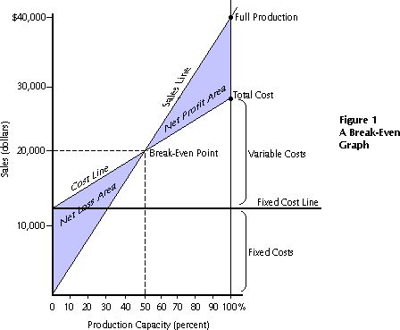Profit Volume Ratio is usually called P. V. ratio. It is one of the most useful ratios for studying the profitability of business. The ratio of contribution to sales is the P/V ratio. It may be expressed in percentage. Therefore, every organization tries to improve the P. V. ratio of each product by reducing the variable cost per unit or by increasing the selling price per unit. The concept of P. V. ratio helps in determining break even-point, a desired amount of profit etc.

UNIT – III INTRODUCTION TO MARKETS
Market is a place where buyer and seller meet, goods and services are offered for the sale and transfer of ownership occurs. A market may be also defined as the demand made by a certain group of potential buyers for a good or service. The former one is a narrow concept and later one, a broader concept. Economists describe a market as a collection of buyers and sellers who transact over a particular product or product class (the housing market, the clothing market, the grain market etc.). For business purpose we define a market as people or organizations with wants (needs) to satisfy, money to spend, and the willingness to spend it. Broadly, market represents the structure and nature of buyers and sellers for a commodity/service and the process by which the price of the commodity or service is established. In this sense, we are referring to the structure of competition and the process of price determination for a commodity or service. The determination of price for a commodity or service depends upon the structure of the market for that commodity or service (i.e., competitive structure of the market). Hence the understanding on the market structure and the nature of competition are a pre-requisite in price determination.
MARKET STRUCTURES
Market structure describes the competitive environment in the market for any good or service. A market consists of all firms and individuals who are willing and able to buy or sell a

particular product. This includes firms and individuals currently engaged in buying and selling a particular product, as well as potential entrants.
The determination of price is affected by the competitive structure of the market. This is because the firm operates in a market and not in isolation. In marking decisions concerning economic variables it is affected, as are all institutions in society by its environment.

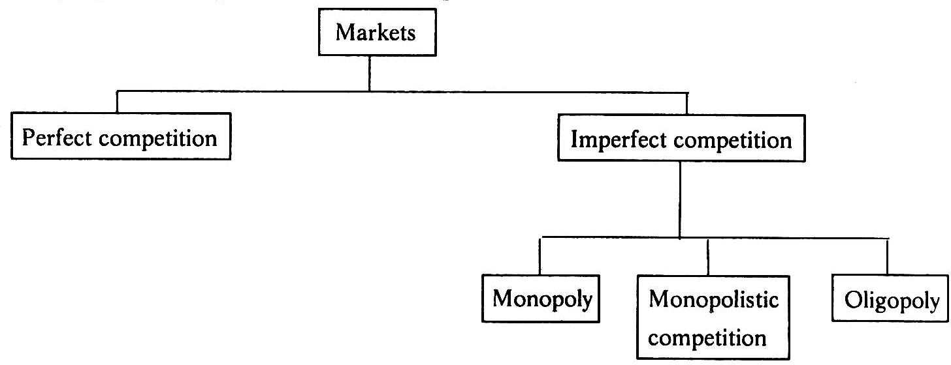

PERFECT COMPETITION
Perfect competition refers to a market structure where competition among the sellers and buyers prevails in its most perfect form. In a perfectly competitive market, a single market price prevails for the commodity, which is determined by the forces of total demand and total supply in the market.
A market structure in which all firms in an industry are price takers and in which there is freedom of entry into and exit from the industry is called perfect competition. The market with perfect competition conditions is known as perfect market.

Features of perfectly competition

- A large number of buyers and sellers: The number of buyers and sellers is large and the share of each one of them in the market is so small that none has any influence on the market price.
There should be significantly large number of buyers and sellers in the market. The number should be so large that it should not make any difference in terms of price of quantity supplied even if one enters the market or one leaves the market.
- Homogenous products or services: the products and services of each seller should be homogeneous. They cannot be differentiated from that of one another. It makes no difference to the buyer whether he buys from firm X or firm Z. in other words, the buyer does not have any particular preference to buy the goods from a particular trader or

supplier. The price is one and the same in every firm. There are no concessions or discounts.
- Freedom to enter or exit the market: there should not be restrictions on the part of the buyers and sellers to enter the market or leave the market. There should not be any barriers. The buyers can enter the market or leave the market whenever they want.
- Prefect information available to the buyers and sellers: each buyer and seller has total knowledge of the prices prevailing in the market at every given point of time, quantity supplied, costs, demand, nature of product, and other relevant information. There is no need for any advertisement expenditure as the buyers and sellers are fully informed.
- Perfect mobility of factors of production: there should not be any restrictions on the utilization of factors of production such as land , labour, capital and so on. In words, the firm or buyer should have free access to the factors of production. Whenever capital or labor is required, it should instantly be made available.
- Each firm is a price taker: an individual firm can alter its rate of production or sales without significantly affecting the market price of the product, a firm in a perfect market cannot influence the market through its own individual actions. It has no alternative other than selling its products at the price prevailing in the market. It cannot sell as much as it wants at its own set price.

Monopoly

The word monopoly is made up of two syllables, Mono and poly. Mono means single while poly implies selling. Thus monopoly is a form of market organization in which there is only one seller of the commodity. There are no close substitutes for the commodity sold by the seller. Pure monopoly is a market situation in which a single firm sells a product for which there is no good substitute.

Features of monopoly
- Single person or a firm: A single person or a firm controls the total supply of the commodity. There will be no competition for monopoly firm. The monopolist firm is the only firm in the whole industry.
- No close substitute: The goods sold by the monopolist shall not have closely competition substitutes. Even if price of monopoly product increase people will not go in far substitute. For example: If the price of electric bulb increase slightly, consumer will not go in for kerosene lamp.
- Large number of Buyers: Under monopoly, there may be a large number of buyers in the market who compete among themselves.
- Price Maker: Since the monopolist controls the whole supply of a commodity, he is a price-maker, and then he can alter the price.

- Supply and Price: The monopolist can fix either the supply or the price. He cannot fix both. If he charges a very high price, he can sell a small amount. If he wants to sell more, he has to charge a low price. He cannot sell as much as he wishes for any price he pleases.
- Downward Sloping Demand Curve: The demand curve (average revenue curve) of monopolist slopes downward from left to right. It means that he can sell more only by lowering price.
Monopolistic competition

Monopolistic competition is said to exist when there are many firms and each one produces such goods and services that are close substitutes to each other. They are similar but not identical. Product differentiation is the essential feature of monopolistic. Products can be differentiated by means of unique facilities, advertising, brand loyalty, packaging, pricing, terms of credit, superior maintenance services, convenient location and so on.

Features of Monopolistic

- Existence of Many firms: Industry consists of a large number of sellers, each one of whom does not feel dependent upon others. Every firm acts independently without bothering about the reactions of its rivals. The size is so large that an individual firm has only a relatively small part in the total market, so that each firm has very limited control over the price of the product. As the number is relatively large it is difficult for these firms to determine its price- output policies without considering the possible reactions of the rival forms. A monopolistically competitive firm follows an independent price policy.
- Product Differentiation: Product differentiation means that products are different in some ways, but not altogether so. The products are not identical but the same time they will not be entirely different from each other. IT really means that there are various monopolist firms competing with each other. An example of monopolistic competition and product differentiation is the toothpaste produced by various firms. The product of each firm is different from that of its rivals in one or more respects. Different toothpastes like Colgate, Close-up, Forehans, Cibaca, etc., provide an example of monopolistic competition. These products are relatively close substitute for each other but not perfect substitutes. Consumers have definite preferences for the particular verities or brands of products offered for sale by various sellers. Advertisement, packing, trademarks, brand names etc. help differentiation of products even if they are physically identical.
- Large Number of Buyers: There are large number buyers in the market. But the buyers have their own brand preferences. So the sellers are able to exercise a certain degree of monopoly over them. Each seller has to plan various incentive schemes to retain the customers who patronize his products.

- Free Entry and Exist of Firms: As in the perfect competition, in the monopolistic competition too, there is freedom of entry and exit. That is, there is no barrier as found under monopoly.
- Selling costs: Since the products are close substitute much effort is needed to retain the existing consumers and to create new demand. So each firm has to spend a lot on selling cost, which includes cost on advertising and other sale promotion activities.
- Imperfect Knowledge: Imperfect knowledge about the product leads to monopolistic competition. If the buyers are fully aware of the quality of the product they cannot be influenced much by advertisement or other sales promotion techniques. But in the business world we can see that thought the quality of certain products is the same, effective advertisement and sales promotion techniques make certain brands monopolistic. For examples, effective dealer service backed by advertisement-helped popularization of some brands through the quality of almost all the cement available in the market remains the same.
- The Group: Under perfect competition the term industry refers to all collection of firms producing a homogenous product. But under monopolistic competition the products of various firms are not identical through they are close substitutes. Prof. Chamberlin called the collection of firms producing close subset

PRICING METHODS COST – BASED PRICING PRICING METHODS

- Cost plus pricing: This is also called full cost or mark up pricing. Here the average cost normal capacity of output is ascertained and then a conventional margin of profit is added to the cost to arrive at the price. In other words, find out the product unit’s total cost and add percentage of profit to arrive at the selling price.
This method is suitable where the cost keep fluctuating from time to time. It is commonly followed in departmental stores and other retail shops. This method is simple to be administered but it does not consider the competition factor. The competitor may produce the same product at lower cost and thus offer it at a lower price.
- Marginal cost pricing : in marginal cost pricing, selling price is fixed in such a way that it covers fully the variable or marginal cost and contributes towards recovery of fixed costs fully or partly, depending upon the market situations. In times of stiff competition, marginal cost offers a guideline as to how far the selling price can be lowered. This is also called break – even pricing or target profit pricing. How break – even analysis helps in taking pricing decisions.

COMPETITION – ORIENTED PRICING:

Some commodities are priced according to the competition in their markets. Thus we have the going rate method of price and the sealed bid pricing technique. Under the former a firm prices its new product according to the prevailing prices of comparable products in the market.
  - Sealed bid pricing: this method is more popular in tenders and contracts. Each contracting firm quotes its price in a sealed cover called tender. All the tenders are opened on a scheduled date and the person who quotes the lowest prices, other things remaining the same, is awarded the contract.
  - Going rate pricing: here the price charged by the firm is in tune with the price charged in the industry as a whole. In other words, the prevailing market price at a given point of time is the guiding factor. When one wants to buy or sell gold, the prevailing market rate at a given point of time is taken as the basis to determine the price, normally the market leaders keep announcing the prevailing prices at a given point of time based on demand and supply positions.
DEMAND – ORIENTED PRICING

The higher the demand, the higher can be the price. Cost is not the consideration here. The key to pricing here is the value as perceived by the consumer. This is a relatively modern marketing concept.
- Price discrimination: price discrimination refer to the practice of charging different prices to customers for the same good. The firm uses its discretion to charge differently the different customer. It is also called differential pricing. Customers of different profile can be separated in various ways, such as by different consumer requirement by nature of product itself , by geographical areas, by income group and so on.
- Perceived value pricing: perceived value pricing refers to where the price is fixed on the basis of the perception of the buyer of the value of the product.
STRATEGY – BASED PRICING:

  - Market skimming: when the product is introduced for the first time in the market, the company follows this method. Under this method, the company fixes a very high price for the product. The main idea is to charge the customer maximum possible. For example Sony introduces a particular TV model , it fixed a very high price and other company.
  - Market penetration: this is exactly opposite to the market skimming method. Here the price of the product is fixed so low that the company can increase its market share. the company attains profits with increasing volumes and increase in the market share. More often , the companies believe that it is necessary to dominate the market in the long –run making profit in the short-run.
  - Two – part pricing : the firms with market power can enhance profits by the strategy of two – part pricing. Under this strategy, a firm charges a fixed fee for the right to

purchase its goods, plus a per unit charge for each unit purchased. Entertainment houses such as country clubs, athletic clubs, golf courses, health clubs usually adopt this strategy. They charge a fixed initiation fee plus a charge, per month or per visit, to use the facilities.
  - Block pricing: block pricing is another way a firm with market power can enhance its profits. We see block pricing in out day – to – day life very frequently. Six lux soaps in a single pack or five magi noodles in a single pack.
  - Commodity bundling: commodity bundling refers to the practice of bundling two or more different products together and selling them at a single bundle price, the package deals offered by the tourist companies, airlines hold testimony to this practice. The package includes the airfare, hotel, meals, sight seeing and so on.
  - Peak load pricing: during seasonal period when demand is likely to be higher, a firm may enhance profits by peak load pricing. The firm philosophy is to charge a higher price during peak times than is charged during off – peak times. Apsrtc, air india, jet air etc,.
  - Cross subsidization: in case where demand for two products produced by a firm is interrelated through demand or costs, the firm may enhance the profitability of its operation through cross subsidization .
  - Transfer pricing: transfer pricing is an internal pricing technique. It refers to a price at which inputs of one department are transferred to another, in order to maximize the overall profits of the company. For example kinetic Honda, hero Honda,
PRICING STRATEGIES IN TIMES OF STIFF PRICE COMPETITION

- Pricing matching: price matching is a strategy in which a firm promise to match a lower price offered by any competitor, while announcing its own price. It is necessary that one should be confident, before this strategy is adopted, that the price cannot be lower in the market than one offered.
- Promoting brand loyalty: this is an advertising strategy where the customers are frequently reminded by the brand value of given product or services. The conviction here is that the customers, once they are loyal to the given branded product or services, will not slip away when the competitors come out with products at lower prices.
- Time – to – time: this is also called randomized pricing strategy where the firm varies its prices form time- to – time, say hour – to – time, say hour – to – hour or day – to – day. This methods offers two advantages , the rival firms can no more play with price cuts. Also customers cannot learn form experience which firm charges the lowers price in the market.
- Promotional pricing: to promote a particular product, at time, the firm may offer the product at the most competitive price. Some time, the price of a particular product is kept intentionally lower to attract the attention f the customer to other products of the firm.

- Target pricing: the company operates with a particular targeted profit in mind. Normally the cost of capital will be one of the yardsticks to guide the targeted rate of return. How much is the rate of return the other companies are achieving also could be another yardstick to determine the price. The higher the risk and investment, the higher is the targeted profit and so is the price.
- PRICE OUTPUT DETERMINATION INCASE OF PERFECT COMPETITION
- SHORT RUN:
- The price and output of the firm are determined, under perfect competition, based on the industry price and its own costs. The industry price has greater say in this process because the firm own sales are very small and insignificant. The process of price output determination in case of perfect competition.
- The firm demand curve is horizontal at the price determined in the industry (MR = AR = price). This demand curve is also known as average revenue curve. This is because if all the units are sold at the same price, on an average , the revenue to the firm equal its price.

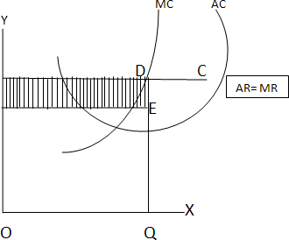

LONG RUN UNDER PERFECT COMPETITION

Having been attracted by supernormal profits, more and more firms enter the industry. With the result, there will be a scramble for scarce inputs among the competing firms pushing the input prices. Hence, the average cost increases. The entry of more and more firms will expand the supply pulling down the market price. The entry of the firms into the industry continues till the supernormal profit is completely eroded. In the long run, the firms will be in the position to enjoy only normal profits but not supernormal profit. Normal profits are the profit that is just sufficient for the firms to stay in the business.

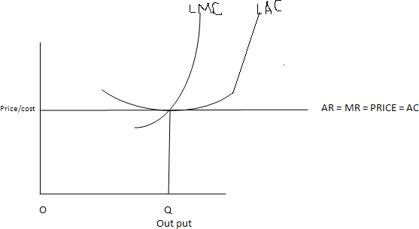

PRICE OUT PUT DETERMINATION IN MONOPOLY

Under monopoly the average revenue curve for a firm is a downward sloping one. It is because, of the monopolist reduces the price of his product, the quantity demanded increase and vice versa. In monopoly, marginal revenue is less than the average revenue.

The monopolist always wants to maximize his profits. To achieve maximum profits, it is necessary that the marginal revenue should be more than the marginal cost.

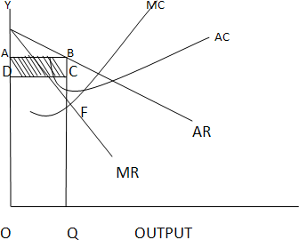

BUSINESS AND NEW ECONOMIC ENVIRONMENT CHARACTERISTIC FEATURES OF BUSINESS

- Easy to start and easy to close: The form of business organization should be such that it should be easy to close. There should not be hassles or long procedures in the process of setting up business or closing the same.
- Division of labour: There should be possibility to divide the work among the available owners.
- Large amount of resources: Large volume of business requires large volume of resources. Some forms of business organization do not permit to raise larger resources. Select the one which permits to mobilize the large resources.
- Liability: The liability of the owners should be limited to the extent of money invested in business. It is better if their personal properties are not brought into business to make up the losses of the business.
- Secrecy: The form of business organization you select should be such that it should permit to take care of the business secrets. We know that century old business units are still surviving only because they could successfully guard their business secrets.
- Transfer of ownership: There should be simple procedures to transfer the ownership to the next legal heir.
- Ownership, Management and control: If ownership, management and control are in the hands of one or a small group of persons, communication will be effective and coordination will be easier. Where ownership, management and control are widely distributed, it calls for a high degree of professional’s skills to monitor the performance of the business.
- Continuity: The business should continue forever and ever irrespective of the uncertainties in future.
- Quick decision-making: Select such a form of business organization, which permits you to take decisions quickly and promptly. Delay in decisions may invalidate the relevance of the decisions.
- Personal contact with customer: Most of the times, customers give us clues to improve business. So choose such a form, which keeps you close to the customers.
- Flexibility: In times of rough weather, there should be enough flexibility to shift from one business to the other. The lesser the funds committed in a particular business, the better it is.
- Taxation: More profit means more tax. Choose such a form, which permits to pay low tax.

SOLE PROPRIETORSHIP:

The sole trader is the simplest, oldest and natural form of business organization. It is also called sole proprietorship. ‘Sole’ means one. ‘Sole trader’ implies that there is only one trader who is the owner of the business.
It is a one-man form of organization wherein the trader assumes all the risk of ownership carrying out the business with his own capital, skill and intelligence. He is the boss for himself. He has total operational freedom. He is the owner, Manager and controller. He has total freedom and flexibility. Full control lies with him. He can take his own decisions. He can choose or drop a particular product or business based on its merits. He need not discuss this with anybody. He is responsible for himself. This form of organization is popular all over the world. Restaurants, Supermarkets, pan shops, medical shops, hosiery shops etc.
Features of sole proprietorship

- It is easy to start a business under this form and also easy to close.
- He introduces his own capital. Sometimes, he may borrow, if necessary
- He enjoys all the profits and in case of loss, he lone suffers.
- He has unlimited liability which implies that his liability extends to his personal properties in case of loss.
- He has a high degree of flexibility to shift from one business to the other.
- Business secretes can be guarded well
- There is no continuity. The business comes to a close with the death, illness or insanity of the sole trader. Unless, the legal heirs show interest to continue the business, the business cannot be restored.
- He has total operational freedom. He is the owner, manager and controller.
- He can be directly in touch with the customers.
- He can take decisions very fast and implement them promptly.
- Rates of tax, for example, income tax and so on are comparatively very low

Advantages of sole proprietorship
- Easy to start and easy to close: Formation of a sole trader from of organization is relatively easy even closing the business is easy.
- Personal contact with customers directly: Based on the tastes and preferences of the customers the stocks can be maintained.
- Prompt decision-making: To improve the quality of services to the customers, he can take any decision and implement the same promptly. He is the boss and he is responsible for his business Decisions relating to growth or expansion can be made promptly.
- High degree of flexibility: Based on the profitability, the trader can decide to continue or change the business, if need be.
- Secrecy: Business secrets can well be maintained because there is only one trader.

- Low rate of taxation: The rate of income tax for sole traders is relatively very low.
- Direct motivation: If there are profits, all the profits belong to the trader himself. In other words. If he works more hard, he will get more profits. This is the direct motivating factor. At the same time, if he does not take active interest, he may stand to lose badly also.
- Total Control: The ownership, management and control are in the hands of the sole trader and hence it is easy to maintain the hold on business.
- Minimum interference from government: Except in matters relating to public interest, government does not interfere in the business matters of the sole trader. The sole trader is free to fix price for his products/services if he enjoys monopoly market.
- Transferability: The legal heirs of the sole trader may take the possession of the business.
Disadvantages of the sole proprietor
- Unlimited liability: The liability of the sole trader is unlimited. It means that the sole trader has to bring his personal property to clear off the loans of his business. From the legal point of view, he is not different from his business.
- Limited amounts of capital: The resources a sole trader can mobilize cannot be very large and hence this naturally sets a limit for the scale of operations.
- No division of labour: All the work related to different functions such as marketing, production, finance, labour and so on has to be taken care of by the sole trader himself. There is nobody else to take his burden. Family members and relatives cannot show as much interest as the trader takes.
- Uncertainty: There is no continuity in the duration of the business. On the death, insanity of insolvency the business may be come to an end.
- Inadequate for growth and expansion: This from is suitable for only small size, one- man-show type of organizations. This may not really work out for growing and expanding organizations.
- Lack of specialization: The services of specialists such as accountants, market researchers, consultants and so on, are not within the reach of most of the sole traders.
- More competition: Because it is easy to set up a small business, there is a high degree of competition among the small businessmen and a few who are good in taking care of customer requirements along can service.
- Low bargaining power: The sole trader is the in the receiving end in terms of loans or supply of raw materials. He may have to compromise many times regarding the terms and conditions of purchase of materials or borrowing loans from the finance houses or banks.

PARTNERSHIP

Partnership is an improved from of sole trader in certain respects. Where there are like- minded persons with resources, they can come together to do the business and share the profits/losses of the business in an agreed ratio. Persons who have entered into such an agreement are individually called ‘partners’ and collectively called ‘firm’. The relationship among partners is called a partnership.
Indian Partnership Act, 1932 defines partnership as the relationship between two or more persons who agree to share the profits of the business carried on by all or any one of them acting for all.
FEATURES OF PARTNERSHIP
- Relationship: Partnership is a relationship among persons. It is relationship resulting out of an agreement.
- Two or more persons: There should be two or more number of persons.
- There should be a business: Business should be conducted.
- Agreement: Persons should agree to share the profits/losses of the business
- Carried on by all or any one of them acting for all: The business can be carried on by all or any one of the persons acting for all. This means that the business can be carried on by one person who is the agent for all other persons. Every partner is both an agent and a principal. Agent for other partners and principal for himself. All the partners are agents and the ‘partnership’ is their principal.
- Unlimited liability: The liability of the partners is unlimited. The partnership and partners, in the eye of law, and not different but one and the same. Hence, the partners have to bring their personal assets to clear the losses of the firm, if any.
- Number of partners: According to the Indian Partnership Act, the minimum number of partners should be two and the maximum number if restricted, as given below:
10 partners is case of banking business 20 in case of non-banking business
- Division of labour: Because there are more than two persons, the work can be divided among the partners based on their aptitude.
- Personal contact with customers: The partners can continuously be in touch with the customers to monitor their requirements.
- Flexibility: All the partners are likeminded persons and hence they can take any decision relating to business.
PARTNERSHIP DEED
The written agreement among the partners is called ‘the partnership deed’. It contains the terms and conditions governing the working of partnership. The following are contents of the partnership deed.
- Names and addresses of the firm and partners
- Nature of the business proposed

- Duration
- Amount of capital of the partnership and the ratio for contribution by each of the partners.
- Their profit sharing ration (this is used for sharing losses also)
- Rate of interest charged on capital contributed, loans taken from the partnership and the amounts drawn, if any, by the partners from their respective capital balances.
- The amount of salary or commission payable to any partner
- Procedure to value good will of the firm at the time of admission of a new partner, retirement of death of a partner
- Allocation of responsibilities of the partners in the firm
- Procedure for dissolution of the firm
- Name of the arbitrator to whom the disputes, if any, can be referred to for settlement.
- Special rights, obligations and liabilities of partners(s), if any.
KIND OF PARTNERS
- Active Partner: Active partner takes active part in the affairs of the partnership. He is also called working partner.
- Sleeping Partner: Sleeping partner contributes to capital but does not take part in the affairs of the partnership.
- Nominal Partner: Nominal partner is partner just for namesake. He neither contributes to capital nor takes part in the affairs of business. Normally, the nominal partners are those who have good business connections, and are well places in the society.
- Partner by Estoppels: Estoppels means behavior or conduct. Partner by estoppels gives an impression to outsiders that he is the partner in the firm. In fact be neither contributes to capital, nor takes any role in the affairs of the partnership.
- Partner by holding out: If partners declare a particular person (having social status) as partner and this person does not contradict even after he comes to know such declaration, he is called a partner by holding out and he is liable for the claims of third parties. However, the third parties should prove they entered into contract with the firm in the belief that he is the partner of the firm. Such a person is called partner by holding out.
- Minor Partner: Minor has a special status in the partnership. A minor can be admitted for the benefits of the firm. A minor is entitled to his share of profits of the firm. The liability of a minor partner is limited to the extent of his contribution of the capital of the firm.
Advantages Of Partnership
- Easy to form: Once there is a group of like-minded persons and good business proposal, it is easy to start and register a partnership.
- Availability of larger amount of capital: More amount of capital can be raised from more number of partners.

- Division of labour: The different partners come with varied backgrounds and skills. This facilities division of labour.
- Flexibility: The partners are free to change their decisions, add or drop a particular product or start a new business or close the present one and so on.
- Personal contact with customers: There is scope to keep close monitoring with customers requirements by keeping one of the partners in charge of sales and marketing. Necessary changes can be initiated based on the merits of the proposals from the customers.
- Quick decisions and prompt action: If there is consensus among partners, it is enough to implement any decision and initiate prompt action. Sometimes, it may more time for the partners on strategic issues to reach consensus.
- The positive impact of unlimited liability: Every partner is always alert about his impending danger of unlimited liability. Hence he tries to do his best to bring profits for the partnership firm by making good use of all his contacts.

Disadvantages of partnership:

- Formation of partnership is difficult: Only like-minded persons can start a partnership. It is sarcastically said,’ it is easy to find a life partner, but not a business partner’.
- Liability: The partners have joint and several liabilities beside unlimited liability. Joint and several liability puts additional burden on the partners, which means that even the personal properties of the partner or partners can be attached. Even when all but one partner become insolvent, the solvent partner has to bear the entire burden of business loss.
- Lack of harmony or cohesiveness: It is likely that partners may not, most often work as a group with cohesiveness. This result in mutual conflicts, an attitude of suspicion and crisis of confidence. Lack of harmony results in delay in decisions and paralyses the entire operations.
- Limited growth: The resources when compared to sole trader, a partnership may raise little more. But when compare to the other forms such as a company, resources raised in this form of organization are limited. Added to this, there is a restriction on the maximum number of partners.
- Instability: The partnership form is known for its instability. The firm may be dissolved on death, insolvency or insanity of any of the partners.
- Lack of Public confidence: Public and even the financial institutions look at the unregistered firm with a suspicious eye. Though registration of the firm under the Indian Partnership Act is a solution of such problem, this cannot revive public confidence into this form of organization overnight. The partnership can create confidence in other only with their performance.

JOINT STOCK COMPANY
The joint stock company emerges from the limitations of partnership such as joint and several liability, unlimited liability, limited resources and uncertain duration and so on. Normally, to take part in a business, it may need large money and we cannot foretell the fate of business. It is not literally possible to get into business with little money. Against this background, it is interesting to study the functioning of a joint stock company. The main principle of the joint stock company from is to provide opportunity to take part in business with a low investment as possible say Rs.1000. Joint Stock Company has been a boon for investors with moderate funds to invest.
Features of joint stock company
- Artificial person: The Company has no form or shape. It is an artificial person created by law. It is intangible, invisible and existing only, in the eyes of law.
- Separate legal existence: it has an independence existence, it separate from its members. It can acquire the assets. It can borrow for the company. It can sue other if they are in default in payment of dues, breach of contract with it, if any. Similarly, outsiders for any claim can sue it. A shareholder is not liable for the acts of the company. Similarly, the shareholders cannot bind the company by their acts.
- Voluntary association of persons: The Company is an association of voluntary association of persons who want to carry on business for profit. To carry on business, they need capital. So they invest in the share capital of the company.
- Limited Liability: The shareholders have limited liability i.e., liability limited to the face value of the shares held by him. In other words, the liability of a shareholder is restricted to the extent of his contribution to the share capital of the company. The shareholder need not pay anything, even in times of loss for the company, other than his contribution to the share capital.
- Capital is divided into shares: The total capital is divided into a certain number of units. Each unit is called a share. The price of each share is priced so low that every investor would like to invest in the company. The companies promoted by promoters of good standing (i.e., known for their reputation in terms of reliability character and dynamism) are likely to attract huge resources.
- Transferability of shares: In the company form of organization, the shares can be transferred from one person to the other. A shareholder of a public company can cell sell his holding of shares at his will. However, the shares of a private company cannot be transferred. A private company restricts the transferability of the shares.
- Common Seal: As the company is an artificial person created by law has no physical form, it cannot sign its name on a paper; so, it has a common seal on which its name is engraved. The common seal should affix every document or contract; otherwise the company is not bound by such a document or contract.

- Perpetual succession: ‘Members may comes and members may go, but the company continues for ever and ever’ A. company has uninterrupted existence because of the right given to the shareholders to transfer the shares.
- Ownership and Management separated: The shareholders are spread over the length and breadth of the country, and sometimes, they are from different parts of the world. To facilitate administration, the shareholders elect some among themselves or the promoters of the company as directors to a Board, which looks after the management of the business. The Board recruits the managers and employees at different levels in the management. Thus the management is separated from the owners.
- Winding up: Winding up refers to the putting an end to the company. Because law creates it, only law can put an end to it in special circumstances such as representation from creditors of financial institutions, or shareholders against the company that their interests are not safeguarded. The company is not affected by the death or insolvency of any of its members.
- The name of the company ends with ‘limited’: it is necessary that the name of the company ends with limited (Ltd.) to give an indication to the outsiders that they are dealing with the company with limited liability and they should be careful about the liability aspect of their transactions with the company.

Advantages of joint stock company
- Mobilization of larger resources: A joint stock company provides opportunity for the investors to invest, even small sums, in the capital of large companies. The facilities rising of larger resources.
- Separate legal entity: The Company has separate legal entity. It is registered under Indian Companies Act, 1956.
- Limited liability: The shareholder has limited liability in respect of the shares held by him. In no case, does his liability exceed more than the face value of the shares allotted to him.
- Transferability of shares: The shares can be transferred to others. However, the private company shares cannot be transferred.
- Liquidity of investments: By providing the transferability of shares, shares can be converted into cash.
- Inculcates the habit of savings and investments: Because the share face value is very low, this promotes the habit of saving among the common man and mobilizes the same towards investments in the company.
- Democracy in management: the shareholders elect the directors in a democratic way in the general body meetings. The shareholders are free to make any proposals, question the practice of the management, suggest the possible remedial measures, as they

perceive, The directors respond to the issue raised by the shareholders and have to justify their actions.
- Economics of large scale production: Since the production is in the scale with large funds at
- Continued existence: The Company has perpetual succession. It has no natural end. It continues forever and ever unless law put an end to it.
- Institutional confidence: Financial Institutions prefer to deal with companies in view of their professionalism and financial strengths.
- Professional management: With the larger funds at its disposal, the Board of Directors recruits competent and professional managers to handle the affairs of the company in a professional manner.
- Growth and Expansion: With large resources and professional management, the company can earn good returns on its operations, build good amount of reserves and further consider the proposals for growth and expansion.

Disadvantages of joint stock company
- Formation of company is a long drawn procedure: Promoting a joint stock company involves a long drawn procedure. It is expensive and involves large number of legal formalities.
- High degree of government interference: The government brings out a number of rules and regulations governing the internal conduct of the operations of a company such as meetings, voting, audit and so on, and any violation of these rules results into statutory lapses, punishable under the companies act.
- Inordinate delays in decision-making: As the size of the organization grows, the number of levels in organization also increases in the name of specialization. The more the number of levels, the more is the delay in decision-making. Sometimes, so-called professionals do not respond to the urgencies as required. It promotes delay in administration, which is referred to ‘red tape and bureaucracy’.
- Lack or initiative: In most of the cases, the employees of the company at different levels show slack in their personal initiative with the result, the opportunities once missed do not recur and the company loses the revenue.
- Lack of responsibility and commitment: In some cases, the managers at different levels are afraid to take risk and more worried about their jobs rather than the huge funds invested in the capital of the company lose the revenue.
- Lack of responsibility and commitment: In some cases, the managers at different levels are afraid to take risk and more worried about their jobs rather than the huge funds invested in the capital of the company. Where managers do not show up willingness to take responsibility, they cannot be considered as committed. They will not be able to handle the business risks.

PUBLIC ENTERPRISES
Public enterprises occupy an important position in the Indian economy. Today, public enterprises provide the substance and heart of the economy. Its investment of over Rs.10,000 crore is in heavy and basic industry, and infrastructure like power, transport and communications. The concept of public enterprise in Indian dates back to the era of pre- independence.
Genesis of Public Enterprises
In consequence to declaration of its goal as socialistic pattern of society in 1954, the Government of India realized that it is through progressive extension of public enterprises only, the following aims of our five years plans can be fulfilled.
- Higher production
- Greater employment
- Economic equality, and
- Dispersal of economic power
The government found it necessary to revise its industrial policy in 1956 to give it a socialistic bent.
Need for Public Enterprises
The Industrial Policy Resolution 1956 states the need for promoting public enterprises as follows:
- To accelerate the rate of economic growth by planned development
- To speed up industrialization, particularly development of heavy industries and to expand public sector and to build up a large and growing cooperative sector.
- To increase infrastructure facilities
- To disperse the industries over different geographical areas for balanced regional development
- To increase the opportunities of gainful employment
- To help in raising the standards of living
- To reducing disparities in income and wealth (By preventing private monopolies and curbing concentration of economic power and vast industries in the hands of a small number of individuals)
Features of Public Enterprises
- Under the control of a government department: The departmental undertaking is not an independent organization. It has no separate existence. It is designed to work under close control of a government department. It is subject to direct ministerial control.
- More financial freedom: The departmental undertaking can draw funds from government account as per the needs and deposit back when convenient.

- Like any other government department: The departmental undertaking is almost similar to any other government department
- Budget, accounting and audit controls: The departmental undertaking has to follow guidelines (as applicable to the other government departments) underlying the budget preparation, maintenance of accounts, and getting the accounts audited internally and by external auditors.
- More a government organization, less a business organization . The set up of a departmental undertaking is more rigid, less flexible, slow in responding to market needs.

Advantages of Public Enterprises
- Effective control: Control is likely to be effective because it is directly under the Ministry.
- Responsible Executives: Normally the administration is entrusted to a senior civil servant. The administration will be organized and effective.
- Less scope for mystification of funds: Departmental undertaking does not draw any money more than is needed, that too subject to ministerial sanction and other controls. So chances for mis-utilisation are low.
- Adds to Government revenue: The revenue of the government is on the rise when the revenue of the departmental undertaking is deposited in the government account.
Disadvantages of Public Enterprises
- Decisions delayed: Control is centralized. This results in lower degree of flexibility. Officials in the lower levels cannot take initiative. Decisions cannot be fast and actions cannot be prompt.
- No incentive to maximize earnings: The departmental undertaking does not retain any surplus with it. So there is no inventive for maximizing the efficiency or earnings.
- Slow response to market conditions: Since there is no competition, there is no profit motive; there is no incentive to move swiftly to market needs.
- Redtapism and bureaucracy: The departmental undertakings are in the control of a civil servant and under the immediate supervision of a government department. Administration gets delayed substantially.
- Incidence of more taxes: At times, in case of losses, these are made up by the government funds only. To make up these, there may be a need for fresh taxes, which is undesirable.

PUBLIC CORPORATION

Having released that the routing government administration would not be able to cope up with the demand of its business enterprises, the Government of India, in 1948, decided to organize some of its enterprises as statutory corporations. In pursuance of this, Industrial Finance Corporation, Employees’ State Insurance Corporation was set up in 1948.
Public corporation is a ‘right mix of public ownership, public accountability and business management for public ends’. The public corporation provides machinery, which is flexible, while at the same time retaining public control.
Definition
A public corporation is defined as a ‘body corporate create by an Act of Parliament or Legislature and notified by the name in the official gazette of the central or state government. It is a corporate entity having perpetual succession, and common seal with power to acquire, hold, dispose off property, sue and be sued by its name”.
Examples of a public corporation are Life Insurance Corporation of India, Unit Trust of India, Industrial Finance Corporation of India, Damodar Valley Corporation and others.
Features of Public Corporation
- A body corporate: It has a separate legal existence. It is a separate company by itself. If can raise resources, buy and sell properties, by name sue and be sued.
- More freedom and day-to-day affairs: It is relatively free from any type of political interference. It enjoys administrative autonomy.
- Freedom regarding personnel: The employees of public corporation are not government civil servants. The corporation has absolute freedom to formulate its own personnel policies and procedures, and these are applicable to all the employees including directors.
- Perpetual succession: A statute in parliament or state legislature creates it. It continues forever and till a statue is passed to wind it up.
- Financial autonomy: Through the public corporation is fully owned government organization, and the initial finance are provided by the Government, it enjoys total financial autonomy, Its income and expenditure are not shown in the annual budget of the government, it enjoys total financial autonomy. Its income and expenditure are not shown in the annual budget of the government. However, for its freedom it is restricted regarding capital expenditure beyond the laid down limits, and raising the capital through capital market.
- Commercial audit: Except in the case of banks and other financial institutions where chartered accountants are auditors, in all corporations, the audit is entrusted to the comptroller and auditor general of India.
- Run on commercial principles: As far as the discharge of functions, the corporation shall act as far as possible on sound business principles.

Advantages of Public Corporation
- Independence, initiative and flexibility: The corporation has an autonomous set up. So it is independent, take necessary initiative to realize its goals, and it can be flexible in its decisions as required.
- Scope for Redtapism and bureaucracy minimized: The Corporation has its own policies and procedures. If necessary they can be simplified to eliminate redtapism and bureaucracy, if any.
- Public interest protected: The corporation can protect the public interest by making its policies more public friendly, Public interests are protected because every policy of the corporation is subject to ministerial directives and board parliamentary control.
- Employee friendly work environment: Corporation can design its own work culture and train its employees accordingly. It can provide better amenities and better terms of service to the employees and thereby secure greater productivity.
- Competitive prices: the corporation is a government organization and hence can afford with minimum margins of profit, It can offer its products and services at competitive prices.
- Economics of scale: By increasing the size of its operations, it can achieve economics of large-scale production.
- Public accountability: It is accountable to the Parliament or legislature; it has to submit its annual report on its working results.
Disadvantages of Public Corporation
- Continued political interference: the autonomy is on paper only and in reality, the continued.
- Misuse of Power: In some cases, the greater autonomy leads to misuse of power. It takes time to unearth the impact of such misuse on the resources of the corporation. Cases of misuse of power defeat the very purpose of the public corporation.
- Burden for the government: Where the public corporation ignores the commercial principles and suffers losses, it is burdensome for the government to provide subsidies to make up the losses.

Government Company
Section 617 of the Indian Companies Act defines a government company as “any company in which not less than 51 percent of the paid up share capital” is held by the Central Government or by any State Government or Governments or partly by Central Government and partly by one or more of the state Governments and includes and company which is subsidiary of government company as thus defined”.
A government company is the right combination of operating flexibility of privately organized companies with the advantages of state regulation and control in public interest.

Government companies differ in the degree of control and their motive also. Some government companies are promoted as
- industrial undertakings (such as Hindustan Machine Tools, Indian Telephone Industries, and so on)
- Promotional agencies (such as National Industrial Development Corporation, National Small Industries Corporation, and so on) to prepare feasibility reports for promoters who want to set up public or private companies.
- Agency to promote trade or commerce. For example, state trading corporation, Export Credit Guarantee Corporation and so such like.
- A company to take over the existing sick companies under private management (E.g.
Hindustan Shipyard)
- A company established as a totally state enterprise to safeguard national interests such as Hindustan Aeronautics Ltd. And so on.
- Mixed ownership company in collaboration with a private consult to obtain technical know how and guidance for the management of its enterprises, e.g. Hindustan Cables)
Features of Government Company
- Like any other registered company: It is incorporated as a registered company under the Indian companies Act. 1956. Like any other company, the government company has separate legal existence. Common seal, perpetual succession, limited liability, and so on. The provisions of the Indian Companies Act apply for all matters relating to formation, administration and winding up. However, the government has a right to exempt the application of any provisions of the government companies.
- Shareholding: The majority of the share are held by the Government, Central or State, partly by the Central and State Government(s), in the name of the President of India, It is also common that the collaborators and allotted some shares for providing the transfer of technology.
- Directors are nominated: As the government is the owner of the entire or majority of the share capital of the company, it has freedom to nominate the directors to the Board. Government may consider the requirements of the company in terms of necessary specialization and appoints the directors accordingly.
- Administrative autonomy and financial freedom: A government company functions independently with full discretion and in the normal administration of affairs of the undertaking.
- Subject to ministerial control: Concerned minister may act as the immediate boss. It is because it is the government that nominates the directors, the minister issue directions for a company and he can call for information related to the progress and affairs of the company any time.

Advantages of Government Company
- Formation is easy: There is no need for an Act in legislature or parliament to promote a government company. A Government company can be promoted as per the provisions of the companies Act. Which is relatively easier?
- Separate legal entity: It retains the advantages of public corporation such as autonomy, legal entity.
- Ability to compete: It is free from the rigid rules and regulations. It can smoothly function with all the necessary initiative and drive necessary to complete with any other private organization. It retains its independence in respect of large financial resources, recruitment of personnel, management of its affairs, and so on.
- Flexibility: A Government company is more flexible than a departmental undertaking or public corporation. Necessary changes can be initiated, which the framework of the company law. Government can, if necessary, change the provisions of the Companies Act. If found restricting the freedom of the government company. The form of Government Company is so flexible that it can be used for taking over sick units promoting strategic industries in the context of national security and interest.
- Quick decision and prompt actions: In view of the autonomy, the government company take decision quickly and ensure that the actions and initiated promptly.
- Private participation facilitated: Government company is the only from providing scope for private participation in the ownership. The facilities to take the best, necessary to conduct the affairs of business, from the private sector and also from the public sector.
Disadvantages of Government Company
- Continued political and government interference: Government seldom leaves the government company to function on its own. Government is the major shareholder and it dictates its decisions to the Board. The Board of Directors gets these approved in the general body. There were a number of cases where the operational polices were influenced by the whims and fancies of the civil servants and the ministers.
- Higher degree of government control: The degree of government control is so high that the government company is reduced to mere adjuncts to the ministry and is, in majority of the cases, not treated better than the subordinate organization or offices of the government.
- Evades constitutional responsibility: A government company is creating by executive action of the government without the specific approval of the parliament or Legislature.
- Poor sense of attachment or commitment: The members of the Board of Management of government companies and from the ministerial departments in their ex-officio capacity. The lack the sense of attachment and do not reflect any degree of commitment to lead the company in a competitive environment.

- Divided loyalties: The employees are mostly drawn from the regular government departments for a defined period. After this period, they go back to their government departments and hence their divided loyalty dilutes their interest towards their job in the government company.
- Flexibility on paper: The powers of the directors are to be approved by the concerned Ministry, particularly the power relating to borrowing, increase in the capital, appointment of top officials, entering into contracts for large orders and restrictions on capital expenditure. The government companies are rarely allowed to exercise their flexibility and independence.

CHANGING BUSINESS ENVIRONMENT TO POST LIBERALIZATION SCENARIO

Economic reform, as envisaged in New industrial policy of 1991, are now 15 year old and there is now ample evidence to assess their impact on Indian economy. The Indian industry for over 40 years since independence was predominantly operating in a regulated and protected economy and hence remained an underperformer. During the implementation of LPG policies, it could sustain extremely well the pressures in the new competitive environment.
The impact of economic reforms can be outlined as follows:

- Attention to world market: many companies are setting their eyes on global markets. With their prudent financial polities, they have emerged cash rich and with liberal flow of foreign direct investment, they are poised to improve in world class ratings.
- Improvement in work culture: everdwhere, including in government organizations, there is noticeable change in the work culture. The employees have realized the need for observing speed in response, customer focus and organization have been focusing on high performing work culture.
- Focus on capital intensive technologies / processes : the focus was on labour intensive policies and processes. Not considering he philosophy that capital intensive technologies will increase unemployment most industries have been focusing on capital intensive technologies.
- Downsizing and rightsizing: with a view to reducing the salary bill and enhancing the productivity per employee, every organization without exception , has reduced the number of employees significantly through voluntary retirement schemes .
- Awareness and stress on quality and R& D: the customer earlier used to trades off between price and quality. In other words, the trader used to successfully clear off his stocks of lower quality by marginally reducing the selling price. This trend has changed now. The quality awareness levels trend, organizations have started earmaking hugebudgets for R&D to attain world class quality in producing goods and rendering the services.

- Scale economies: it is common to find leading companies in every sector to double/ triple their volume of production to attain scale economies through rapid technological growth and increased productivity.
- Aggressive brand building: the market place became increasingly competitive in view of domestic companies becoming more aggressive in promoting their brands and foreign companies invading . Indian markets through their cost effective quality products/ service.

UNIT -IV CAPITAL BUDGETING
Capital is defined as wealth, which is created over a period of time through abstinence to spend. There are different forms of capital property, cash or titles to wealth. It is the aggregate of funds used in the short run and long run. An economist views capital as the value total assets available with the business. An accountant sees the capital as the different between the assets and liabilities.

Significance of capital

- To promote a business: Capital is required at the promotion stage. A large variety of expenses have to be incurred on project reports, feasibility studies and reports, preparation and filing of various documents, and for meeting various other expenses in connection with the raising of capital from the public.
- To conduct business operations smoothly: Business firms also need capital for the purpose of conducting their business operations such as research and development, advertising, sales promotion, distribution and operation expenses.
- To expand and diversify: The firm requires a lot of capital for expansion and diversification purposes. This includes development expense such as purchase of sophistical machinery and equipment and also payment towards sophisticated technology.
- To meet contingencies: A firm needs funds to meet contingencies such as sudden fall in sales, major litigation, nature calamities like fire, and so on.
- To pay taxes: The firm has to meet its statutory commitments such as income tax and sales tax, excise duty and so on.
- To pay dividends and interests: The business has to make payment towards dividends and its interest to shareholders and financial institutions respectively.
- To replace the assets: The business needs to replace its assets like plant and machinery after a certain period of use. For this purpose the firm needs funds to make suitable replacement of assets in place of old and worn out assets.

- To support welfare programmes: The company may also have to take up social welfare programmes such as literacy drive, and health camps, It may have to donate to charitable trusts, educational institutions or public services organizations.
- To wind up: At the time of winding up, the company may need funds to meet liquidation expenses

Types of capital

- Fixed capital
- Working capital

FIXED CAPITAL

Fixed capital is that portion of capital which invested in acquiring long term assets such as land and buildings, plant and machinery, furniture and fixtures, and so on, fixed capital forms the skeleton of the business. It provides the basic assets as per the business needs.

Features of fixed assets:

- Permanent in nature: fixed capital is more or less permanent in nature, it is generally not withdrawn as long as the business carries on its business.
- Profit generation: fixed asset are the sources of profits but they can never generate profits by themselves. They use stocks, cash and debtors to generate profits.
- Low liquidity: the fixed assets cannot be converted into cash quickly. Liquidity refers to conversion of assets into cash.
- Amount of fixed capital : the amount of fixed capital of a company depends on a number of factors such as size of the company, nature of business, method of production and so on. A manufacturing company such as steel factory may require relatively large finance when compared to a service organization such as a software company.
- Utilized for promotional and expansion: the fixed capital is mostly needed at the time of promoting the company to purchase the fixed assets or at the time of expansion. In other words, the need for fixed capital arises less frequently.

Types of fixed assets

- Tangible fixed assets : these are physical items which can be seen and touched. Most of the common fixed assets are land, buildings, machinery, motor vehicles, furniture and so on.
- Intangible fixed assets : these do not have physical form. They cannot be seen or touched. But these are very valuable to business. Examples are goodwill, brand names, trademarks, patents, copy rights and so on.
- Financial fixed assets : these are investments in shares, foreign currency deposits, government bonds , shares held by the business in other companies and so on.

WORKING CAPITAL

Working capital is the flesh and blood of the business. It is that portion of capital that makes a company work. It is not just possible to carry on the business with only fixed assets. Working capital is a must, working capital is also called circulating capital. It is used to meet regular or recurring needs of the business. The regular needs refer to the purchase of materials, payment of wages and salaries, expenses like rent, advertising, power and so on. In short , working capital is the amounts needed to cover the cost of operating the business.
Definition of working capital

Working capital define as a current assets excess of current liabilities

Its also define in mathematically formula as

working capital = current assets – current liabilities features of working capital
- Short life span: working capital changes in its form cash to stock, stock to debtors, debtors to cash, the cash balances may be kept idle for a week or so, debtors have a life span of a few months , raw materials are held for a short – time until they go into production, finished goods as held for a short – time until they are sold.
- Smoothly flow of operations: adequate amount of working capital enables the business to conduct its operations smoothly. It is there fore, called the flesh and blood of the business.
- Liquidity: the assets represented by the working capital can be converted into cash quickly within a short period of time unlike fixed assets.
- Amount of working capital: the amount of working capital of a business depends on many factors such as size and nature of the business, production and marketing policies, business cycles and so on.
- Utilized for payment of current expenses: the working capital is used to pay for current expenses such as suppliers of raw materials, payment of wages and salaries, rent and other expenses and so on.

Components of working capital:

Current assets: current assets are those assets which are converted into cash with in accounting period or within the year. For example, cash in hand, cash at bank, sundry debtor, bill receivable, prepaid expenses etc.
Current liabilities: current liabilities are those liabilities to pay outside with in the year. For example sundry creditor, bill payable, bank overdraft, outstanding expenses.

Gross working capital:

In the broader sense, the term working capital refers to the gross working capital. The notion of the gross working capital refers to the capital invested in total current assets of the enterprise. Current assets are those assets, which in the ordinary course of business, can be converted into cash within a short period, normally one accounting year.

Net working capital:

In a narrow sense, the term working capital refers to the net working capital. Networking capital represents the excess of current assets over current liabilities.

WORKING CAPITAL CYCLE
Cash
Creditor
Bills payables
Raw materials

sales
Dedtors
Bills receivables
Finished goods
Work in process

Factors determining the working capital requirements

- Nature or character of business: The working capital requirements of a firm basically depend upon the nature of its business. Public utility undertakings like electricity, water supply and railways need very limited working capital as their sales are on cash and are engaged in provision of services only. On the other hand, trading firms require more investment in inventories, receivables and cash and such they need large amount of working capital. The manufacturing undertakings also require sizable working capital.
- Size of business or scale of operations: The working capital requirements of a concern are directly influenced by the size of its business, which may be measured in terms of scale of operations. Greater the size of a business unit, generally, larger will be the requirements of working capital. However, in some cases, even a smaller concern may need more working capital due to high overhead charges, inefficient use of available resources and other economic disadvantages of small size.
- Production policy: If the demand for a given product is subject to wide fluctuations due to seasonal variations, the requirements of working capital, in such cases, depend upon

the production policy. The production could be kept either steady by accumulating inventories during stack periods with a view to meet high demand during the peck season or the production could be curtailed during the slack season and increased during the peak season. If the policy is to keep the production steady by accumulating inventories it will require higher working capital.
- Manufacturing process/Length of production cycle: In manufacturing business, the requirements of working capital will be in direct proportion to the length of manufacturing process. Longer the process period of manufacture, larger is the amount of working capital required, as the raw materials and other supplies have to be carried for a longer period.
- Seasonal variations: If the raw material availability is seasonal, they have to be bought in bulk during the season to ensure an uninterrupted material for the production. A huge amount is, thus, blocked in the form of material, inventories during such season, which give rise to more working capital requirements. Generally, during the busy season, a firm requires larger working capital then in the slack season.
- Working capital cycle: In a manufacturing concern, the working capital cycle starts with the purchase of raw material and ends with the realization of cash from the sale of finished products. This cycle involves purchase of raw materials and stores, its conversion into stocks of finished goods through work–in progress with progressive increment of labour and service costs, conversion of finished stock into sales, debtors and receivables and ultimately realization of cash. This cycle continues again from cash to purchase of raw materials and so on. In general the longer the operating cycle, the larger the requirement of working capital.
- Credit policy: The credit policy of a concern in its dealings with debtors and creditors influences considerably the requirements of working capital. A concern that purchases its requirements on credit requires lesser amount of working capital compared to the firm, which buys on cash. On the other hand, a concern allowing credit to its customers shall need larger amount of working capital compared to a firm selling only on cash.
- Business cycles: Business cycle refers to alternate expansion and contraction in general business activity. In a period of boom, i.e., when the business is prosperous, there is a need for larger amount of working capital due to increase in sales. On the contrary, in the times of depression, i.e., when there is a down swing of the cycle, the business contracts, sales decline, difficulties are faced in collection from debtors and firms may have to hold large amount of working capital.
- Rate of growth of business: The working capital requirements of a concern increase with the growth and expansion of its business activities. The retained profits may provide for a part of working capital but the fast growing concerns need larger amount of working capital than the amount of undistributed profits.

METHODS AND SOURCES OF FINANCE

Methods of finance

- Long term finance
- Medium term finance
- Short term finance SOURCES OF FINANCE
- Long term finance: long term finance available for a long period say five years and above. The long term methods outlined below are used to purchase fixed assets such as land and buildings, plant and so on.
- Own capital : irrespective of the form of organization such as soletrader, partnership or a company, the owners of the business have to invest their own finances to start with. Money invested by the owners, partners or promoters is permanent and will stay with the business throughout the life of business.
- Share capital : normally in the case of a company, the capital is raised by issue of shares. The capital so raised is called share capital. The share capital can be of two types, preference share capital and equity share capital.
- Debentures: debentures are the loans taken by the company. It is a certificate or letter by the company under its common seal acknowledging the receipt of loan. A debenture holder is the creditor of the company. A debenture holder is entitled to a fixed rate of interest on the debenture amount.
- Government grants and loans: government may provide long term finance directly to the business houses or by indirectly subscribing to the shares of the companies. The government gives loans only if the project satisfies certain conditions, such as setting up a project in a notified area, or ventures into projects which are beneficial for the society as a whole.

Medium term finance
- Bank loans ; bank loans are extended at a fixed rate of interest. Repayment of the loan and interest are scheduled at the beginning and are usually directly debited to the current account of the borrower. These are secured loans.
- Hire purchase: it is a facility to buy a fixed asset while paying the price over a long period of time. In other words , the possession of the asset can be taken by making a down payment of a part of the price and the balance will be repaid with a fixed rate of interest in agreed number of installments.
- Leasing or renting: where there is a need for fixed assets, the asset need not be purchased. It can be taken on lease or rent for specified number of years. The company who owns the assets is called lessor and the company which takes the asset on lease is called lessee. The agreement between the lessor and lessee is called a lease agreement.

- Venture capital: this form of finance is available only for limited companies. Venture capital is normally provided in such projects where there is relatively a higher degree of risk. For such projects, finance through the conventional sources may not be available. Many banks offer such finance through their merchant banking divisions, or specialist banks which offer advice and financial assistance. The financial assistance may take form of loans and venture capital.

- SHORT TERM FINANCE

- Commercial paper: it is new money market instrument introduced in india in recent times. Cps are issued in large denominations by the leading, nationally reputed, highly rated and credit worthy, large manufacturing and finance companies in the public and private sector. The proceeds of the issue of commercial paper are used to finance current transactions and seasonal and interim needs for funds.
- Bank overdraft: this is special arrangement with the banker where the customer can draw more than what he has in his saving/ current account subject to a maximum limit. interest is charged on a day to day basis on the actual amount overdrawn .
- Trade credit: this is short term credit facility extended by the creditors to the debtors, normally, it is common for the traders to buy the materials and other supplies from the suppliers on credit basis. After selling the stocks the traders pay the cash and buy fresh stocks again on credit. Sometimes , the suppliers may insist on the buyer to sign a bill.

CAPITAL BUDGETING

Capital budgeting is the process of making investment decision in long-term assets or courses of action. Capital expenditure incurred today is expected to bring its benefits over a period of time. These expenditures are related to the acquisition & improvement of fixes assets.
Capital budgeting is the planning of expenditure and the benefit, which spread over a number of years. It is the process of deciding whether or not to invest in a particular project, as the investment possibilities may not be rewarding. The manager has to choose a project, which gives a rate of return, which is more than the cost of financing the project. For this the manager has to evaluate the worth of the projects in-terms of cost and benefits. The benefits are the expected cash inflows from the project, which are discounted against a standard, generally the cost of capital.

Methods of capital budgeting

The capital budgeting appraisal methods are techniques of evaluation of investment proposal will help the company to decide upon the desirability of an investment proposal depending upon their; relative income generating capacity and rank them in order of their desirability. These methods provide the company a set of norms on the basis of which either it has to accept or reject the investment proposal. The most widely accepted techniques used in estimating the cost-returns of investment projects can be grouped under two categories.
- Traditional methods
- Discounted Cash flow methods

1. Traditional methods

These methods are based on the principles to determine the desirability of an investment project on the basis of its useful life and expected returns. These methods depend upon the accounting information available from the books of accounts of the company. These will not take into account the concept of ‘time value of money’, which is a significant factor to determine the desirability of a project in terms of present value.

- Pay-back period method: It is the most popular and widely recognized traditional method of evaluating the investment proposals. It can be defined, as ‘the number of years required to recover the original cash out lay invested in a project’.
According to Weston & Brigham, “The pay back period is the number of years it takes the firm to recover its original investment by net returns before depreciation, but after taxes”.
According to James. C. Vanhorne, “The payback period is the number of years required to recover initial cash investment.
The pay back period is also called payout or payoff period. This period is calculated by dividing the cost of the project by the annual earnings after tax but before depreciation under this method the projects are ranked on the basis of the length of the payback period. A project with the shortest payback period will be given the highest rank and taken as the best investment. The shorter the payback period, the less risky the investment is the formula for payback period is
Merits:
- It is one of the earliest methods of evaluating the investment projects
- It is simple to understand and to compute.
- It dose not involve any cost for computation of the payback period
- It is one of the widely used methods in small scale industry sector
- It can be computed on the basis of accounting information available from the books.

Demerits:
- This method fails to take into account the cash flows received by the company after the pay back period.

- It doesn’t take into account the interest factor involved in an investment outlay.
- It doesn’t take into account the interest factor involved in an investment outlay.
- It is not consistent with the objective of maximizing the market value of the company’s share.
- It fails to consider the pattern of cash inflows i. e., the magnitude and timing of cash in flows.

Pay-back period =
Cash outlay (or) original cost of project

-------------------------------------------

Annual cash inflow

- Accounting (or) Average rate of return method (ARR):

It is an accounting method, which uses the accounting information repeated by the financial statements to measure the probability of an investment proposal. It can be determine by dividing the average income after taxes by the average investment i.e., the average book value after depreciation.
According to ‘Soloman’, accounting rate of return on an investment can be calculated as the ratio of accounting net income to the initial investment, i.e.,

Average rate of return= average annual profit after tax
---------------------------------------- x 100
Average investment

Average annual profit after tax = sum of profit after tax
----------------------------------
No. of the years

Average investment = cost – scrap value
--------------------- + additional working capital + scrap value 2

Merits:

  - It is very simple to understand and calculate.
  - It can be readily computed with the help of the available accounting data.
  - It uses the entire stream of earning to calculate the ARR.

Demerits:

- It is not based on cash flows generated by a project.
- This method does not consider the objective of wealth maximization

- IT ignores the length of the projects useful life.
- It does not take into account the fact that the profits can be re-invested.

II: Discounted cash flow methods:

The traditional method does not take into consideration the time value of money. They give equal weight age to the present and future flow of incomes. The DCF methods are based on the concept that a rupee earned today is more worth than a rupee earned tomorrow. These methods take into consideration the profitability and also time value of money.
A. Net present value method (NPV)

The NPV takes into consideration the time value of money. The cash flows of different years and valued differently and made comparable in terms of present values for this the net cash inflows of various period are discounted using required rate of return which is predetermined.
According to Ezra Solomon, “It is a present value of future returns, discounted at the required rate of return minus the present value of the cost of the investment.”
NPV is the difference between the present value of cash inflows of a project and the initial cost of the project.
According the NPV technique, only one project will be selected whose NPV is positive or above zero. If a project(s) NPV is less than ‘Zero’. It gives negative NPV hence. It must be rejected. If there are more than one project with positive NPV’s the project is selected whose NPV is the highest.

NPV = PRESENT VALUE OF CASH INFLOW – PRESENT VALUE OF CASH OUTFLOW
Merits:

- It recognizes the time value of money.
- It is based on the entire cash flows generated during the useful life of the asset.
- It is consistent with the objective of maximization of wealth of the owners.
- The ranking of projects is independent of the discount rate used for determining the present value.

Demerits:

- It is different to understand and use.
- The NPV is calculated by using the cost of capital as a discount rate. But the concept of cost of capital. If self is difficult to understood and determine.

- It does not give solutions when the comparable projects are involved in different amounts of investment.
- It does not give correct answer to a question whether alternative projects or limited funds are available with unequal lines.

Unit-V
INTRODUCTION TO FINANCIAL ACCOUNTING

1Q. Define Accounting. Explain its objectives. Ans: Definitions of Accounting:
According to Smith and Ashburne, “Accounting is the science of recording and classifying business transactions and events, primarily of financial character and art of making significant summaries, analysis and interpretations of those transactions and events and communicating the results to persons who must make decisions or form judgements”.
According to committee on terminology of American Institute of Certified Public Accountants (AICPA), “Accounting is the art of recording, classifying and summarizing in a significant manner and in terms of money transactions and events which are in part, at least of financial character and interpreting the results thereof.”
Another definition given by the same professional body, namely, AICPA stated that: “Accounting is the collection, measurement, recording, classification and communication of economic data relating to an enterprise for the purpose of reporting, decision making and control.
In 1966, the American Accounting Association defined accounting as follows: “Accounting is the process of identifying, measuring and communicating economic information to permit informed judgements and decisions by the users of the information.”
Meaning of Accounting

Accounting is an art as well as science of recording, classifying and summarizing business transactions which are of financial character and are expressed in terms of money. It also includes interpretation aspect of the recorded information.

Objectives of Accounting:

- Maintaining proper/systematic record of Business Transactions: Accounting replaces the limitations of human memory. The main purpose of accounting is to identify business transactions of financial nature and enter them into appropriate books of

accounts. Accounting helps to keep record of all financial transactions and events systematically in proper books of accounts.
- To ascertain the financial results of the enterprise: One of the main objects of accounting is to ascertain or calculate the profit or loss of the business enterprise. Income statements are prepared with the help of trial balance (prepared with the balances of ledger accounts). At the end of the accounting period, we prepare trading account and
ascertain gross profit or gross loss. Afterwards profit and loss account is prepared to ascertain net profit or net loss.
- To ascertain financial position or financial health of the business: At the end of the accounting period, we prepare position statement. Blance sheet is a statement of assets and liabilities of the business on a particular date and serves as a parameter to measure the financial health of the business.
- To help in decision making: Accounting serves as an information system for helping to arrive at rational decisions. American Accounting Association also stresses upon this point while defining the term Accounting as “the process of identifying, measuring and communicating economic information to permit informed judgements and decisions by
the users of the information. Accounting keeps systematic record of all transactions and events which are used to assist the management in its function of decision making and control.
- Providing Effective Control over the Business: Accounting reveals the actual performance of the business in terms of production, sales, profit, loss, cost of production and the book value of the sundry assets. The actual performance can be compared with the planned and or desired performance of the business. I t can also be compared with the previous performance. Comparison reveals deviation in terms of weaknesses and plus points.
- Making Information to various groups: Accounting makes information available to all these interested parties. Proprietors have interest in profit or dividend, debenture holders, lenders and investors are concerned with the safety of money advanced by them to the business and interest thereon. The object of the accounting is to provide meaningful information to all these interested parties.

2Q. Explain the Importance/ Advantages of Accounting. Ans: Advantages of Accounting:

  - Replacement of memory: In a large business it is very difficult for a business- man to remember all the transactions. Accounting provides records which will furnish information as and when desired and thus it replaces human memory. All financial transactions are recorded in a systematic manner in books of accounts so that there is no need to relay on memory.
  - Evidence in court: Properly maintained accounts are often treated as good evidence in the court to settle a dispute.
  - Settlement of taxation liability: If accounts are properly maintained, it will be of great assistance to the businessman in settling the income tax and sale tax liability otherwise tax authorities may impose any amount of tax which the businessman will have to pay.
  - Comparative study: Accounting provides the facility of comparative study of the various aspects of the business such as profits, sales, expenses etc. with that of previous year and helps the business man to locate significant factor leading to the change, if any. Systematic maintenance of business records enables the accountant to compare the profit of one year with those of earlier year’s profits and to know the significant facts about the changes. This helps the business to plan its future affairs accordingly.
  - Sale of the business: If accounts are properly maintained, it helps to ascertain the proper purchase price in case the businessman is interested to sell his business.
  - Assistance to the insolvent person: If a person is maintaining proper accounts and unfortunately he becomes insolvent (i.e., when he is unable to pay to his creditors), he can explain many things about the past with the help of accounts and can start a fresh life.
  - Assistance to various interested parties: It provides information to various interested parties, i.e., owners, creditors, investors, government, managers, research scholars, public and employees and financial position of a business enterprise from their own view point. Various interested parties or groups are interested in accounting information related to various aspects viz., sales, production, profit etc. Accounting provides suitable information to such interested parties.
  - Preparation of Financial Statements: Systematic records enable the accountant to prepare financial statements. Trading and Profit and Loss account is prepared for calculating profit or loss during a particular period and Balance sheet is prepared to state the financial position of the business on a particular date.
  - Decision Making: The accountant helps the management by providing the relevant information for solving the day to day problems of the business.

  - Planning and Control of Operations: Planning operations like sales, production, cash requirements for the next account period are achieved with the help of accounting information and estimates can be prepared based on that information.
  - Value of Business: Accounting records kept in a proper way enables a business unit to determine the purchase or sale value of the business in a simple manner.

3.Q. What are the limitations or disadvantages of Accounting?

Ans: The following are the limitations of Accounting.

- Records only monetary transactions: Accounting records only those transactions which can be measured in monetary terms. Those transactions which can not be measured in monetary terms as conflict between production manager and marketing manager , office management etc., may be very important for concern but not recorded in the business books.
- Effect of price level changes not considered: Accounting transactions are recorded at cost in the books. The effect of price level changes is not brought into the books with the result that comparison of various years becomes difficult. For example, the sales to total assets in 2007 would be much higher than in 2003 due to rising prices, fixed assets being shown at cost and not at market price.

- No realistic information: Accounting information may not be realistic as accounting statements are properly prepared by following basic concepts and conventions. For example, going concern concept gives us an idea that the business will continue and assets are to be recorded at cost but the book value which the asset is showing may not be actually realizable. Similarly, by following the principles of conservation the financial statements will not reflect the true position of the business.
- No real test of managerial performance: Profit earned during an accounting period is the test of managerial performance. Profit may be shown in excess by manipulation of accounts by suppressing such costs as depreciation, advertisement and research and development or taking excess value of closing stock. Consequently real idea of managerial performance may not be available by manipulated profit.
- Historical in nature: Usually accounting supplies information in the form of Profit and Loss Account and Balance Sheet at the end of the year. So, the information provided is of historical interest and only gives post-mortem analysis of the past accounting information. For control and planning purposes management is interested in quick and timely information which is not provided by financial accounting.
- Personal bias / judgement of Accountant affects the accounting Statements: Accounting statements are influenced by the personal judgement of the accountant. He may select any method of depreciation, valuation of stock, amortization of fixed assets and treatment of deferred revenue expenditure. Such judgement based on integrity and competency of the accountant will definitely affect the preparation of accounting statements.

- Permits alternative treatments: Accounting permits alternernative treatments within generally accepted accounting concepts and conventions. For example, method of charging depreciation may be straight line method or diminishing balance method or some other method. Similarly, closing stock may be valued by FIFO(First-in-First Out) or LIFO(Last in First Out) or Average Price Method. Application of different methods may give different results and results may not be comparable.

4.Q. What is Double Entry System? What are the advantages and limitations of Double Entry System?
Ans: Double entry system is a scientific way of presenting accounts. As such all the business concerns feel it convenient to prepare the accounts under double entry system. The taxation authorities also compel the businessmen to prepare the accounts under Double Entry System. Under dual aspect the Account deals with the two aspects of business transaction i.e., (1) Receiving Aspect and (2) Giving Aspect. Receiving Aspect is known as Debit aspect and Giving Aspect is known as Credit aspect. Under which system these two aspects of transactions are recorded in chronological manner in the books of the business concern is known as Double Entry System. In Double Entry System these two aspects are recorded facilitating the preparation of Trial Balance and the Final Accounts there from.

Principle of Double Entry System

Every business transaction has got two accounts, where one account is debited and the other account is credited. If one account receives a benefit, there should be another account to impart/give the benefit. The principle of Double Entry is based on the fact that there can be no giving without receiving nor can there be receiving without something giving. The receiving account is debited (i.e., entered on the debit side of the account) and the giving account is credited (i.e., entered on the credit side of the account).
The principle under which both debit and credit aspects are recorded is known as the principle of double entry. According to this principle every debit must necessarily have a corresponding credit and vice versa.

Advantages of Double Entry System:

- Scientific system: Double entry system records, classifies and summarizes business transactions in a systematic manner and, thus, produces useful information for decision makers. It is more scientific as compared to single entry of book-keeping.
- Full Information: Full and authentic information can be had about all transactions as the trader maintains the ledger with all types of accounts.

- Assessment of Profit and Loss: The businessman/trader will be able to know correctly whether he had earned profit or sustained loss. It facilitates the trader to take such steps so as to increase the efficiency of the firm.
- Knowledge of Debtors: The trader will be able to know exactly what amounts are owed by different customers to the firm. If any amount is pending for a long time from any customer, he may stop credit facility to that customer.
- Knowledge of Creditors: The trader is also knows the exact amounts owed by the firm to others and he will be able to arrange prompt payment to obtain cash discount.
- Arithmetical Accuracy: The arithmetical accuracy of the books can be proved by the trial balance.
- Assessment of Financial Position: The trader will be able to prepare the Balance Sheet which will help the interested parties to know fully about the financial position of the firm.
- Comparison of Results: It facilitates the comparison of current year results with those of previous years.
- Maintenance according to Income Tax Rules: Proper maintenance of books will satisfy the tax authorities and facilitates accurate assessment. In India Joint stock companies should maintain accounts under double entry system.
- Detection of Frauds: The systematic and scientific recording of business transactions on the basis of this system minimizes the chances of embezzlement and frauds or errors. The frauds or errors can be easily detected by vouching, verification and auditing of accounts.

Limitations / Disadvantages of Double Entry System:

The Double Entry System however may not provide any solution to the following errors.

- Not Practical to All Concerns: This system requires the maintenance of a number of books of accounts which is not practical in small concerns.
- Costly system: This system is costly because of a number of records are to be maintained.

- No guarantee of Absolute Accuracy of the Books of Account: There is no guarantee of absolute accuracy of the books of account inspite of agreement of the trial balance because of there are some errors like errors of principles, errors of omission, compensating errors etc., which remain understand inspite of agreement of trial balance.
- Errors of Omission: In case the entire transaction is not recorded in the books of accounts, the mistake cannot be detected by accounting. The Trial Balance will tally inspite of the mistakes.

- Errors of Principle: Double entry is based upon the fact that every debit has its corresponding credit and vice versa. It will not be able to detect the mistake such as debiting Ram’s account instead of Rao’s account or Building account in place of Repairs account.
- Compensating Errors: If Rahim’s account is by mistake debited with Rs. 15 lesser and Mohan’s account is also by mistake credited with Rs.15 lesser, the Trial Balance will tally but mistake will remain in accounts.

5.Q. Explain the process of accounting.
Answer: Accounting Process consists of the following stages:

- Recording of entries for all business transactions in Journal.
- Posting of entries into Ledger.
- Balancing of accounts.
- Preparing of Trial Balance with the help of different accounts to know the arithmetical accuracy.
- Preparing final accounts with the help of Trial Balance.
  - Trading and Profit and Loss Account is prepared to know the Profit or Loss.
  - Balance Sheet is prepared to know the financial position of the Business concern.
Accounting Process is also known as accounting cycle.

6.Q. Explain the steps which are involved in the Accounting Cycle.
An Accounting cycle is a complete sequence beginning with the recording of the transactions and ending with the preparation of the final accounts. The sequential steps involved in an accounting cycle are as follows:

Accounting Cycle Chart:

Business
Transactions
Preparing
Final Accounts
Recording of
Entries
Preparing
Trial Balance
Posting in
Ledger

Step 1: Journalizing: Record the transactions and events in the Journal.

Step 2: Posting: Transfer the transactions in the respective accounts opened in the Ledger.
Step 3: Balancing: Ascertain the difference between the total of debit amount column and the total of credit amount column of a ledger account.
Step 4: Trial Balance: Prepare a list showing the balance of each and every account to verify whether the sum of the debit balances is equal to the sum of the credit balances.
Step 5: Income Statement: Prepare Trading and Profit and Loss account to ascertain the profit or loss for accounting period.
Step 6: Position Statement/Balance Sheet: Prepare the Balance Sheet to ascertain the financial position as at the end of accounting period.

Q. Explain the Classification of Accounts and their Principles (Rules of Debit and Credit).
Answer:

Meaning of an Account:

  - An account is a classified summary of business transactions relating to a particular person or property or an income or an expense Or An Account is a classified record of business transactions which are relating to a particular person or an Item or a thing.
  - It is vertically divided into two halves/parts.
  - It is prepared in the form of Alphabet T.
  - The left side of this account is known as Debit side and right side of the account is known as Credit side.
  - Debit is the Receiving Aspect / Benefit and Credit is the Giving Aspect / Benefit.
  - The word Dr should be written at the top left hand corner side of the account.
  - The word Cr should be written at the top right hand corner side of the account.
  - The title or name of the account should be written at the top in the middle of the account.
  - The word ‘To’ should be written on the debit side of an account in the particulars column.
  - The word ‘By’ should be written on the credit side in the particulars column of an account.
  - All the Receiving Aspects are entered on the debit side and all the Giving Aspects are entered on the credit side of the account in the particulars column.
  - All accounts are maintained in Ledger. So they are called “Ledger accounts”.

Proforma of an Account: An account contains the following columns on the following columns on either side. 1) Date column 2) Particulars column 3) Journal Folio column 4) Amount column. The format or ruling of an account is as follows:

Date | Particulars | J.F | Amount  Rs. | Date | Particulars | J.F | Amount  Rs.
 | To Particulars of benefits received |  | Xxxxxx |  | By Particulars of benefits given |  | xxxxxx

Classification of Accounts: Broadly speaking accounts are classified into two types. They are
- Personal Accounts

- Impersonal Accounts. Impersonal accounts are again divided into Real Accounts and Nominal Accounts. Thus accounts are of Three types.
- Personal Accounts
- Real Accounts
- Nominal Accounts

Real and Nominal Accounts are collectively called “Impersonal Accounts”.
- Personal Accounts: Personal Accounts are those which are opened in the names of persons. These are accounts of persons and institutions with whom the business deals. A separate account is kept for each person. Personal accounts can be also sub classified into three categories:
They are i) Natural personal accounts ii) Artificial Personal accounts iii) Representative Personal accounts.
  - Natural Personal Accounts: The term Natural Persons means who are creations of Gods. For example Ravi Account, Rani Account, Raghu account Nagarjuna Account etc., are called as Natural Personal Accounts.
  - Artificial Personal Accounts: These accounts include accounts of corporate bodies or institutions which are recognized as persons in business dealings. The account of a Limited Company, the accounts of co-operative society, the accounts of clubs, the account of Government, the account of insurance company, the account of Colleges, Schools, Universities and Hotels etc., are examples of Artificial Personal Accounts.
  - Representative Personal Accounts: These are accounts which represent a certain person or group of persons. For example, Outstanding expenses A/c, Prepaid expenses A/c, Income Receivable A/c and Income received in advance A/c, Drawings A/c and Capital A/c are termed as Representative Accounts.

Principle/ Rule of Personal Account:

- Debit the receiver and
- Credit the giver.
For example, if cash has been paid to Raja, the account of Raja will have to be debited since Raja is the receiver of cash.
Similarly, if cash received from Krishna, the account of Krishna will have to be credited since Krishna is the giver of cash.

2. Real Account: Real Accounts are those which are relating to Properties and Assets of the business concern. Accounts relating to properties or assets or possessions of the firm are called Real Accounts. Every business firm needs Fixed Assets such as Land and Buildings, Plant and Machinery, Furniture and Fixtures etc for running its business. A separate account is maintained for each asset. There are Four types of Assets. They are
- Fixed Assets: Those assets which are acquired for long term use by the business concern are known as Fixed assets. For example Land and Buildings, Plant and Machinery, Furniture and Fixtures etc are called as Fixed Assets.

- Current Assets: Those assets which are possible to convert into cash are known as known as Current assets. For example cash in hand, cash at Bank, Stock in trade, Debtors, Bills Receivable etc., are called as current assets.
- Tangible Assets: Tangible assets are those which relate to such things which can be touched, felt, measured etc., Tangible assets have physical existence. Hence these assets may be transferred from one place to another place. Fixed assets and Current assets are the examples of
Tangible assets.
- Intangible Assets: These accounts represent such things which cannot be touched. Of course, they can be measured interms of money. Intangible assets haven’t any physical existence. Goodwill, copy rights, patents and trademarks are the examples of Intangible assets.

Principle/Rule of Real Account:

- Debit what comes into the business and
- Credit what goes out of the business.

For example, if machinery has been purchased for cash, machinery account should be debited since Machinery is coming into the business, while cash account should be credited since cash is going out of the business.
If furniture is sold for cash, cash account should be debited since cash is coming into the business, while Furniture account should be credited since furniture is going out of the business.
- Nominal Accounts: Nominal accounts include accounts of all Expenses, Losses, Incomes and Profits or Gains.
The examples of Expenses and Losses are salaries, wages, rent, taxes, lighting charges, transport charges, travelling charges, coolie charges, warehouse rent, insurance, advertisement paid, Bad debts, commission paid, Discount allowed, interest paid, interest paid on capital,
The examples of Incomes and Profits are rent received, interest received, commission received, discount received, dividend received, interest on investment received, bad debts recovered etc.,
These accounts are opened in the books to simply explain the nature of the transactions. They do not really exist. For example, in a business when salary is paid to the manager, commission is paid to the salesmen, rent is paid to landlord, cash goes out of the business and it is something real, while salary, commission, or rent as such does not exist. The accounts of these items are opened simply to explain how the cash has been spent. In the absence of such information, it

may be difficult for the cashier to explain how the cash at his disposal was utilized. Nominal accounts are also called Fictitious Accounts.

Principle or Rule of Nominal Account:

  - Debit all Expenses and Losses and
  - Credit all Incomes and Profits/Gains.

For example when salaries paid in cash, salaries account should be debited since Salaries is an expenditure to the business, while cash account should be credited since cash is going out of the business.
For example If Rent received in cash, Cash account should be debited since cash is coming into the business, while rent account should be credited since Rent Received is an income to the business.

The principle of Nominal account is quite opposite to the principles of personal account and real account. As per the principle of Nominal account receiving aspects (Incomes and profits) are credited and giving aspects (expenses and losses) are debited. But as per the principles of personal account and real account, receiving aspect is debited and giving aspect is credited. Hence the rule of Nominal account is different from the principles of Real account and Nominal account.

8. Q. Describe the functions / scope of Financial Accounting.

Ans: The various functions of accounting are as follows:

- Systematic record of business transactions / Recording: Recording is the basic function of accounting. Accounting records business transactions in terms of money. It is essentially concerned with ensuring that all business transactions of financial nature are properly recorded. Recording is done in Journal or subsidiary books in chronological order. To keep systematic record of transactions, post them into ledger and ultimately to prepare the final accounts is the first function of accounting.
- Classifying: Accounting also facilitates classification of all business transactions recorded in the journal. Items of similar nature are classified under appropriated heads. It deals with classification of recorded transactions so as to group similar transactions at one place. The work of classification is done in a book called the Ledger, where similar transactions are recorded at one place under individual account heads. Eg. In sales account all sale of goods are recorded. In purchases account all purchase of goods are recorded.
- Summarizing: It involves presenting classified transactions in a manner useful to both its internal and external users. It involves preparation of financial statements i.e profit& loss

account and Balance sheet etc., Accounting summarizes the classified information. This process leads to the preparation of Trial balance, Income statement and balance sheet.
- Analyzing: The recorded data in financial statement is analyzed to make useful interpretation. The figures given in financial statements need to be put in a simplified manner. Eg. All items relating to fixed assets are placed at one place while long term liabilities are placed at one place.
- Interpretation: It deals with explaining the meaning and significance of the data simplified. The accountants should interpret the statements in a manner useful to the users. Interpretation of data helps management, outsiders and shareholders in decision making. It aims at drawing meaningful conclusions from the information. Different parties can make meaningful judgments about the financial condition and profitability of business operations.

Communicating Results to Interested Parties:

Accounting also serves as an information system. It is the language of the business. It supplies the meaningful information about the financial activities of the business to varies parties i.e., owners, creditors, investors, employees, government, public, research scholars and managers at the right time. It is a service function. It is not an end itself but a means to an end. It involves preparation and distribution of reports to the users to make decisions.
- Compliance with legal requirements: The accounting system must aim at fulfilling the requirements of law. Under the provisions of law, the business man has to file various statements such as income-tax returns, sales tax returns etc.
- Protecting the property of the business: For performing this function the accountant is required to devise such a system of recording information so that assets of the business are not put to wrong use and a complete record of the assets of the concern is available without any difficulty.

Q. Explain different types of Accounting Concepts.

Ans: Account is a system evolves to achieve a set of objectives. In order to achieve the goals, we need a set of rules or guide lines. These guide lines are termed as “Basic accounting concepts”. The term concept means an idea or thought. Basic accounting concepts are the fundamental ideas or basic assumptions underlying theory and practice of financial accounting.
These concepts are termed as “generally accepted accounting principles”. These are broad working rules of accounting activity. They are evolved over a period in response to changing business environment. They are developed and accepted by accounting profession. The concepts guide the identification of events and transactions to be accounted for.

The concepts help in bringing about uniformity in the practice in accounting. In accountancy following concepts are quite popular.
- Business Entity Concept: Business is treated separate from the proprietor. All the transactions are recorded in the books of the proprietor. The proprietor is also treated as a creditor for the business. When he contributes capital, he is treated as a person who has invested his amount in the business. Therefore, capital appears in the liabilities of balance sheet of the proprietor.

Effects of this Concept:

  - Financial position of the business can be easily found out.
  - Earning position of the business can be easily ascertained.

- Going Concern Concept: This concept relates with the long life of the business. The assumption is that business will continue to exist unlimited period unless it is dissolved due to some reason or the other. When final accounts are prepared, record is made for outstanding expenses and prepaid expenses because of the assumption that business will continue. Going concern concept helps other business undertaking to make contracts with specific business unit for business dealing in future.

Effects of this concept:

  - Working life of asset is taken into consideration for writing of depreciation because of this concept.
  - Accountant always remains hopeful about continuity of the business. Therefore, he does not stop writing transactions even though the condition of business is deteriorating.
- Money Measurement Concept: Only those transactions are recorded in accounting which cannot be expressed in terms of money. The transactions which cannot be expressed in money fall beyond the scope of accounting. One serious short coming of this concept is that the money value of that date is recorded on which transaction has taken place. It does not recognize the changes in the purchasing power of monitory unit.

Effects of this concept:

  - In the absence of this concept, it would have not been possible to add various processions. For example : A proprietor has 40 chairs, 50 tables, 15 machines and 20 acres of land. He cannot add them. But total amount of all these processions can be easily found out by finding out their value in money.

  - I t fails to keep any record of such matters which cannot be expressed in terms of money. Fo r example: ability of the board of directors, quality of the articles produced and efficiency of workers cannot be recorded.

- Cost Concept: According to this concept, an asset is recorded at its cost in the books of account, i.e., the price, which is paid at the time of acquiring it. In balance sheet, these assets appear not at cost price every year, but depreciation is deducted and they appear at the amount, which is cost less depreciation. Under this concept, all such events are ignored which affect the business but have no cost. For example, if an important and influential director dies, then the earning capacity and position of the business will be affected. But this event has no cost. Hence it will not be recorded in account books.

Effects of this concept:

  - Under this concept market price is ignored. Balance sheet indicates financial position on cost and expired cost less.
  - This concept is mainly for fixed assets. Current assets are not affected by it. Current assets appear in balance sheet at cost or market price whichever is lower. But both these assets are acquired at cost price.
- Account Period Concept: Every businessman wants to know the result of his investment and efforts after a certain period. Usually one-year period is regarded as an ideal for this purpose. The life of the business is considered to be indefinite, but the measurement of income cannot be postponed for a very long period of time. Therefore, it is necessary to have a period for which the operational results are assessed for external reporting. Hence a period of one year i.e., twelve months is considered as accounting period. It may be a calendar year (January to December or any period of one year.) In India, the accounting period begins on 1st April every year and ends on 31st March every year. This concept implies that at the end of each accounting period, financial statements i.e., profit & loss account and balance sheet are to be prepared. It is mandatory under Income Tax Act to assess profit of the business every year and determine tax liability.

Effects of this concept:

  - Financial position and earning capacity of one year maybe compared with another year.
  - These comparisons help the management in planning and increasing the efficiency of business.

- Dual Aspect Concept: Under this concept, every transaction has got a twofold aspects i.e., (i) receiving aspect/ receiving benefit and (ii) giving aspect/ giving of benefit. For

instance, when a firm acquires an asset (receiving of the benefit), it must have to pay cash (giving of benefit).

Therefore, two accounts are to be passed in the books of accounts. One for the receiving benefit and the other for the giving of benefit. Thus, there will be a double entry for every transaction – debit for receiving the benefit and credit for giving the benefit.

Effects of this Concept:

  - This concept is of great help in indicating the true position of the business.
  - This concept helps in detecting the errors of employees and in having strict control over them.
  - The accounting equation, i.e., Assets= Equities (or liabilities + capital) is based on this concept.

- Matching Concept: Every businessman is eager to make maximum profit at minimum cost. Hence, he tries to find out revenue and cost during the accounting period. An accountant records all expenses of a year (whether they are paid in cash or are outstanding) and all revenues of a year (whether they are received in cash or accrued).
Expenses, which are incurred during a particular accounting period for earning the revenue of the related period, are to be considered. All expenses incurred during the accounting period must not be taken. Only relevant cost should be deducted from the revenue of a period for periodic income statement. The process of relating costs to revenue is called “Matching process”. While ascertaining profit, other appropriate cost which are not directly related to cost of goods sold are to be taken into consideration. Example, rent paid, interest paid, depreciation etc., Thus appropriate costs have to be matched against the appropriate revenues for the accounting period.

Effects of this Concept:

  - Proprietor can easily know about his profit or loss.
  - On the basis of this concept, he can make efforts to create economy, increasing efficiently and increasing his income.

- Realisation Concept: This concept is also known as “revenue recognition concept”. Revenue results out of sale of goods and services. According to this concept revenue is realized when a sale is made. Sale is considered to be made at the point when the property in goods passes to the buyer and he becomes legally liable to pay. No profit or income will arise without the realization of sales. Likely sales and anticipated revenues are not to be recorded in account books. The realization concept is important in ascertaining the

exact profit earned during a period in a business concern. According to this concept, the revenue should be considered only when it is realized. Any business transaction should be recorded only after it actually taken place. Production of goods does not mean that the total production is sold, it should be recorded only when they are sold and cash realized or obligation created.
- Objectivity Concept: This concept implies that all accounting records should be supported by proper documents. Cash memos, invoices, correspondence, agreements, vouchers, etc., are examples of business documents. These documents supply the information. They form the basis for record of entries in the books of account. Accounting record based on documentary evidence is readily and objectively verifiable.
- Accrual Concept: This concept implies that revenue is recognized in the period in which it is earned irrespective of the fact whether it is received or not during the period. For example, commission Rs.2,000 earned in the year 2008, but received in cash in the year 2009, then the commission is to be taken as income for the year 2008 only, not as income of the year 2009.

10.Q. Explain different types of Accounting Conventions.

Answer: In accounting, convention means a custom or tradition, used as a guide for the preparation of accounting statement. The following are the accounting conventions:
- Convention of Full Disclosure: Accounting to this convention, accounts should be prepared honestly and they should disclose all materials and significant information. Every company shall keep proper books of accounts. Auditor records expenses, incomes, profits, losses, assets and liabilities. The essential items to be disclosed in the Profit and Loss Account are given. There is legal form for the balance sheet.
- Convention of Consistency: In every business, the management draws important conclusion from the financial statements, regarding working of the concern, for this purpose in preparing the final accounts.
The same principle and practices should be followed from year to year.

- Convention of Conservation: This is very important in preparing final accounts. This term suggests caution. All prospective profits should be ignored. All outstanding expenses should be taken into account. Adequate reserves or provisions should be provided for. This means that there should be no window dressing and secret reserves.
- Convention of Materiality: This is also called the convention of reasonable degree of accuracy. According to this, the information given in the accounts should be reasonable accurate. All the entries should be exact. Fraction of a rupee is avoided.

- Convention of Relevance: As per this convention, the firm should give relevant accounting information whenever required with documentary evidence like, purchases or sales invoices, vouchers etc., as documentary proof of a transaction.

11.Q. What is the Journal? What are the advantages/ Importance and Limitations/ Disadvantages of the Journal?
Ans: The word Journal is derived from the French word ‘Jour’ which means a day. Journal, therefore, means a daily record of business transactions. Journal is a book of original entry/prime entry because transaction is first written in the journal from which it is posted to the ledger at any convenient time. The journal is a complete and chronological record of business transactions. It is recorded in a systematic manner. The process of recording a transaction in the journal is called Journalising. The entries made in the book are called Journal Entries.

Proforma of Journal

Journal Entries in the books of-------------------

Date | Particulars | L.F | Debit (Rs.) | Credit (Rs.)

Advantages of Journal/ Importance of Journal

The main advantages of Journal are given below:

- Availability of Full information/Complete Record: All business transactions date-wise will be recorded in the Journal As such the total information for every transaction can be obtained very easily without late. So Journal serves as a complete record. It provides a chronological record of all transactions and hence provides permanent record.
- Posting becomes easy: When once the transactions are entered in the Journal, recording the same in the relevant accounts in the ledger can be made easily. The businessman can have an understanding on debit and credit principles in the beginning itself. It provides information of debit and credit in an entry and an explanation to make it understandable properly.
- Explanation of the transaction: Every Journal entry will be briefly explained with a narration. Narration helps in proper understanding of the entry.
- Location of the errors easy: Journal helps to locate the errors easily. Both debit and credit aspects of a transaction are recorded in the journal. Since the amount recorded in debit amount column and credit amount column must be equal. Therefore, the possibility of committing errors is reduced and the detection of errors, if any, committed becomes easy.

- Chronological order: Transactions are recorded in a chronological order in the Journal. Hence, when any information is required, the information can be traced out quickly and easily.
- Eliminates the need for reliance on memory: It eliminates the need for a reliance on memory of the accounts keeper. Some transactions are of a complicated nature and without the journal, the entries may be difficult, if not impossible.

Journal provides information relating to the following aspects:

  - Credit sale and purchase of fixed assets, investment or any thing else not dealt in by the firm.
  - Special allowances received from suppliers or given to the customers.

  - Writing off extra-ordinary losses viz. losses due to fire, earth quakes, theft etc., and bad debts.
  - Recording in the reduction of the assets i.e., depreciation.

  - Receipt and issue of bills of exchange, promissory notes, hundies and their dishonour, renewal etc.,
  - Transactions with Bank(unless bank column added to the cash book)

  - Income earned but not received in cash.

  - Expenses incurred but not yet paid for in cash and other similar adjusting entries.
  - Transfer entries viz. posting total of subsidiary books to the respective impersonal accounts in the ledger at the end of every month, transfer of gross profit or loss to the Profit & Loss A/c and net profit or net loss and also drawings A/c to the Capital A/c at the end of the trading period.
  - Closing entries-entries to close the books at the time of preparing trading and profit &loss account.

LIMITATIONS / DISADVANTAGES OF JOURNAL:

The following are the main limitations of the journal.

- The Journal will be too long and becomes unwieldy if all transactions are recorded in the journal.

- The Journal is unable to ascertain daily cash balance. That is why cash transactions are directly recorded in a separate cash book so that daily cash balances may be available.
- It becomes difficult in practice to post each and every transaction from the Journal to the ledger. Hence in order to make the accounting easier and systematic, transactions are recorded in total in different books.

Q. Define the Ledger. Explain the features and importance of the Ledger.

Ans: The Third stage in the accounting cycle is ledger posting it means posting transactions entered in the journal into their respective accounts in the ledger. It is the book of final entry. The Ledger is designed to accommodate the various accounts maintained by a trader. It contains the final and permanent record of all transactions in duly classified form. A ledger is a book which contains various accounts. The process of transferring the entries from the journal into the ledger is called posting.
A Ledger may be defined as a summary statement of all the transactions relating to a person, asset, expense or income which have taken place during a given period of time and shows their net effect. The up to date state of any account can be easily known by referring to the ledger.

Features of a Ledger:

- Ledger contains all the accounts-personal, real and nominal accounts.

- It is a permanent record of business transactions.

- It provides a means of easy reference.

- It provides final balance of the accounts.

Ledger is the principal book of accounts because it helps us in achieving the objectives of accounting. It gives answers to the following pertinent questions.
  - How much amount is due from others to the business?
  - How much amount is owed to others?
  - What are the total sales to an individual customer and what are the total purchases from an individual supplier?

  - What is the amount of profit or loss made during a particular period?

  - What is the financial position of the firm on a particular date?

Advantages/ Utilities/Importance of Ledger

The following are the main utilities of Ledger

- It provides complete information about all accounts in one book.
- It is easy to ascertain how much money is due to suppliers (trade creditors from creditors’ ledger) and how much money is due from customers (trade debtors from debtors’ ledger).
- It enables to ascertain, what are the main items of revenues/incomes (Nominal accounts).
- It enables to ascertain, What are the main items of expenses(Nominal accounts)
- It enables to know the kind of assets the enterprise holds and their respective values(Real Accounts)
- It facilitates preparation of trial balance and thereafter preparation of financial statements i.e., profit and loss account and balance sheet.

Q. Distinguish between the Journal and the Ledger.
Ans: Differences between Journal and Ledger

Sl.No. | Point of  difference | Journal | Ledger
1. | Nature | It is a book of original entry | It is a book of final entry
2. | Object | It is prepared to record all the transactions. | It is prepare to know the net effect of various transactions affecting a  particular account.
3. | Basis of preparation | It is prepared on the basis of  source document (voucher) of transaction. | It is prepared on the basis of journal.
4. | Stage of  recording | Recording in the journal is the  first stage. | Recording in the ledger is the  second stage.
5. | Balancing | Journal is not balanced. | All ledger accounts are balanced.
6. | Narration | Narration is written for each entry. | No narration is given.
7. | Format | In journal there are five columns viz.,date,particulars, ledger folio, debit and credit. | In the ledger there are four columns on debit and credit side viz., date, particulars, journal folio and  amount.
8. | Name of the process of  recording entries | The process of recording in journal is called journalizing. | The process of recording in the ledger is called posting.
9. | Basis of preparation of final  accounts | Journal direcly does not serve as basis for preparation of final accounts.

- Q. Define Trial Balance. Explain its features, Merits/Importance and Limitations of the Trial Balance?
Ans: Trial Balance is a statement in which debit and credit balances of all ledger accounts are shown to test the Arithmetical accuracy of the books of account. Trial Balance is not conclusive proof of accuracy of books of accounts.

Definitions of Trial Balance:

According to J.R.Batliboi, “ A Trial Balance is a statement of Debit and Credit balances extracted from the various accounts in the ledger with a view to test the arithmetical accuracy of the books.”
According to Spicer and Peglar, “ A Trial Balance is a list of all the balances sttanding on the ledger accounts and cash book of a concern at any given date.”

Features of a Trial Balance:

- It is not an account., it is only a statement which is prepared to veryfy the arithmetical accuracy of ledger accounts.
- It contains debit and credit balances of ledger account.

- It is prepared on a particular date generally at the end o f business year.

- Trial Balance helps in preparing final accounts.

- As it is prepared by taking up the ledger account balances, both debit and credit side of a Trial Balance are always equal.
- The preparation of Trial Balance is not compulsory. There is no hard fast rule in this regard.

Importance / Merits /Advantages of Trial Balance:

- Proof of Arithmetical accuracy: It helps in checking the arithmetical accuracy of books of accounts.
- Preparation of financial statements: It helps in the preparation of final accounts i.e., Trading Account, Profit & Loss Account and Balance Sheet.

- Detection of Errors: It will help in detection of errors in the books of accounts and in their rectification.
- Rectification of Errors: It serves as instrument for carrying out the job of rectification of errors.
- Easy Checking: It is possible to find out the balances of various accounts at one place.

Limitations of Trial Balance:

- Trial balance can be prepared only in those concerns where double entry system of accounting is adopted. This system is very costly and time consuming. It cannot be adopted by the small business concerns.
- Though Trial Balance gives arithmetical accuracy of the books of accounts but there are certain errors which are not disclosed by Trial Balance. That is why it is said that Trial balance is not a conclusive proof of the accuracy of the books of accounts.
- If Trial Balance is not prepared correctly then the final accounts prepared will not reflect the true and fair view of the state of the affairs/financial position of the business. Whatever conclusions and decisions are made by the various groups of persons will not be correct and will mislead such persons.
- Trial Balance tallies even though errors are existing in the books of accounts.

- Even some transactions are omitted the Trial Balance tallies.

Q. What are the objectives of Trial Balance? Explain the main methods of preparing the Trial Balance.
Ans: The following are the main objectives of preparing the Trial Balance.

- To have balances of all the accounts of the ledger in order to avoid the necessity of going through the pages of the ledger to find it out.
- To have a proof that the double entry of each transaction has been recorded because of its agreement.
- To have arithmetical accuracy of the books of accounts because of the agreement of the Trial Balance.
- To have material for preparing the profit or loss account and balance sheet of the business.

Methods of preparing Trial Balance:
There are two methods of preparing Trial Balance;

  - Totals Method: Under this method the total of debits and credits of all ledger accounts are shown in the debit and credit side of the Trial Balance. The Trial Balance prepared under this method is known as gross Trial Balance.
  - Balance Method: Under this method all the balances of each and every account will be shown against the debit or credit side of the Trial Balance. If an account has no balance then it will not be shown in the Trial Balance. This method is more convenient and commonly used.
  - Total and Balance Method: Under this method, the above two methods are combined. Under this method statement of trial balance contains seven columns instead of two columns.

Rules of Preparing Trial Balance:

While preparing the trial balance from the given list of ledger balances, following rules should be taken into care:
1. The balances of all (i) assets accounts (ii) expenses accounts (iii) Losses (iv) drawings (v) cash and bank balances are placed in the debit column of the trial balance. 2. The balances of all
- liabilities accounts (ii) incomes accounts (iii) profits (iv) capital are placed in the credit column of trial balance.

Proforma of Trial Balance

Trial Balance of X as on -------------------

Serial No. | Heads of Accounts | L.F | Debit Balance Rs. | Credit Balance Rs.

1. | Drawings |  | xxxxxx
2. | Capital |  |  | xxxxxx
3. | Assets |  | xxxxxx
4. | Liabilities |  |  | xxxxxx
5. | Expenses |  | xxxxxx
6. | Losses |  | xxxxxx
7. | Incomes |  |  | xxxxxx
8. | Profits |  |  | xxxxxx
 | Total |  | xxxxxxx | xxxxxxx

Q. What do you know about Trading Account? What are the Advantages or Importance of Trading Account?
Ans: This account is prepared to know the trading results or gross margin on trading of business, i.e., how much gross profit the business has earned from buying and selling during a particular period. The difference between the sales and cost of goods sold is gross profit. This is a nominal account in its nature hence all the trading expenses should be debited where as all the trading incomes should be credited to Trading Account. The balance of trading account will be considered as Gross Profit (credit balance) or Gross Loss (debit balance) and will be transferred to profit and loss A/c. While preparing the trading A/c the following equations also can be used.
Sales less returns – Cost of goods sold = Gross Profit or Gross Loss Sales = Total cash sales + credit sales.
Cost of goods sold = Opening stock + purchases less purchase returns + Direct expenses

– Closing stock of goods.

Advantages / Importance of Trading A/c:

Trading Account has the following advantages.

Information of Gross profit or Gross Loss:

Trading Account provides information regarding gross profit and sets the upper limit within which indirect expenses are to be incurred. Indirect expenses should be much less than the gross profit so that a good amount of profit may be earned. If trading account discloses gross loss , it is better to close the business rather than running at a gross loss because gross loss will further increase when indirect expenses are added to it.
  - Gross Profit Ratio: This ratio is calculated as follows: Gross profit Ratio = Gross Profit / Sales X 100
Higher the ratio, it is better condition. Gross profit ratio can be calculated with the help the Trading account year after year and comparison of performance of year after year can be made. A low ratio indicates unfavorable trend in the form of reduction in selling prices not accompanied by the proportionate decrease in cost of goods purchased or increase in cost of production.

Comparison of Closing Stock with Opening Stock :

Comparison of stock figures of one period with another period will be helpful in avoiding overstocking. Investment in stock should be reasonable so that production and sales go on smoothly.
  - Fixation of selling price: In case of a new product, the selling price can be easily fixed by adding in the cost of purchases or cost of goods manufactured the desired percentage of gross profit.
  - It enables the comparison of sales, purchases and direct expenses of one period with another period. The comparative study helps the management to control the affairs of the business and take sound decisions.
  - It helps to check the direct expenses.
  - It gives us the information about the proportion of gross profit or gross loss to the direct expenses. This study helps the management in arresting the unnecessary expenditure on any time.

Q. What do you understand by Profit and Loss Account? What are the Advantages or Importance of Trading Account?
Ans: This account is prepared to calculate the net profit or net loss of the business concern. There are certain items of incomes and expenses of the business which must be taken into

consideration for calculating net profit or net loss of the business concern. These are of indirect nature i.e., the whole business and relating to various activities which are done by the business for the purpose of making the goods available to the customers. Indirect expenses may be administrative expenses or management expenses, selling and distribution expenses, financial expenses and extra-ordinary losses and expenses to maintain the assets into working order. This account is prepared from nominal accounts and its balance is transferred to capital account as the whole the profit or loss will be that of the owner and it will increase or decrease the capital.

Importance of Profit and Loss Account:

  - Information of Net profit or Net loss: One of the important objectives of maintains the accounts are to see whether the business has earned profit of suffered loss during the accounting period. Profit and Loss A/c provides information regarding this important objective because it gives information about the profitability or otherwise of the business.
  - Comparison of current profit with the last year profit: Profit and Loss A/c affords comparison of the current year’s net profit with those of the past years. With this comparison it can be ascertained whether net profit of the business is showing a rising trend or down ward trend.
  - Comparison of expenses: Comparison of various expenses included in the profit and loss account with expenses of the previous period helps in taking effective steps for control of unnecessary expenses.
  - Helpful in preparation of Balance Sheet: Net profit or Net loss disclosed by the profit and loss A/c is transferred to capital Account and Capital Account appears on the liabilities side of the Balance Sheet. Without taking net profit or net loss, the balance sheet cannot be completed. Thus, the profit and loss account helps in the preparation of the balance sheet.
  - Helpful in future Growth of business: On the basis of their profit figures of the current and previous period, estimates about the profits in the years to come can be made and projections about the expansion of the business can be made.

Q. what is Balance Sheet? What are the characteristics or features and importance of the Balance Sheet?
Ans: A Balance Sheet a statement prepared with a view to measure the financial position of a business on a certain fixed date. The financial position of a concern is indicated by its assets on a given date and its liabilities on that date. Excess of assets over liabilities represent the capital and is indicative of the financial soundness of a company.
A Balance sheet is also described as a “statement showing the sources and application of the capital”. It is a statement and not an account and prepared from real and personal accounts. Sources or liabilities are shown on the left hand side of the Balance Sheet. Application of funds (Assets) is shown on the right hand side of the Balance Sheet.

Characteristics of Balance Sheet:
  - It is prepared on a particular date and not for a particular period.
  - It is prepared after preparation of the Trading and Profit & Loss A/c.
  - As assets must be equal to the total liabilities. The two sides of the Balance must have the same total.
  - It shows the financial position of a business as a going concern.
  - It is a statement of assets and liabilities and not an account. Information that Balance Sheet convey to Outsiders (Importance):
- The nature and the value of assets.
- It shows the nature and extent of liabilities.
- It shows the owner’s equity (i.e., assets-liabilities = capital)
- It tells about the creditworthiness and solvency of the firm.
- It reflects the liquidity of a firm.
- It reveals other information required to changes in economic reserves and obligations.

RATIO ANALYSIS

- Q. Define Ratio Analysis. What are the advantages/ Importance of Ratio Analysis?
Answer: Alexander Wall is considered to be the pioneer of Ratio Analysis. He presented the detailed system of Ratio Analysis in 1909 and explained its usefulness in financial analysis.
Ratio Analysis is most widely used powerful tool of financial analysis. It is an important technique of analysis and interpretation of financial statements. It is also used to analyze various aspects of operational efficiency and degree of profitability.
Ratio Analysis is based on different ratios which are calculated from the accounting information contained in the financial statements. Different ratios are used for different purposes.

Meaning of Ratio

  - Ratio is a figure expressed in terms of another.

  - It is an expression of relationship between one figure, two figures and the other figures which are mutually inter-dependent.
  - In other words a ratio is a mathematical relationship between two items expressed in a quantitative form. When ratio is explained with reference to the items shown in the financial statements.
  - It is called as an Accounting Ratio.

  - The ratio analysis facilitates easy understanding of financial statements. ADVANTAGES OF RATIO ANALYSIS
Ratio Analysis is an important technique of financial analysis.

It is used as a device to analyze and interpret the financial health of enterprises. Its usefulness is not only confined to business managers but also extends to various interested parties like government, creditors, employees, investors, consumers etc.
- Helps in Decision making:

Though Financial Statements provide necessary data for decision making. It is not possible to take appropriate decisions merely on the basis of each data. Ratio Analysis provides a meaningful analysis and interpretation to the data contained in Financial Statements. This ratio analysis facilitates the managers to take correct decisions.
- Helps in Financial Forecasting and Planning

Ratios calculated for a number of years reveal the trends in the phenomenon. As such, it is possible to make predictions for a future period. Thus, ratio analysis helps in financial forecasting and planning
- Helps in assessing the operational efficiency:

Ratio Analysis helps in analyzing the strengths and weaknesses of a concern. It helps in diagnosing the financial health of a concern in terms of liquidity, solvency, profitability etc
- Helps in controlling business:

With the help of ratio analysis, it is possible to identify the weak spots with regard to the performance of the managers.
Weakness in financial structure due to incorrect policies in the past and present is revealed by the ratios. These weaknesses may be communicated to the people

concerned and as such ratio analysis helps in better communication, Coordination and control of unfavorable situations.

- Helps in comparison of performance:

Through accounting ratios comparison can be made between one departments of a firm with another of the same firm in order to evaluate the performance of various departments in the firm. This is needed for the smooth functioning of the departments.
- Ratio analysis simplifies the complex financial data. It reveal the change in the financial position.
- Ratio analysis may be used as instruments of management control, particularly in the area of sales and control.
- Ratios facilitates the function of communication and enhance the value of financial statements.
- Ratios are helpful in assessing the financial position and profitability of a concern.

- Ratio Analysis also helps in effective control of business – measuring performance, control of costs etc., Effective control is a keystone of better management.
- Ratio analysis helps the investors in making investment decisions to make a profitable investment.
2. Q. Explain the limitations of Ratio Analysis.

Answer:

Limitations of Ratio Analysis

- Limited use of a Single Ratio:

  - A single ratio does not convey meaningful message. As such, a number of ratios will have to be calculated for a better understanding of particular situation.
  - Thus, a series of ratios computed may create confusion.

  - Ratios can be useful only when they are computed in a sufficient large number.

  - calculation of more ratios sometimes confuses the analysts than help him. 2. Lack of Adequate Standards:

  - Expecting a few situations, in majority cases, universally accepted standards for ratios are not available.
  - It renders interpretation of ratios difficult. 3. Lack of comparability:
  - The results of two firms are comparable with the help of accounting ratios only if they follow the same accounting methods.
  - Comparison becomes difficult if they follow different methods.

  - Similarly, utilization of facilities , availability of facilities and scale of operation affects the Financial Statements of different firms.
  - Comparison of such firms would be misleading.

- Inherent Limitations of Accounting:

  - Accounting records contain historical data. As such, ratios based on data drawn from accounting records also suffer from the inherent weaknesses of accounting records.
  - Thus, accounting ratios of the past may not be true indicators of the future.

- Changes in Accounting Procedures:

  - Change in accounting procedure by a firm often makes ratio analysis misleading.

  - E.g., a change in the valuation of methods of inventories from FIFO to LIFIO Increase the cost of sales and reduces the value of the closing stock which makes inventory turnover ratio to be impressive and an unfavorable gross profit ratio.
- Window Dressing:

  - Financial statements easily be window dressed to present a better picture of its financial and profitability position to outsiders.
  - Hence, one has to be very careful in making a decision from ratios calculated from such Financial Statements.
  - However, it may be difficult for an outsider to learn about the window dressing made by a firm.
- Price-Level Changes:

Since ratios are computed for historical data, no consideration is made to the changes in price levels and this makes the interpretation of ratios invalid
- Personal Bias:

  - Ratios are only means of financial analysis and not an end in itself.

  - They have to be interpreted and different people may interpret the same ratio in different ways.
- Ignoring qualitative factors:

Ratio analysis ignores the qualitative factors which generally influence the conclusions derived.
- Reliability of data:

  - The accuracy and correctness of ratios are totally dependent upon reliability of data contained in financial statements.
  - If there are any mistakes or omissions in the financial statements, ratio analysis presents a wrong picture about the concern.
1. Q. Explain the classification of Ratios and their formulas Answer:
- Classification according to the nature of accounting statement from which the ratios are derived into three categories.
They are

- Balance sheet Ratios

- Profit and Loss Account Ratios

- Combined or Composite Ratios

- BALANCE SHEET RATIOS:

These ratios deal with the relationship between two items appearing in the Balance sheet. Eg. Current Ratio, Liquid Ratio, Debt to Equity Ratio
- PROFIT AND LOSS ACCOUNT RATIOS:

This type of ratios show the relationship between two items which are in the profit and loss account itself.

Eg. Gross Profit Ratios, Net Profit Ratios and Operating Ratios.

- COMBINED OR COMPOSITE RATIOS:

These ratios show the relationship between items one of which is taken from profit and loss account and the other from the balance sheet.
Eg. Rate of Return on capital Employed, Debtors Turnover Ratio, creditors turnover ratio, stock/ inventory turnover ratio and capital turnover ratio etc.
- CLASSIFICATION FROM POINT OF VIEW OF FINANCIAL MANAGEMENT OR OBJECTIVE.
Ratios may be classified into four categories. They are

- Liquidity Ratios

- capital structure/ gearing Ratios.(Leverage / Solvency Ratios)

- Turnover Ratios

- Profitability Ratios

IMPORTANT FORMULAE IN RATIO ANALYSIS

  - LIQUIDIDTY RATIOS:

    - Current Ratio =

Current Assets/ Current Liabilities.

    - Quick Ratio/ Liquid Ratio = Liquid Assets / Quick Liabilities
    - Absolute Liquidity Ratio =

Highly liquid Assets / Current Liabilities

  - CAPITAL STRUCTURE/ SOLVENCY / LEVERAGE RATIOS:

    - Debt- Equity Ratio =

Long-Term Debts/ Shareholders Funds

or

External Equity / Internal Equity

    - Proprietary Ratio = Shareholders’ Funds / Total Assets
    - Interest Coverage Ratio=

Earnings before Interest and Taxes (EBIT) / Fixed Interest Charges.

5. Debts to Total Funds Ratio =
Debts / Total Funds.
  - TURNOVER/ ACTIVITY RATIOS:

    - Inventory /Stock Turnover Ratio=

Cost of Goods Sold / Average inventory at cost

Or

Net Sales/ Average Inventory at selling prices or Closing stock. or
Net Sales / Average Inventory at cost or Closing stock.

    - (i) Debtors Turnover Ratio =

Net Credit Sales / Average Debtors.

- Average Collection Period (in terms of days) = (Debtors / Credit Sales) x 365 Days.
OR

365 DAYS / Debtors Turnover Ratio

    - Creditors Turnover Ratio =

Net Credit purchases/ Average Creditors

(ii) Average Payment Period (in terms of days) = 365 DAYS / Creditors Turnover Ratio
    - Working Capital Turnover Ratio =

Cost of Sales / Net Working Capital

    - Fixed Assets Turnover Ratio= Cost of sales / Fixed Assets at cost Less

Accumulated Depreciation.

    - Capital Turnover Ratio=

Cost of sales / Capital Employed

  - PROFITABILITY RATIOS

- Gross Profit Ratio=

(Gross Profit / Net Sales) x 100 or
(Net Sales- cost of goods sold / net sales )x 100

- Net Profit Ratio=

(Net Profit / Net Sales) x 100

- Operating Ratio=

( Cost of goods sold + operating expenses )/ Net Sales.

- Operating Profit Ratio=

(Operating Net profit / Net Sales) x 100

OR

100% - Operating Ratio

2. Expenses Ratios:

For cost of Materials =

(Materials consumed / Net sales ) x 100 For Selling Expenses=
(Selling Expenses / Net Sales) x 100

6. Return on Investment Ratio (ROI)=

(Net profit before interest and Taxes / Total Capital Employed) x

100

- Returns on Shareholders Funds=

(Net Profit after Interest and Taxes/ Shareholders Funds) x 100

- Return on Equity Share Capital=

(Net profit after interest, Taxes and Dividend / Equity Shareholders Funds) x 100

- Earnings Per Share (EPS)=

(Net Profit after Taxes- Preference Dividend)/ Number of Equity Shares

- Dividend Payout Ratio=

Dividend per Share / Earning per share.

- Price Earnings Ratio (P/E Ratio)=

Market Price per Equity Share / Earning per share.

Prepared By:
Dr. J.S.V.GOPALA SARMA;
PROFESSOR in MBA Department; IARE,
HYDERABAD.

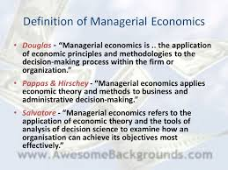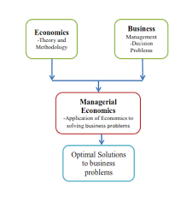

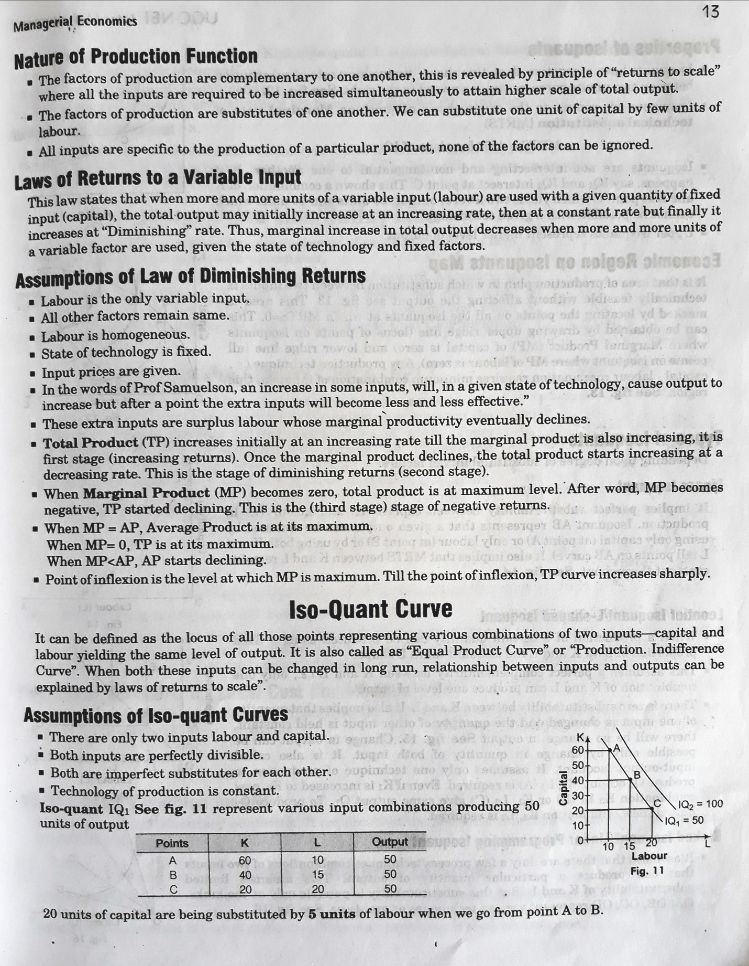

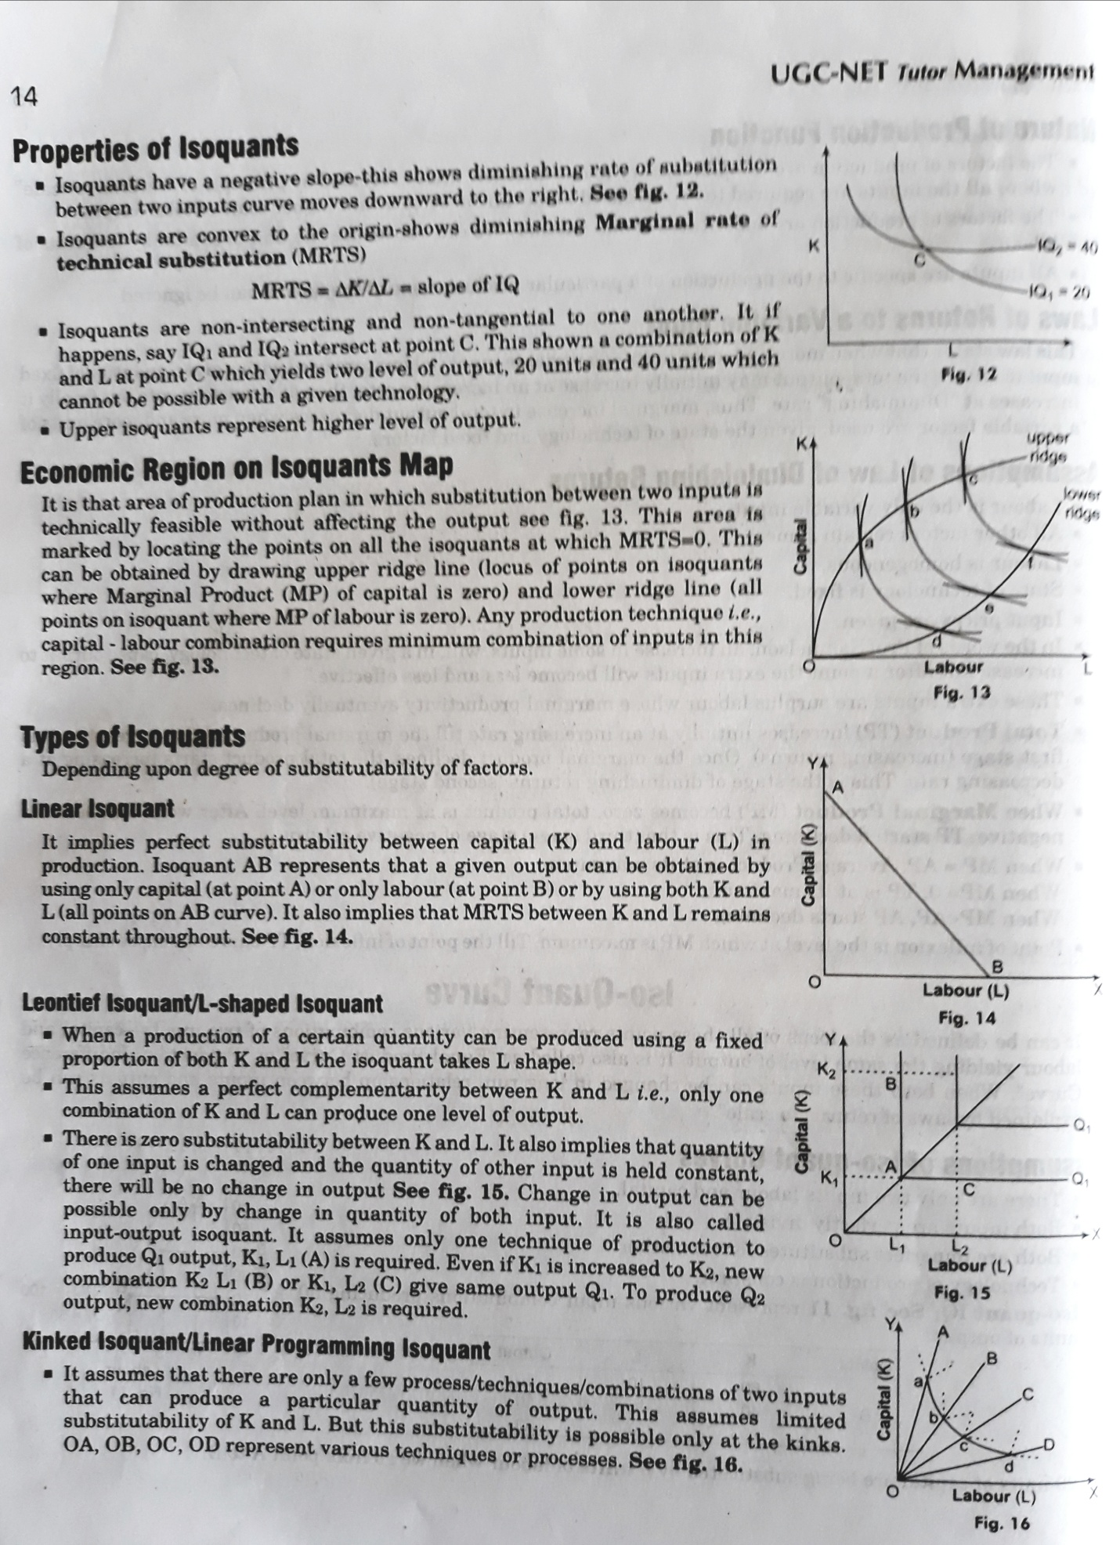
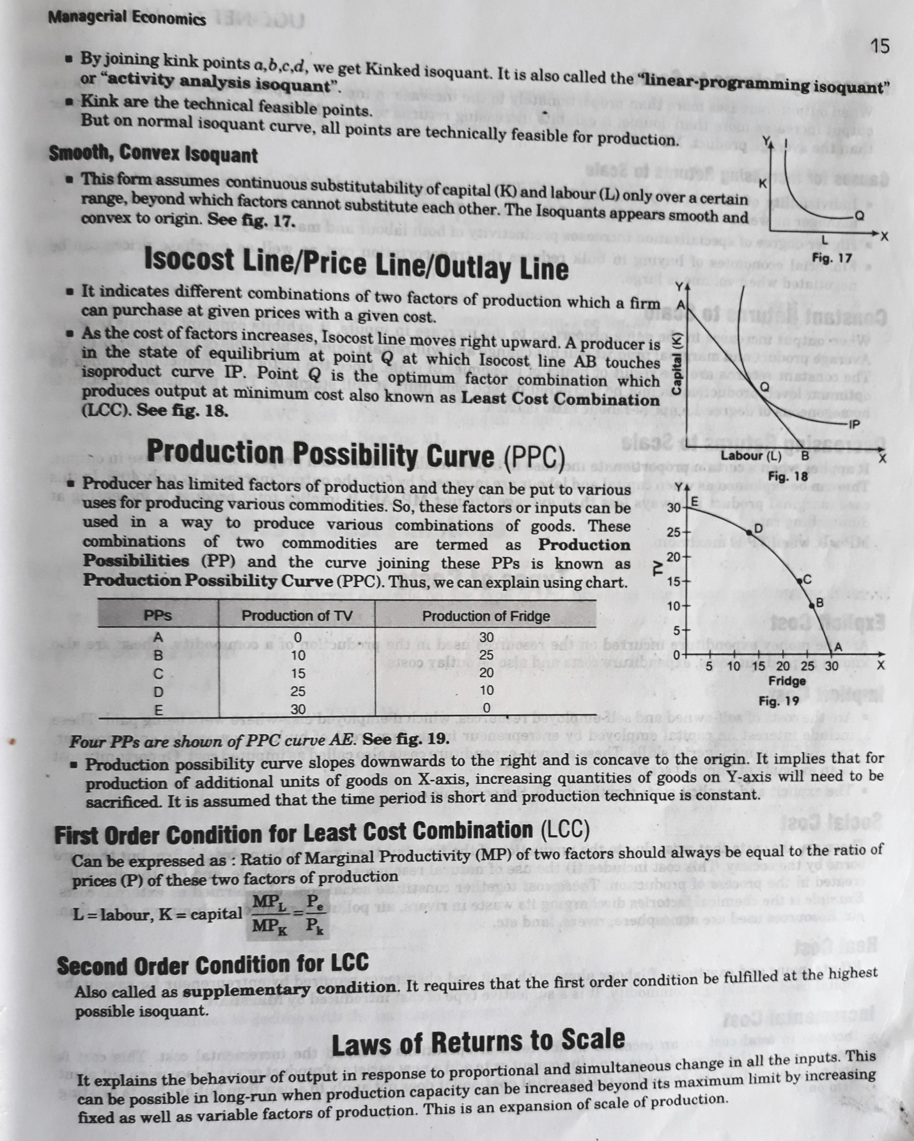

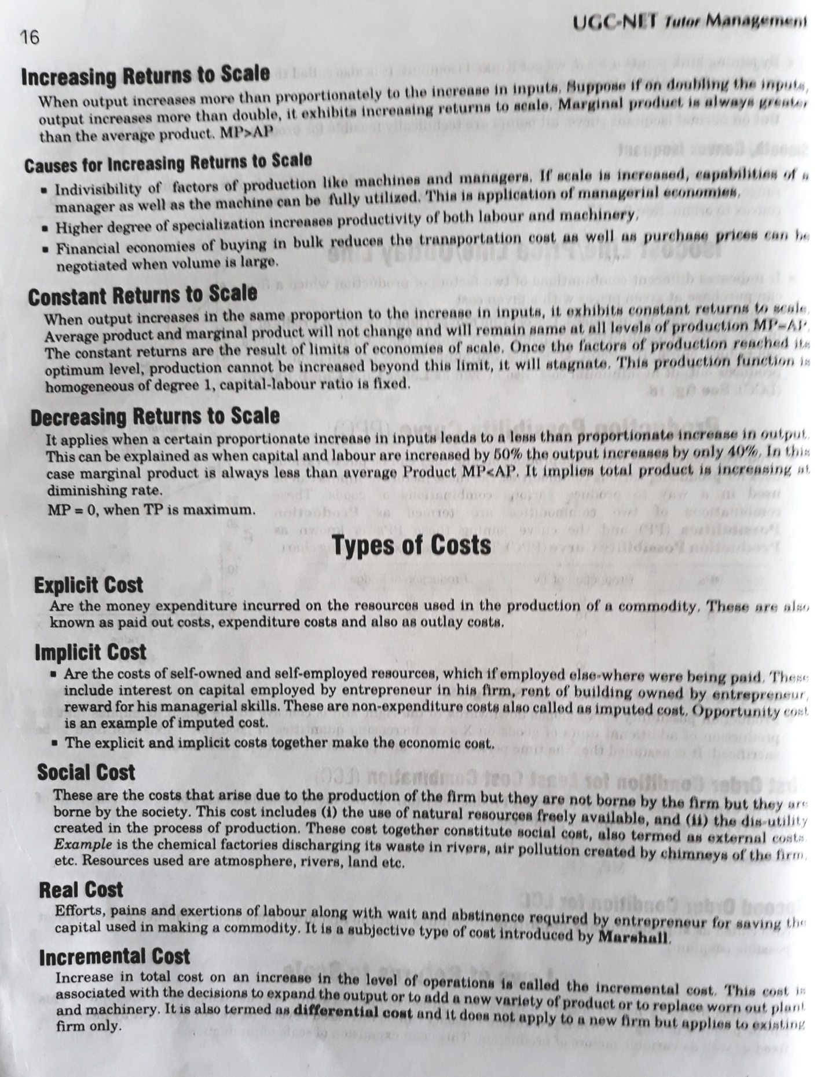

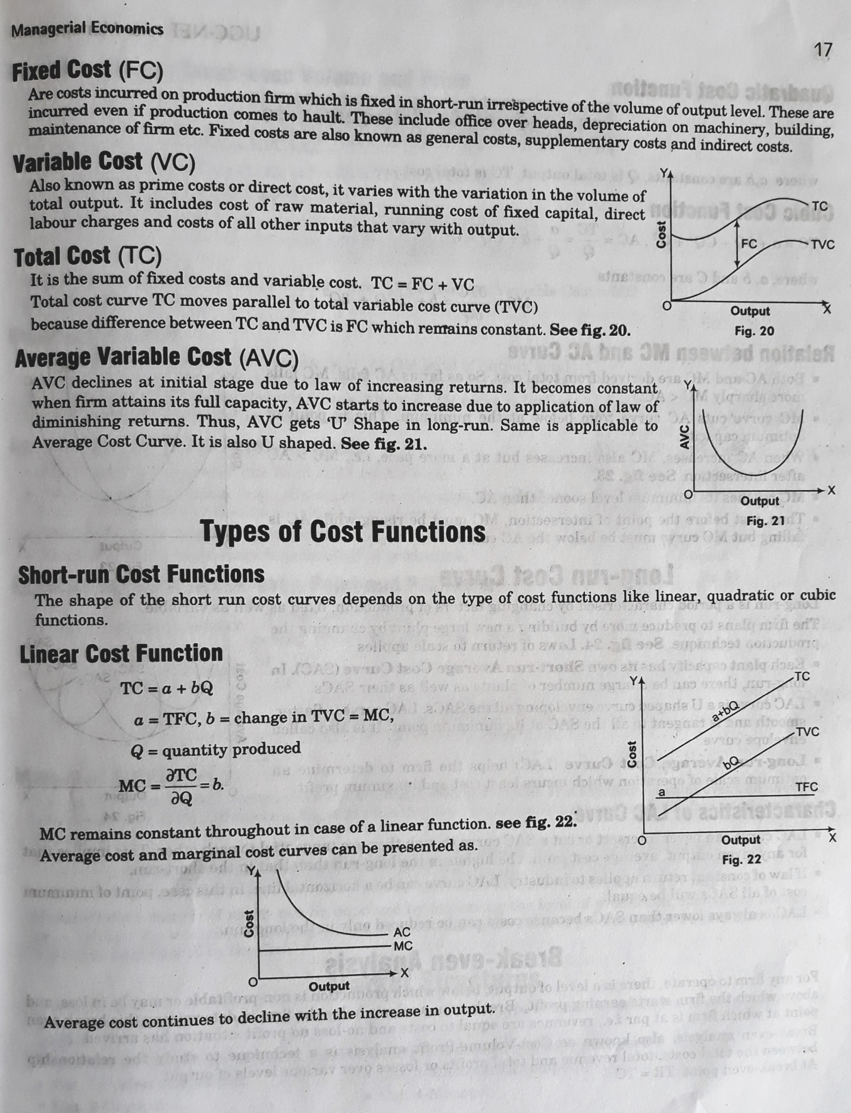

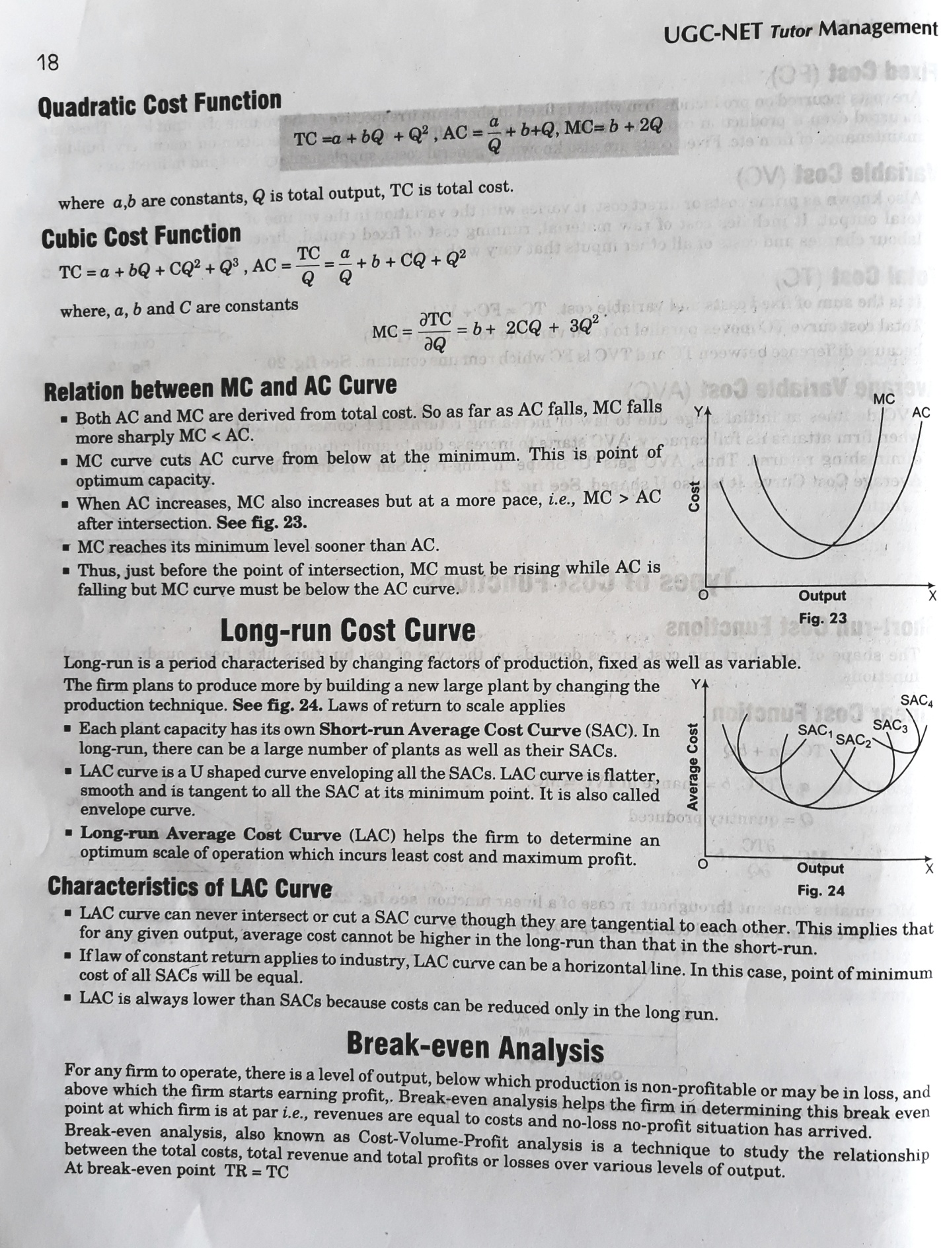

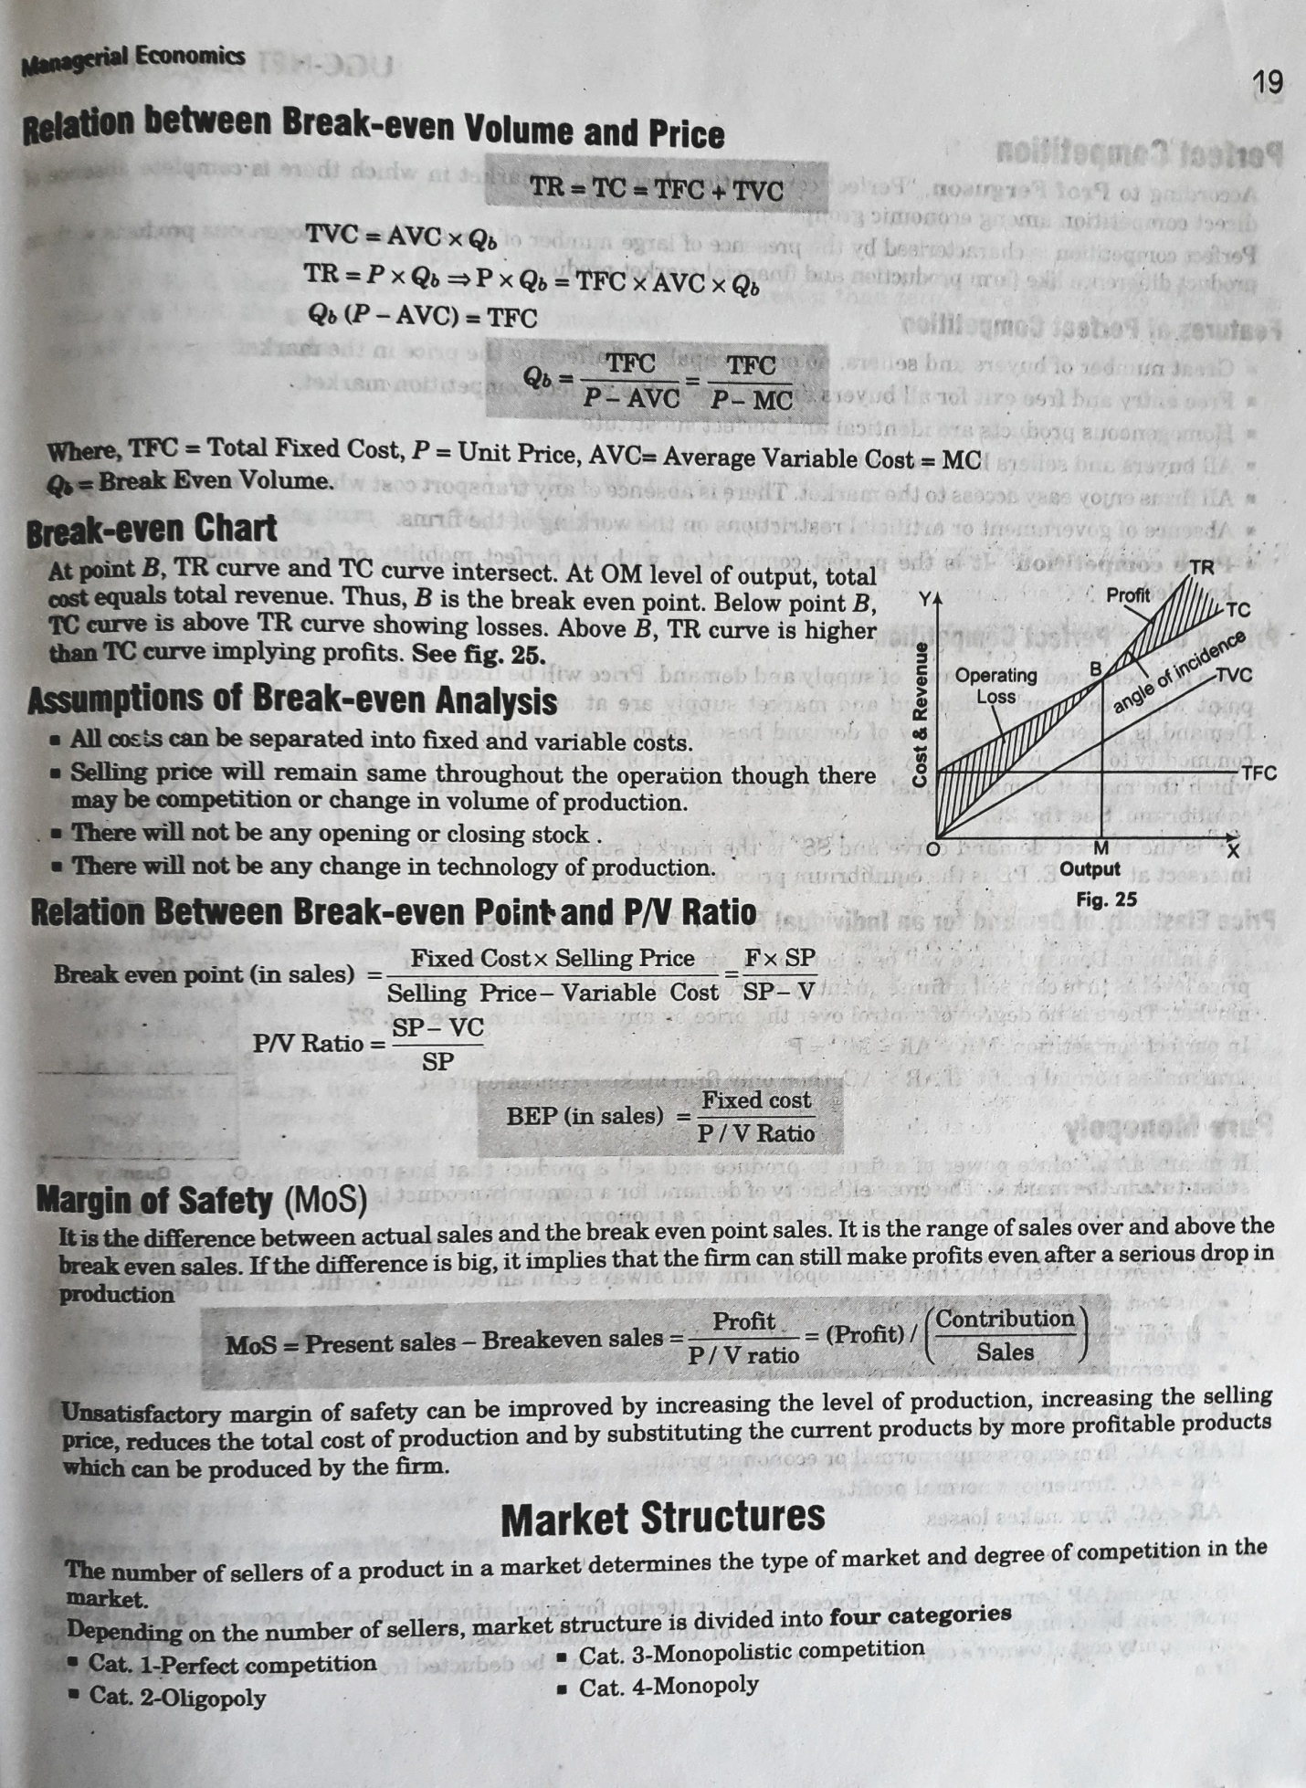
Managerial Economics. Managerial Economics: Demand Analysis. Demand Demand is the quantity of good and services that customers are willing and able to purchase during a specified period under a given set of economic conditions.
Definition: The Demand Analysis is a process whereby the management makes decisions with respect to the production, cost allocation, advertising, inventory holding, pricing, etc. ... Thus, the marketer is required to analyze properly thedemand for its product in the market and must hold inventory accordingly.
Definition: Demand Forecasting refers to the process of predicting the futuredemand for the firm's product. In other words, demand forecasting is comprised of a series of steps that involves the anticipation of demand for a product in future under both controllable and non-controllable factors.
he different types of demand (as shown in Figure-1) are discussed as follows:
- i. Individual and Market Demand: ...
- ii. Organization and Industry Demand: ...
- iii. Autonomous and Derived Demand: ...
- iv. Demand for Perishable and Durable Goods: ...
- v. Short-term and Long-term Demand:

Demand refers to how much (quantity) of a product or service is desired by buyers. The quantity demanded is the amount of a product people are willing to buy at a certain price; the relationship between price and quantity demanded is known as thedemand relationship. Supply represents how much the market can offer.
Demand theory is a principle relating to the relationship between consumerdemand for goods and services and their prices. Demand theory forms the basis for the demand curve, which relates consumer desire to the amount of goods available.
Marshallian demand function. In microeconomics, a consumer's Marshallian demand function (named after Alfred Marshall) specifies what the consumer would buy in each price and income or wealth situation, assuming it perfectly solves the utility maximization problem.
In microeconomics, a consumer's Marshallian demand function (named after Alfred Marshall) specifies what the consumer would buy in each price and income or wealth situation, assuming it perfectly solves the utility maximization problem.
Find out the definition and meaning for demand analysis to discover the customer requests for a product or service in a particular market. Demand is the amount of goods that consumers or buyers are willing and capable to buy for a specific price in a specific time period while everything else remains the same.
Examples of the Supply and Demand Concept. Supply refers to the amount of goods that are available. Demand refers to how many people want those goods. When supply of a product goes up, the price of a product goes down and demandfor the product can rise because it costs loss.

Definition: Demand Analysis
Demand analysis is a research done to estimate or find out the customer demand for a product or service in a particular market. Demand analysis is one of the important consideration for a variety of business decisions like determining sales forecasting, pricing products/services, marketing and advertisement spending, manufacturing decisions, expansion planning etc. Demand analysis covers both future and retrospective analysis so that they can analyse the demand better and understand the product/service's past success and failure too. For a new company, the demand analysis can tell whether a substantial demand exists for the product/service and given the other information like number of competitors, size of competitors, industry growth etc it helps to decide if the company could enter the market and generate enough returns to sustain and advance its business.
Below is the demand analysis for US restaurant industry (Source: Dun & Bradstreet)
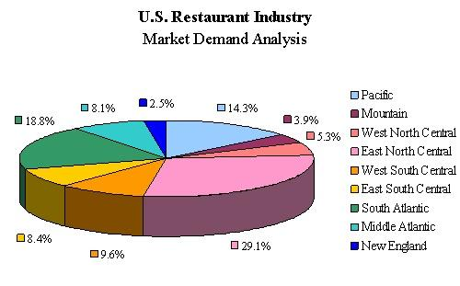
It shows that market activity is highest in East North Central area. The figures are arrived by tracking the annual sales in each region.
Demand analysis helps in identifying key business areas where demand is highest and areas which needs attention as very low demand indicates different problems like either the customers are not aware of the product/service and more focus must be in advertisement and promotion or the customer needs are not met by current product/service and improvements are needed or competitors have sprung up with better offerings etc.

Hence, this concludes the definition of Demand Analysis along with its overview.
Managerial Economics: Demand Analysis
Demand Demand is the quantity of good and services that customers are willing and able to purchase during a specified period under a given set of economic conditions. The period here could be an hour, a day, a month, or a year. The conditions to be considered include the price of good, consumer’s income, the price of the related goods, consumer’s preferences, advertising expenditures and so on. The amount of the product that the customers are willing to buy, or the demand, depends on these factors. There are two types of demand. The first of these is called direct demand. This model of demand analysis individual demand for goods and services that directly satisfy consumers desires. The prime determinant of direct demand is the utility gained by consumption of goods and services. Consumers budget, product characteristics, individuals preferences are all important determinants of direct demand. The other type of demand is called derived demand. Derived demand is the demand resulting from the need to provide the final goods and services to the consumers. Intermediate goods, office machines are examples of derived demand. An other good example is mortgage credit. Mortgage credit demand is not demanded directly, but derived from the demand for housing.
Market demand function The market demand function for a product is a function showing the relation between the quantity demanded and the factors affecting the quantity of demand. A demand function for the good X can be expressed as follows: Quantity of product X demanded = Qx = f (the price of X, prices of related goods, expectations of price changes, income, preferences, advertising expenditures and so on. ) For use in managerial decision making, the relation between quantity of demand and each demand determining variable must be specified.
Demand Curve The demand function specifies the relation between the quantity demanded and all factors that determine demand. But the demand curve expresses the relation between the price of a product and the quantity demanded, holding constant all the other factors affecting demand.
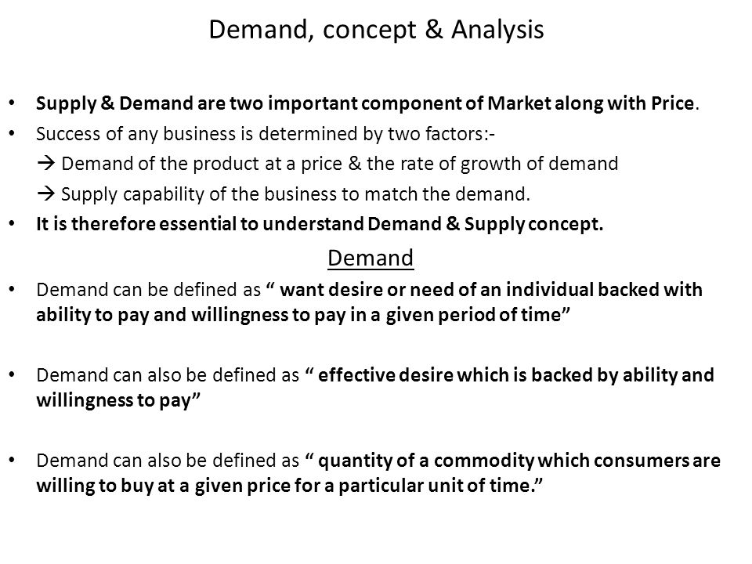
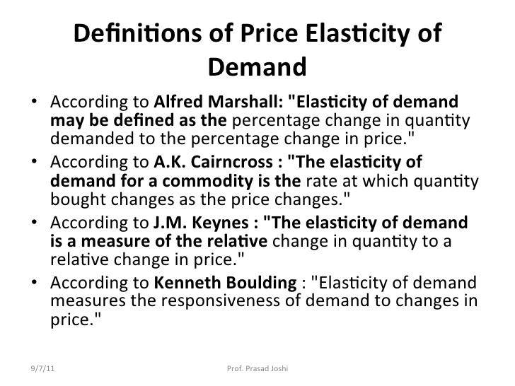
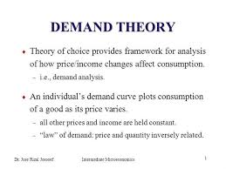

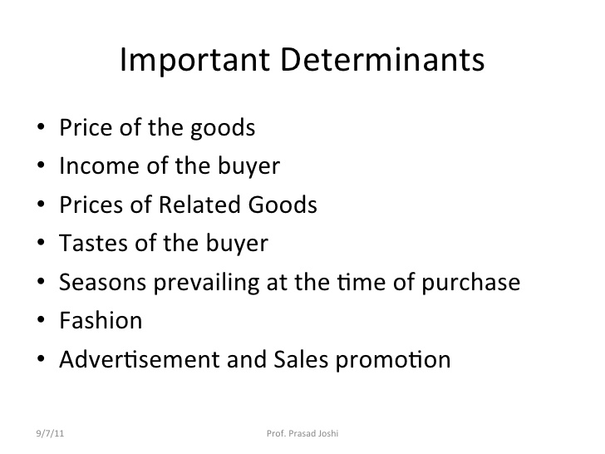

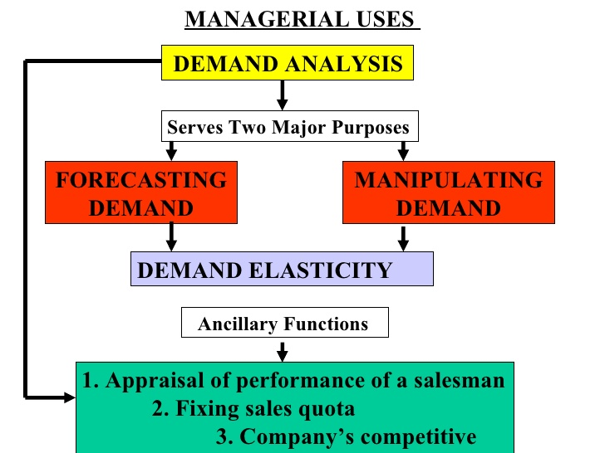
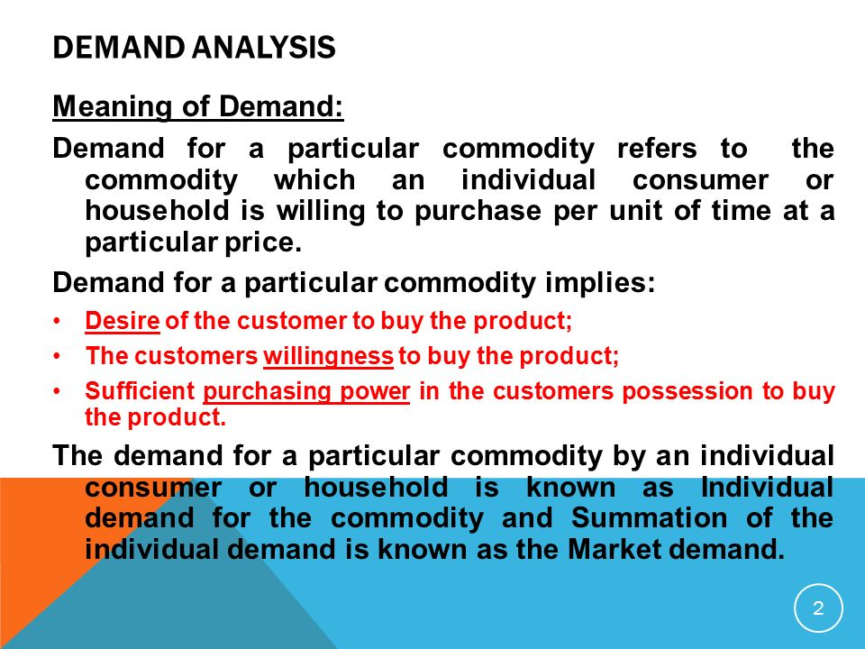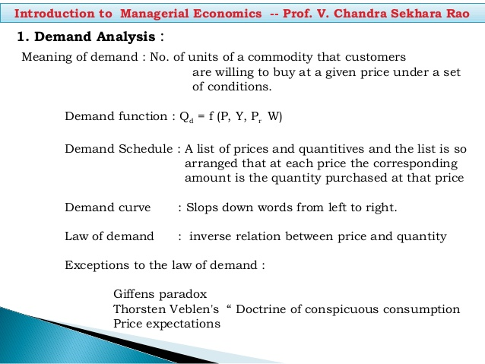

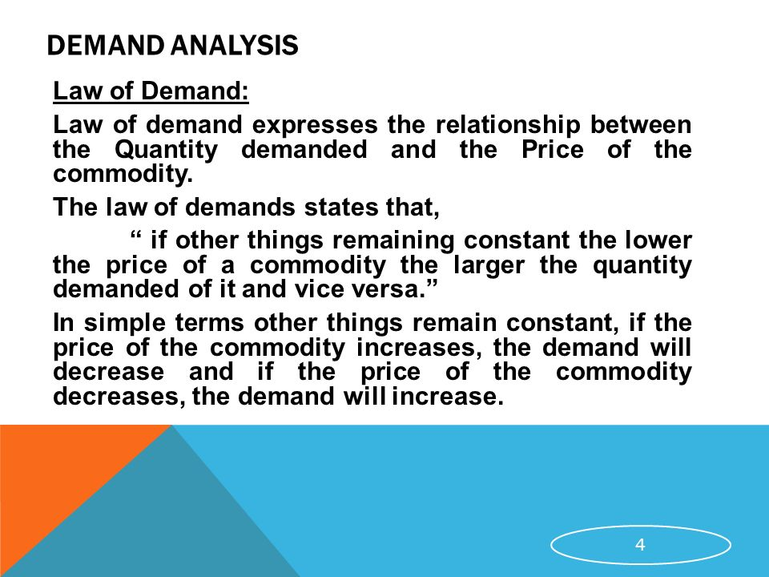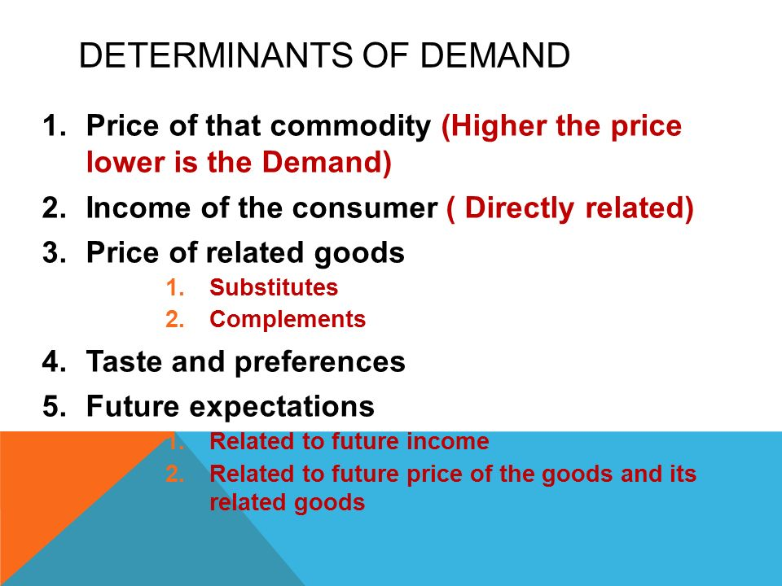

Definition: Demand Forecasting refers to the process of predicting the futuredemand for the firm's product. In other words, demand forecasting is comprised of a series of steps that involves the anticipation of demand for a product in future under both controllable and non-controllable factors.
Demand forecasting involves quantitative methods such as the use of data, and especially historical sales data, as well as statistical techniques from test markets.

Top 7 Methods of Demand Forecasting | Managerial Economics
The following points highlight the top seven methods of demand forecasting. the methods are:
1. Survey of Buyer’s Intentions 2. Collective Opinion or Sales Force Composite Method 3. Trend Projection 4. Executive Judgment Method 5. Economic Indicators 8. Controlled Experiments 7. Expert’s Opinions.

Demand Forecasting Method # 1. Survey of Buyer’s-Intentions:
This is a short-term method of knowing and estimating customer’s demand. This is direct method of estimating demand of customers as to what they intend to buy for the forthcoming time—usually a year.
By this the burden of forecasting goes to the buyer. This method is useful for the producers who produce goods in bulk.
Still their estimates should not entirely depend upon it. This method does not hold good for household consumers because of their inability to foresee their choice when they see the alternatives. Besides the household consumers there are many which make this method costly and impracticable. It does not expose and measure the variables under management control.

Demand Forecasting Method # 2. Collective Opinion or Sales Force Competitive Method:
Under this method, the salesman are nearest persons to the customers and are able to judge, their minds and market. They better understand the reactions of the customers to the firms products and their sales trends. The estimates of the different salesmen are collected and estimates sales are predicted.
These estimates are revised from time to time with changes in sales price, product, designs, publicity programmes, expected changes in competition, purchasing power, income distribution, employment and population. It makes use of collective wisdom of salesmen, departmental heads and top executives.
Advantages:
(1) It is simple, common sense method involving no mathematical calculations.
(2) It is based on the first-hand knowledge of salesman and the persons directly connected with sales.
(3) This method is particularly useful for sales of new product. It has the salesman’s judgment.
Dis-advantages:
(1) It is a subjective approach.
(2) This method can be used only for short-term forecasting.
For long-term planning it is not useful.

Demand Forecasting Method # 3. Trend Projection or Time Trend of the Time Series:
This is the most popular method of analysing time series and is generally used to project the time trend of the time series. A trend line can be filled through the series in visual or statistical way by the method of least squares.
The analyst can make a plausible algebraic relation—may it be linear, a quadratic or logarithmic between sales on one hand and independent variable time on the other. The trend line is then projected into the future for purpose of extrapolation.
Advantages:
This method is most popular as it is simple and in-extensive and because of time series data often exhibits a persistent growth trend.
Assumptions:
The basic assumption of this method is that the past rate of change of the variable under study will be continuing in future. This assumption gives good safe results till the time series exhibits a persistent tendency to move in the same direction.
When the burning point comes, the trend projection breaks down. Even though a forecaster could hope normally to be correct in most forecasts when the turning points are few and spaced at long intervals from each other.
In fact, the actual challenge of forecasting is in the prediction of turning points rather than in the trend projection. At such turning points the management will have to change and revise its sales and projection strategies most drastically.
There are four factors responsible for the characterization of time series.
They are:
1. Fluctuations and turning points.
2. Trend seasonal variations.
3. Cyclical fluctuations, and
4. Irregular or random forces.
The problem in forecasting is to separate and measure each of these factors.
This time series is expressed by the following equation:
O = TSCI
where, O = observed data
T = a secular tend
S = a seasonal factor
C = cyclical element
I = an irregular movement.
The usual practice is to calculate the trend first from the basic data. The trend values are then taken out from the observed data (TSCI /T). The next step is to reckon the seasonal index that is utilised to remove the seasonal effect (SCI/S).
It is fitted through chain to the remainder that also gives the irregular effect. This approach to the breaking up of time series data is an analytical device of usefulness for the knowledge of the nature of business fluctuations.
Assumptions:
(a) Analysis of movements would be in the order of trend, seasonal variations and cyclical changes.
(b) The effects of every component are not dependent on any other components.

Demand Forecasting Method # 4. Executive Judgment Method:
Under this method opinions are sought from the executives of different discipline i.e., marketing, finance, production etc. and estimates for future demands are made. Thus, this is a process of combining, averaging or evaluating in some other way the opinions and views of the top executives.
Advantages:
The main advantages of this method are:
1. The forecasts can be made speedily by analysing the opinions and views of top executives. The techniques is quite easy and simple.
2. No need of elaborate statistics:
There is no need of collecting elaborate. Statistics for the forecasts hence it is not much expensive.
3. Only feasible method to follow:
In the absence of adequate data is it the only feasible method to be followed.
Dis-advantages:
The chief dis-advantages of the of this method are:
(1) No factual basis of such forecast:
There is no factual basis of such forecasts, so the method is inferior to others.
(2) No accuracy:
Accuracy cannot be claimed under this method.
(3) Responsibility for the accuracy of data cannot be fixed on any one.

5. Economic Indicators:
This method has its base for demand forecasting on few economic indicators.
(a) Construction contracts:
For demand towards building materials sanctioned for Cement.
(b) Personal Income:
Towards demand of consumer goods.
(c) Agricultural Income:
Towards demand of agricultural imports instruments, fertilisers, manner etc.
(d) Automobiles Registration:
Towards demand of car parts and petrol. These and other economic indicators are given by specialised organisation. The analyst should establish relationship between the sale of the product and the economic indicators to project the correct sales and to measure as to what extent these indicators affect the sales. To establish relationship is not an easy task especially in case of New Product where there is no past records.
Steps:
Following steps may be remembered:
(a) If there is any relationship between the demand for a product and certain economic indicator.
(b) Make the relationship by the method of least squares and derive the regression equation. Supposing the relationship is Linear the equation will be of the form y = α + bx. There can be curvilinear relationship also.
(c) Once the regression equation is obtained any value of X (economic indicator) can be applied to forecast the value of Y (demand).
(d) Past relationship may not recur. Therefore, need for value judgments are felt. Other new factors may also have to be taken into consideration.
Limitations:
The limitations of economic indicators are as follows:
(1) It is difficult to find out an appropriate economic indicator.
(2) For few products it is not good, as no past data are available.
(3) This method of forecasting is best suited where relationship of demand with a particular indicator is characterised by a Time Lag, such as construction contracts will give consequence to demand for building materials with some amount of Time Lag.
But where the demand does not Lag behind the particular economic index, the utility is restricted because forecast may have to be based on projected economic index itself that may not result true.

Demand Forecasting Method # 6. Controlled Experiments:
Under this method, an effort is made to ascertain separately certain determinants of demand which can be maintained, e.g., price, advertising etc. and conducting the experiment, assuming etc., and conducting the experiment, assuming that the other factors remain constant.
Thus, the effect of demand determinants like price, advertisement packing etc., on sales can be assessed by either varying them over different markets or by varying them over different time periods in the same market.
For example:
Different prices would be associated with different sales on that basis the price, quantity relationship is estimated in the form of regression equation and used for forecasting purposes. It must be noted that the market divisions here must be homogeneous with regard to income, tastes etc.
Such experiments have been conducted widely in the USA and were successful. This is a new experiment. This is quite new and less applied.
The main reasons for non-application of this method so far as follows:
1. The method is expensive and time consuming.
2. It is risky because it may lead to un-favourable reactions on dealers, consumers and competitors.
3. It is not always easy to determine what conditions should be taken to be constant and what factors should be regarded as variable, so as to separated and measures their influence on demand.
4. It is hard to satisfy the homogeneity of market conditions. In-spite of these drawbacks, controlled experiments have sufficient potentialities to become a useful method for business research and analysis in future.

Demand Forecasting Method # 7. Expert’s Opinions:
Under this method expert’s opinions are sought from specialists in the field, outside the organisations or the organisation collects opinions from such specialists; views of expert’s published in the newspaper and journals for the trade, wholesalers and distributors for the company’s products, agencies and professional experts.
These opinions and views are analysed and deductions are made therefrom to arrive at the figure of demand forecasts.
Advantages:
The advantages of this method are:
(1) Forecasts can be done easily and speedily.
(2) It is based on expert’s views and opinions hence estimates are nearly accurate.
(3) The method is suitable where past records of sales are not available.
(4) The method is economical because survey is done to collect the data. The expenses of seeking the opinions and views of experts are much less than the expenses of actual survey.
Dis-advantages:
The important dis-advantages of this method are:
(1) Estimates for a market segment cannot be possible.
(2) The reliability of forecasting is always subjective because forecasting is not based on facts.

Methods of Demand Forecasting
Demand forecasting is the art as well as the science of predicting the likely demand for a product or service in future. This prediction is based on the past behavior patterns and the continuing trends in the present. Hence, it is not simply guessing the future demand but is estimating the demand scientifically and objectively. Thus, there are various methods of demand forecasting which we will discuss here.

Methods of Demand Forecasting
There is no easy or simple formula to forecast the demand. Proper judgment along with the scientific formula is needed to correctly predict the future demand for a product or service. Some methods of demand forecasting are discussed below:

1] Survey of Buyer’s Choice
When the demand needs to be forecasted in the short run, say a year, then the most feasible method is to ask the customers directly that what are they intending to buy in the forthcoming time period. Thus, under this method, the potential customers are directly interviewed. This survey can be done in any of the following ways:
- Complete Enumeration Method: Under this method, nearly all the potential buyers are asked about their future purchase plans.
- Sample Survey Method: Under this method, a sample of potential buyers is chosen scientifically and only those chosen are interviewed.
- End-use Method: It is especially used for forecasting the demand of the inputs. Under this method, the final users i.e. the consuming industries and other sectors are identified. The desirable norms of consumption of the product are fixed, the targeted output levels are estimated and these norms are applied to forecast the future demand of the inputs.
Hence, it can be said that under this method the burden of demand forecasting is on the buyer. However, the judgments of the buyers are not completely reliable and so the seller should take decisions in the light of his judgment also.
The customer may misjudge their demands and may also change their decisions in the future which in turn may mislead the survey. This method is suitable when goods are supplied in bulk to industries but not in the case of household customers.

2] Collective Opinion Method
Under this method, the salesperson of a firm predicts the estimated future sales in their region. The individual estimates are aggregated to calculate the total estimated future sales. These estimates are reviewed in the light of factors like future changes in the selling price, product designs, changes in competition, advertisement campaigns, the purchasing power of the consumers, employment opportunities, population, etc.
The principle underlying this method is that as the salesmen are closest to the consumers they are more likely to understand the changes in their needs and demands. They can also easily find out the reasons behind the change in their tastes.
Therefore, a firm having good sales personnel can utilize their experience to predict the demands. Hence, this method is also known as Salesforce opinion or Grassroots approach method. However, this method depends on the personal opinions of the sales personnel and is not purely scientific.

3] Barometric Method
This method is based on the past demands of the product and tries to project the past into the future. The economic indicators are used to predict the future trends of the business. Based on the future trends, the demand for the product is forecasted. An index of economic indicators is formed. There are three types of economic indicators, viz. leading indicators, lagging indicators, and coincidental indicators.
The leading indicators are those that move up or down ahead of some other series. The lagging indicators are those that follow a change after some time lag. The coincidental indicators are those that move up and down simultaneously with the level of economic activities.

4] Market Experiment Method
Another one of the methods of demand forecasting is the market experiment method. Under this method, the demand is forecasted by conducting market studies and experiments on consumer behavior under actual but controlled, market conditions. Certain determinants of demand that can be varied are changed and the experiments are done keeping other factors constant. However, this method is very expensive and time-consuming.

5] Expert Opinion Method
Usually, the market experts have explicit knowledge about the factors affecting the demand. Their opinion can help in demand forecasting. The Delphi technique, developed by Olaf Helmer is one such method. Under this method, experts are given a series of carefully designed questionnaires and are asked to forecast the demand. They are also required to give the suitable reasons. The opinions are shared with the experts to arrive at a conclusion. This is a fast and cheap technique.

6] Statistical Methods
The statistical method is one of the important methods of demand forecasting. Statistical methods are scientific, reliable and free from biases. The major statistical methods used for demand forecasting are:
- Trend Projection Method: This method is useful where the organization has sufficient amount of accumulated past data of the sales. This date is arranged chronologically to obtain a time series. Thus, the time series depicts the past trend and on the basis of it, the future market trend can be predicted. It is assumed that the past trend will continue in future. Thus, on the basis of the predicted future trend, the demand for a product or service is forecasted.
- Regression Analysis: This method establishes a relationship between the dependent variable and the independent variables. In our case, the quantity demanded is the dependent variable and income, the price of goods, price of related goods, the price of substitute goods, etc. are independent variables. The regression equation is derived assuming the relationship to be linear. Regression Equation: Y = a + bX. Where Y is the forecasted demand for a product or service.

Solved Example For You
Which of the following are the techniques of Trend Projection Method of forecasting?
- Barometric method
- Expert Opinion Method
- Market Experiment Method
- Graphical Method and Fitting trend equation.
Ans: The correct option is D. Under the Graphical Method of trend projection, the data of the time series is plotted on a graph. The direction of the curve shoes the trend. If the curve is moving upwards it shows an increase in future demand. However, this method is not very reliable.
Fitting trend equation or Least Square Method is based on the assumption that the past trend will continue in future. This method is a procedure for fitting a line to a set of observed data points mathematically so that the sum of the squared differences between the calculated and observed value is minimized. A trend that best fits the data is found out and demand is forecasted accordingly.

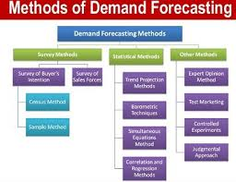
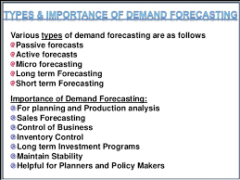

Elasticity of Demand: Meaning and Types of Elasticity (explained with diagram)

Meaning of Elasticity of Demand:
Demand extends or contracts respectively with a fall or rise in price. This quality of demand by virtue of which it changes (increases or decreases) when price changes (decreases or increases) is called Elasticity of Demand.
“The elasticity (or responsiveness) of demand in a market is great or small according as the amount demanded increases much or little for a given fall in price, and diminishes much or little for a given rise in price”. – Dr. Marshall.
Elasticity means sensitiveness or responsiveness of demand to the change in price.
This change, sensitiveness or responsiveness, may be small or great. Take the case of salt. Even a big fall in its price may not induce an appreciable ex appreciable extension in its demand. On the other hand, a slight fall in the price of oranges may cause a considerable extension in their demand. That is why we say that the demand in the former case is ‘inelastic’ and in the latter case it is ‘elastic’.
The demand is elastic when with a small change in price there is a great change in demand; it is inelastic or less elastic when even a big change in price induces only a slight change in demand. In the words of Dr. Marshall, “The elasticity (or responsiveness) of demand in a market is great or small according as the amount demanded increases much or little for a given fall in price, and diminishes much or little for a given rise in price.”But the demand cannot be perfectly ‘elastic’ or ‘inelastic’.
Completely elastic demand will mean that a slight fall (or rise) in the price of the commodity concerned induces an infinite extension (or contraction) in its demand. Completely inelastic demand will mean that any amount of fall (or rise) in the price of the commodity would not induce any extension (or contraction) in its demand. Both these conditions are unrealistic. That is why we say that elasticity of demand may be ‘more or less’, but it is seldom perfectly elastic or absolutely inelastic.

Types of Elasticity:
Distinction may be made between Price Elasticity, Income Elasticity and Cross Elasticity. Price Elasticity is the responsiveness of demand to change in price; income elasticity means a change in demand in response to a change in the consumer’s income; and cross elasticity means a change in the demand for a commodity owing to change in the price of another commodity.

Degrees of Elasticity of Demand:
We have seen above that some commodities have very elastic demand, while others have less elastic demand. Let us now try to understand the different degrees of elasticity of demand with the help of curves.
(a) Infinite or Perfect Elasticity of Demand:
Let as first take one extreme case of elasticity of demand, viz., when it is infinite or perfect. Elasticity of demand is infinity when even a negligible fall in the price of the commodity leads to an infinite extension in the demand for it. In Fig. 10.1 the horizontal straight line DD’ shows infinite elasticity of demand. Even when the price remains the same, the demand goes on changing.
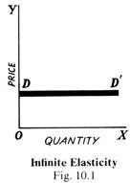
(b) Perfectly Inelastic Demand:
The other extreme limit is when demand is perfectly inelastic. It means that howsoever great the rise or fall in the price of the commodity in question, its demand remains absolutely unchanged. In Fig. 10.2, the vertical line DD’ shows a perfectly inelastic demand. In other words, in this case elasticity of demand is zero. No amount of change in price induces a change in demand.
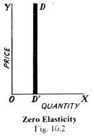
In the real world, there is no commodity the demand for which may be absolutely inelastic, i.e., changes in its price will fail to bring about any change at all in the demand for it. Some extension/contraction is bound to occur that is why economists say that elasticity of demand is a matter of degree only. In the same manner, there are few commodities in whose case the demand is perfectly elastic. Thus, in real life, the elasticity of demand of most goods and services lies between the two limits given above, viz., infinity and zero. Some have highly elastic demand while others have less elastic demand.
(c) Very Elastic Demand:
Demand is said to be very elastic when even a small change in the price of a commodity leads to a considerable extension/contraction of the amount demanded of it. In Fig. 10.3, DD’ curve illustrates such a demand. As a result of change of T in the price, the quantity demanded extends/contracts by MM’, which clearly is comparatively a large change in demand.
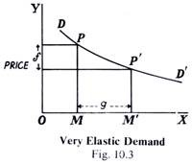
(d) Less Elastic Demand:
When even a substantial change in price brings only a small extension/contraction in demand, it is said to be less elastic. In Fig. 10.4, DD’ shows less elastic demand. A fall of NN’ in price extends demand by MM’ only, which is very small.